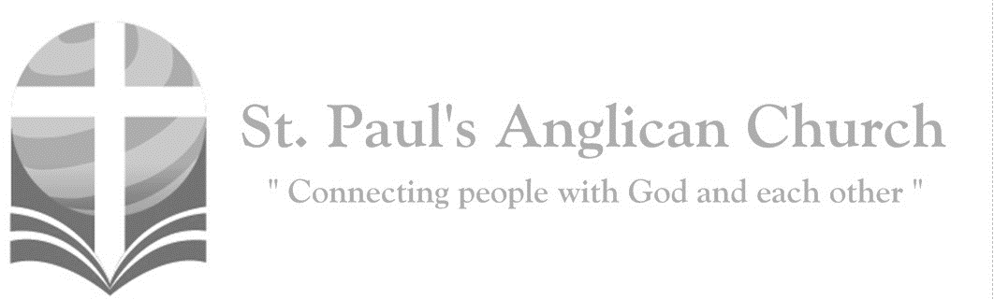
Sunday, March 22, 2020: 4th Sunday in Lent
Seek the Lord while he wills to be found, call upon him when he draws near; let the wicked forsake their ways, and the evil ones their thoughts; and let them return to the Lord, and he will have compassion, and to our God, for he will richly pardon.
(Isaiah 55:6-7)

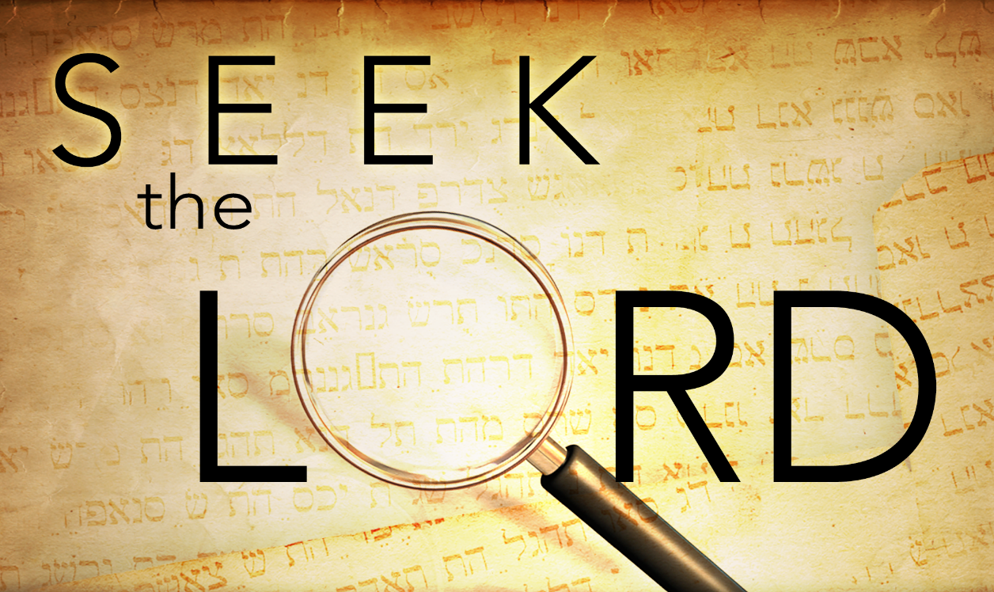

Opening Song: Great is Thy Faithfulness (Beginning to End)
(Chorus) Beginning to end
My life in Your hands
Great, great is Your faithfulness
You never let go, this one thing I know
Great, great is Your faithfulness

Great is Thy faithfulness
O God, my Father
There is no shadow of turning with Thee
Thou changest not
Thy compassions they fail not
As Thou hast been Thou forever wilt be

Summer and winter
And springtime and harvest
Sun, moon, and stars
In their courses above
Join with all nature in manifold witness
To Thy great faithfulness
Mercy and love (To Chorus)

Pardon for sin
And a peace that endureth
Thine own dear presence
To cheer and to guide
Strength for today
And bright hope for tomorrow
Blessings all mine
With ten thousand beside (To Chorus)

Great is Thy faithfulness
Great is Thy faithfulness
Morning by morning new mercies I see
All I have needed
Thy hand has provided
Great is Thy faithfulness Lord unto me

Penitential Rite
Rev. Myron: Dear friends in Christ, as we prepare to worship almighty God, let us with penitent and obedient hearts confess our sins, that we may obtain forgiveness by his infinite goodness and mercy.
Silence is Kept
All: Most merciful God, we confess that we have sinned against you in thought, word, and deed, by what we have done and by what we have left undone. We have not loved you with our whole heart; we have not loved our neighbours as ourselves. We are truly sorry and we humbly repent. For the sake of your Son Jesus Christ, have mercy on us and forgive us, that we may delight in your will, and walk in your ways, to the glory of your name. Amen.
Rev. Myron: Almighty God have mercy upon you, pardon and deliver you from all your sins, confirm and strengthen you in all goodness, and keep you in eternal life; through Jesus Christ our Lord.
All: Amen.
Morning Prayer
Rev. Myron: The Lord is full of compassion and mercy: O come, let us worship. (Venite - Psalm 95.1–7) Come, let us sing to the Lord; let us shout for joy to the rock of our salvation. Let us come before his presence with thanksgiving and raise a loud shout to him with psalms. For the Lord is a great God, and a great king above all gods. In his hand are the caverns of the earth, and the heights of the hills are his also. The sea is his for he made it, and his hands have moulded the dry land. Come, let us bow down, and bend the knee, and kneel before the Lord our maker. For he is our God, and we are the people of his pasture and the sheep of his hand. Oh, that today you would hearken to his voice!

The Reading of Scripture
First Reading: 1 Samuel 16:1-13
The LORD said to Samuel, "How long will you grieve over Saul? I have rejected him from being king over Israel. Fill your horn with oil and set out; I will send you to Jesse the Bethlehemite, for I have provided for myself a king among his sons." Samuel said, "How can I go? If Saul hears of it, he will kill me." And the LORD said, "Take a heifer with you, and say, 'I have come to sacrifice to the LORD.' Invite Jesse to the sacrifice, and I will show you what you shall do; and you shall anoint for me the one whom I name to you." Samuel did what the LORD commanded, and came to Bethlehem. The elders of the city came to meet him trembling, and said, "Do you come peaceably?" He said, "Peaceably; I have come to sacrifice to the LORD; sanctify yourselves and come with me to the sacrifice." And he sanctified Jesse and his sons and invited them to the sacrifice. When they came, he looked on Eliab and thought, "Surely the Lord's anointed is now before the LORD." But the LORD said to Samuel, "Do not look on his appearance or on the height of his stature, because I have rejected him; for the LORD does not see as mortals see; they look on the outward appearance, but the LORD looks on the heart." Then Jesse called Abinadab, and made him pass before Samuel. He said, "Neither has the LORD chosen this one." Then Jesse made Shammah pass by. And he said, "Neither has the LORD chosen this one." Jesse made seven of his sons pass before Samuel, and Samuel said to Jesse, "The LORD has not chosen any of these." Samuel said to Jesse, "Are all your sons here?" And he said, "There remains yet the youngest, but he is keeping the sheep." And Samuel said to Jesse, "Send and bring him; for we will not sit down until he comes here." He sent and brought him in. Now he was ruddy, and had beautiful eyes, and was handsome. The LORD said, "Rise and anoint him; for this is the one." Then Samuel took the horn of oil, and anointed him in the presence of his brothers; and the spirit of the LORD came mightily upon David from that day forward. Samuel then set out and went to Ramah.
Reader: The Word of the Lord.
People: Thanks be to God.

Canticle: Psalm 23
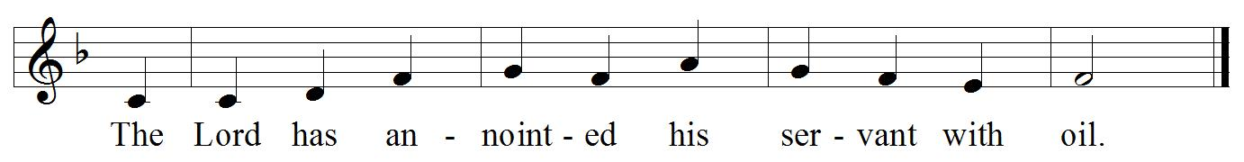
Refrain:

The Lord is my shepherd; I shall not be in want. He makes me lie down in green pastures, and leads me beside still waters. Refrain

He revives my soul and guides me along right pathways for his name’s sake. Though I walk through the valley of the shadow of death, I shall fear no evil; for you are with me; your rod and your staff, they comfort me. Refrain

You spread a table before me in the presence of those who trouble me; you have anointed my head with oil, and my cup is running over. Surely your goodness and mercy shall follow me all the days of my life, and I will dwell in the house of the Lord for ever. Refrain

Second Reading: Ephesians 5:8-14
For once you were darkness, but now in the Lord you are light. Live as children of light- for the fruit of the light is found in all that is good and right and true. Try to find out what is pleasing to the Lord. Take no part in the unfruitful works of darkness, but instead expose them. For it is shameful even to mention what such people do secretly; but everything exposed by the light becomes visible, for everything that becomes visible is light. Therefore, it says, "Sleeper, awake! Rise from the dead, and Christ will shine on you."
Reader: The Word of the Lord.
People: Thanks be to God.

The Gospel Reading
Rev. Myron: The Lord be with you.
People: And also with you.
Rev. Myron: The Holy Gospel of our Lord Jesus Christ according to St. John.
People: Glory to you, Lord Jesus Christ.
Gospel Reading: John 9:1-41
As he walked along, he saw a man blind from birth. His disciples asked him, "Rabbi, who sinned, this man or his parents, that he was born blind?" Jesus answered, "Neither this man nor his parents sinned; he was born blind so that God's works might be revealed in him. We must work the works of him who sent me while it is day; night is coming when no one can work. As long as I am in the world, I am the light of the world." When he had said this, he spat on the ground and made mud with the saliva and spread the mud on the man's eyes, saying to him, "Go, wash in the pool of Siloam" (which means Sent). Then he went and washed and came back able to see. The neighbors and those who had seen him before as a beggar began to ask, "Is this not the man who used to sit and beg?" Some were saying, "It is he." Others were saying, "No, but it is someone like him." He kept saying, "I am the man." But they kept asking him, "Then how were your eyes opened?" He answered, "The man called Jesus made mud, spread it on my eyes, and said to me, 'Go to Siloam and wash.' Then I went and washed and received my sight." They said to him, "Where is he?" He said, "I do not know." They brought to the Pharisees the man who had formerly been blind. Now it was a sabbath day when Jesus made the mud and opened his eyes. Then the Pharisees also began to ask him how he had received his sight. He said to them, "He put mud on my eyes. Then I washed, and now I see." Some of the Pharisees said, "This man is not from God, for he does not observe the sabbath." But others said, "How can a man who is a sinner perform such signs?" And they were divided. So they said again to the blind man, "What do you say about him? It was your eyes he opened." He said, "He is a prophet." The Jews did not believe that he had been blind and had received his sight until they called the parents of the man who had received his sight and asked them, "Is this your son, who you say was born blind? How then does he now see?" His parents answered, "We know that this is our son, and that he was born blind; but we do not know how it is that now he sees, nor do we know who opened his eyes. Ask him; he is of age. He will speak for himself." His parents said this because they were afraid of the Jews; for the Jews had already agreed that anyone who confessed Jesus to be the Messiah would be put out of the synagogue. Therefore, his parents said, "He is of age; ask him." So for the second time they called the man who had been blind, and they said to him, "Give glory to God! We know that this man is a sinner." He answered, "I do not know whether he is a sinner. One thing I do know, that though I was blind, now I see." They said to him, "What did he do to you? How did he open your eyes?" He answered them, "I have told you already, and you would not listen. Why do you want to hear it again? Do you also want to become his disciples?" Then they reviled him, saying, "You are his disciple, but we are disciples of Moses. We know that God has spoken to Moses, but as for this man, we do not know where he comes from." The man answered, "Here is an astonishing thing! You do not know where he comes from, and yet he opened my eyes. We know that God does not listen to sinners, but he does listen to one who worships him and obeys his will. Never since the world began has it been heard that anyone opened the eyes of a person born blind. If this man were not from God, he could do nothing." They answered him, "You were born entirely in sins, and are you trying to teach us?" And they drove him out. Jesus heard that they had driven him out, and when he found him, he said, "Do you believe in the Son of Man?" He answered, "And who is he, sir? Tell me, so that I may believe in him." Jesus said to him, "You have seen him, and the one speaking with you is he." He said, "Lord, I believe." And he worshiped him. Jesus said, "I came into this world for judgment so that those who do not see may see, and those who do see may become blind." Some of the Pharisees near him heard this and said to him, "Surely we are not blind, are we?" Jesus said to them, "If you were blind, you would not have sin. But now that you say, 'We see,' your sin remains.
Rev. Myron: The Gospel of Christ.
People: Praise to you, Lord Jesus Christ.

Message from Rev. Myron

Affirmation of Faith – Hear, O Israel
All: Hear, O Israel, the Lord our God, the Lord is one. Love the Lord your God with all your heart, with all your soul, with all your mind, and with all your strength. This is the first and the great commandment. The second is like it: Love your neighbour as yourself. There is no commandment greater than these.

Prayers of the People

The Collect
Rev. Myron: Almighty God, through the waters of baptism your Son has made us children of light. May we ever walk in his light and show forth your glory in the world; through Jesus Christ our Lord, who is alive and reigns with you and the Holy Spirit, one God, now and for ever.
All: Amen.

The Lord’s Prayer
Celebrant: And now, as our Saviour Christ has taught us, we are bold to say,
All: Our Father, who art in heaven, hallowed be thy name, thy kingdom come, thy will be done, on earth as it is in heaven. Give us this day our daily bread. And forgive us our trespasses, as we forgive those who trespass against us. And lead us not into temptation, but deliver us from evil. For thine is the kingdom, the power, and the glory, for ever and ever. Amen.

Closing Song: Cornerstone

My hope is built on nothing less
Than Jesus' blood and righteousness
I dare not trust the sweetest frame
But wholly trust in Jesus' Name
(Chorus) Christ alone, cornerstone
Weak made strong in the Saviour's love
Through the storm He is Lord
Lord of all

When darkness seems to hide His face
I rest on His unchanging grace
In every high and stormy gale
My anchor holds within the veil
(To Chorus)

When He shall come
With trumpet sound
Oh may I then in Him be found
Dressed in His righteousness alone
Faultless stand before the throne
(To Chorus)

The Dismissal
Rev. Myron: Let us bless the Lord.
All: Thanks be to God.
Rev. Myron: The Lord bless us and keep us. The Lord make his face shine on us and be gracious to us. The Lord look upon us with favour and grant us peace.
All: Amen.
St. Paul’s Staff:
Rector: The Rev. Myron B. Penner
Office Administrator: RJ Chambers
Youth Leader: Victoria Eeles

For Care/Concern Team
or other prayer requests, email:
office@stpauls-anglican.ca
For urgent prayer requests call
the church office: (780) 455-0771
For pastoral emergencies call:
(587) 334-2130

@StEdmonton
facebook.com/stpachurchedmonton
St. Paul’s Vestry:
Peter Jackson, Rector’s Warden
Margot Byer, People’s Warden
David Heritage, Treasurer
Barb Dixon, Vestry Member
John Green, Vestry Member
Deanna Kalles, Vestry Member
David Parker, Vestry Member
Carol Rudat, Vestry Member

Office Hours:
Monday-Thursday: 9:00AM-12:00PM
Closed: Fri/Sat/Sun and Stat Holidays
St. Paul’s Anglican Church
10127 145 Street, Edmonton T5N 2X6
Phone: (780) 455-0771; Email: office@stpauls-anglican.ca
Website: www.stpauls-anglican.ca

This Week’s Readings:
1 Samuel 16:1-13 (in bulletin)
Psalm 23 (in bulletin)
Ephesians 5:8-14 (in bulletin)
John 9:1-41 (in bulletin)

This Week’s Ministry Teams:
Public Gatherings Suspended
During this Time

St. Paul’s Cycle of Prayer:
Chandra Singham, Hannah David, and Tisha Raj; Rick and Barb Mickelson;
Connie Pistawka; Ranji Samuel

Anglican Cycle of Prayer:
Diocese of Athabasca; the Rt. Rev. David Greenwood, Bishop. The Anglican Church Women of the Diocese of Edmonton: Judy Korop, Diocesan President. Buyé Diocese, Gisitwe Parish: Isaie Pascal Sindayigaya, Rector. Alexander First Nation.

Next Week’s Ministry Teams:
Public Gatherings Suspended
During this Time

