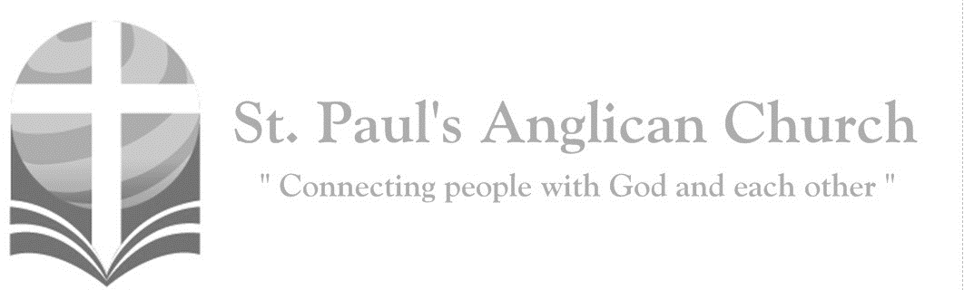

Sunday, February 9, 2020: 5th Sunday After Epiphany

*Creative Engagement Service*

*I am the light of the world, says the Lord. Those who follow me will not walk in darkness, but will have the light of life. (John 8:12)*



SUNDAYS AT ST. PAUL’S

**REGULAR SERVICES**

* Weekly services held Sundays at 10:00AM
* Interface services - Art based services throughout the year
* Sermons available on our website

**SUNDAY PRAYER**

* Prayer for the service at 9:30AM in the Luke Room
* Individual Prayer in the Chapel during the Sunday service

**SERVING AT ST. PAUL’S**

* Join a Ministry Team (Sunday service team, music team, children’s ministry, Altar guild, or many others)
* Regular or One-Time Giving (cash, cheque, automatic debit, and credit options available)

**LARGE PRINT MATERIALS** Large print Bibles and   
 Books of Alternative   
 Services (BAS) are availableat each Sanctuary door.

Page numbers will not be the same as those listed in the bulletin.

**VISITING TODAY?**

We want to get to know   
 you! Please join us for

in the Hall for coffee and

fellowship following the service. The greeters are also available to help if you have any questions.





**Assisted listening**

**is available. Please**

**ask a greeter**

**for assistance.**



CONNECT

**St. Paul’s CHILDREN’S MINISTRY**

**KIDS** Pre-School-Grade 2 in the hall / Grade 3-5 in the Matthew Room

Sunday School teaching is weekly during the 10:00AM service.

**St. Paul’s YOUTH MINISTRY**

**YOUTH** Youth Grades 6-12 meet weekly during the 10:00AM service.

Youth also meetbi-weekly for fun events and devotionals.

**St. Paul’s ADULT MINISTRY**

**ADULTS** St. Paul’s has a number of small groups where you can connect with others through Christ. If you are interested in joining a small   
group or starting a small group of your own, please speak with Pat Stretch.

**Lent Study – 8:45AM on Sundays**

During Lent (March 1-April 10), Rev. Myron will be leading a Lent study series called “A Gospel-Shaped World.” It will be an excellent companion to his sermon series over the same period. Please plan to join us!!

**AGM and Sandwiches – Today!!**

Please join us for the St. Paul’s Annual General Meeting following the service on February 9. We will also be having a Sandwich Sunday that day so please plan to join us for lunch!!

**Returning Palm Crosses**

**If you still have your palm crosses from last year, please return them by February 23 so we can make ashes for Ash Wed.**

**A Night with the Persecuted Church – Monday, February 24, 7:00PM**

Please join Open Doors and St. Paul's as we host this event. This is an opportunity to hear stories of how people have sacrificed everything to follow Christ. You’ll be challenged to follow the examples of faith lived by those who follow Jesus no matter the cost. You’ll also have the opportunity to connect through letters and prayer.

**Games Night – February 14, 6:00PM**

Join us for board games in the Hall!! Come learn a new game, bring your favourite game to teach others, or play a classic with new friends. We also have a Puzzlers Corner for those who want to build puzzles together. We sometimes even have goodies to snack on!

**Wholeness Through Christ**

Wholeness Through Christ (WTC) is a scripturally-based, Spirit-led ministry to

the whole person. WTC is offering a Prayer Ministry Course in Calgary May 19-24. If you register by April 19, you save

$100.00! To register or to find out more information, please visit wholenessthroughchrist.com.

**Confirmation/Baptism Interest?**

**There will be a service of Confirmation on March 1. If you are interested in Confirmation or Baptism, please speak with Rev. Myron or contact the office.**

**Ash Wednesday Supper – 5:45PM on Wednesday, February 26**

The *Wednesday Night before Sunday Bible Study Group* would like to invite the congregation to join us for a soup / bread / salad supper before the Ash Wednesday evening service on February 26th. Supper would be available anytime between 5:45- 6:30PM. Gluten free alternatives will be provided based on demand. Please confirm attendance by Sunday, February 23 to [pjackson@sjsa.ab.ca](mailto:pjackson@sjsa.ab.ca) or Peter Jackson or John Green in person.

**Ash Wednesday Service – 7:00PM on Wednesday, February 26**

**Please join us on Ash Wednesday at 7:00PM in the Sanctuary.**



@StEdmonton

facebook.com/stpachurchedmonton

**St. Paul’s Vestry:**

Peter Jackson, *Rector’s Warden*

Pat Stretch, *People’s Warden*

David Heritage, *Treasurer*

Margot Byer, *Vestry Member*

John Green, *Vestry Member*

Deanna Kalles, *Vestry Member*

David Parker, *Vestry Member*

Carol Rudat, *Vestry Member*

**St. Paul’s Staff:**

*Rector:*

The Reverend Myron Bradley Penner  
*Office Administrator:*

RJ Chambers

*Youth Leader:* Victoria Eeles

**For prayer requests** **email**:

office@stpauls-anglican.ca

**For urgent prayer requests call**

the church office: (780) 455-0771

**For pastoral emergencies call:**

(587) 334-2130

**Office Hours:**

Monday-Thursday: 9:00AM-12:00PM

Closed: Fri/Sat/Sun and Stat Holidays

**St. Paul’s Anglican Church**

10127 145 Street, Edmonton T5N 2X6

Phone: (780) 455-0771; Email: office@stpauls-anglican.ca

Website: www.stpauls-anglican.ca

**This Week’s Readings:**

Isaiah 58:1-12 (on screen)

Psalm 112:1-9 (in bulletin)

1 Corinthians 2:1-16 (on screen)

Matthew 5:13-20 (on screen)

**This Week’s Ministry Teams:**

Music/Sound: Jodi and Youth/Asher H.

Service Team: Heritage Team

Prayers: Kids; Vestry: Pat S.

Chapel Prayer: Kjeryn A. and Barb M.

Kid’s Ministry: All kids remain in service

**St. Paul’s Cycle of Prayer:**

Edwin and Elvie Exconde;   
Gary and Carol George;

Karen Jaresh

**Anglican Cycle of Prayer:**

Diocese of Yukon; the Rt. Rev. Larry Robertson, Bishop; the Ven. Lesley Wheeler-Dame, Coadjutor Bishop-elect. Diocese of Edmonton camp ministries; children’s and young peoples’ ministries throughout the diocese. Buyé Diocese, Buringanire Parish: Oscar Murengerantwari, Rector. Paul First Nation.

**Next Week’s Ministry Teams**

Music/Sound: Andrew’s Team/RJ C.

Service Team: B Team

Prayers: Barb M.; Vestry: John G.

Chapel Prayer: Dudley B. and Pat H-B.

Kid’s Ministry: Jodi P. and Carol R.