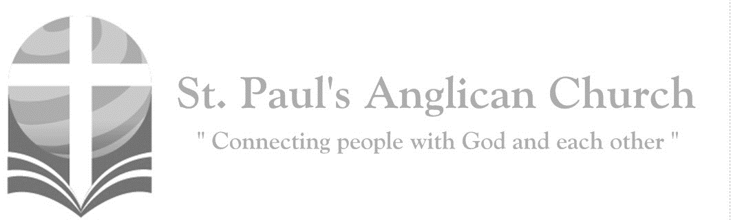

Sunday, January 26, 2020: 3rd Sunday After Epiphany

*Jesus preached the gospel of the kingdom*

*and healed every infirmity among the people.   
(Matthew 4:23)*

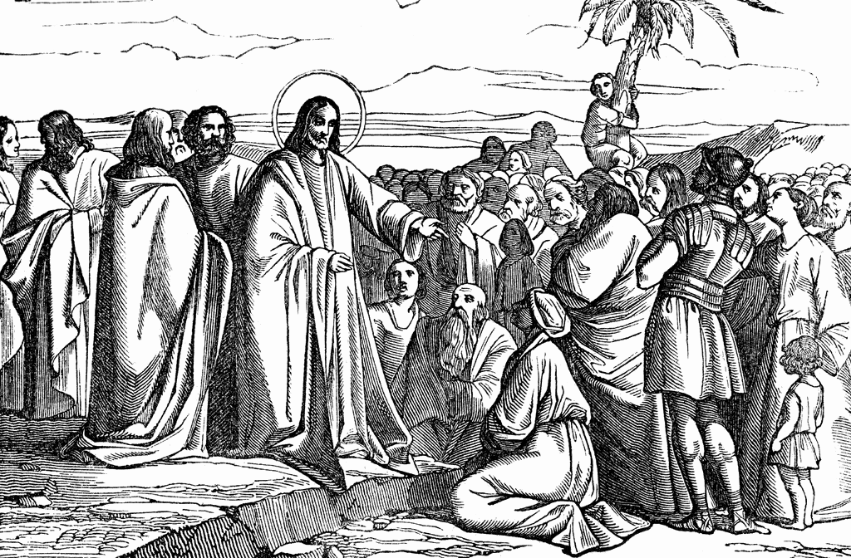

SUNDAYS AT ST. PAUL’S

**REGULAR SERVICES**

* Weekly services held Sundays at 10:00AM
* Interface services - Art based services throughout the year
* Sermons available on our website

**SUNDAY PRAYER**

* Prayer for the service at 9:30AM in the Luke Room
* Individual Prayer in the Chapel during the Sunday service

**SERVING AT ST. PAUL’S**

* Join a Ministry Team (Sunday service team, music team, children’s ministry, Altar guild, or many others)
* Regular or One-Time Giving (cash, cheque, automatic debit, and credit options available)

**LARGE PRINT MATERIALS** Large print Bibles and   
 Books of Alternative   
 Services (BAS) are availableat each Sanctuary door.

Page numbers will not be the same as those listed in the bulletin.

**VISITING TODAY?**

We want to get to know   
 you! Please join us for

in the Hall for coffee and

fellowship following the service. The greeters are also available to help if you have any questions.

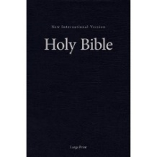



**Assisted listening**

**is available. Please**

**ask a greeter**

**for assistance.**



CONNECT

**St. Paul’s CHILDREN’S MINISTRY**

**KIDS** Pre-School-Grade 2 in the hall / Grade 3-5 in the Matthew Room

Sunday School teaching is weekly during the 10:00AM service.

**St. Paul’s YOUTH MINISTRY**

**YOUTH** Youth Grades 6-12 meet weekly during the 10:00AM service.

Youth also meetbi-weekly for fun events and devotionals.

**St. Paul’s ADULT MINISTRY**

**ADULTS** St. Paul’s has a number of small groups where you can connect with others through Christ. If you are interested in joining a small   
group or starting a small group of your own, please speak with Pat Stretch.

**Opening Song: *Come Thou Fount, Come Thou King***

Come Thou Fount of every blessing  
Tune my heart to sing Thy grace  
Streams of mercy never ceasing  
Call for songs of loudest praise  
Teach me some melodious sonnet  
Sung by flaming tongues above  
Praise the mount I'm fixed upon it  
Mount of Thy redeeming love

I was lost in utter darkness  
'Til You came and rescued me  
I was bound by all my sin   
When Your love came and set me free  
Now my soul can sing a new song  
Now my heart has found a home  
Now Your grace is always with me  
And I'll never be alone

(*Chorus*) Come Thou Fount

Come Thou King  
Come Thou precious Prince of Peace  
Hear Your bride, to You we sing  
Come Thou Fount of our blessing

O to grace how great a debtor  
Daily I'm constrained to be  
Let Thy goodness like a fetter  
Bind my wandering heart to Thee  
Prone to wander, Lord I feel it  
Prone to leave the God I love  
Here's my heart, Lord, take and seal it  
Seal it for Thy courts above (*To Chorus*)

**The Gathering of the Community**

Celebrant: *(BAS pg. 185)* The grace of our Lord Jesus Christ, and the love of God, and the fellowship of the Holy Spirit, be with you all.

**People: And also with you.**

Celebrant:Almighty God,

**All:to you all hearts are open, all desires known, and from you no secrets are hidden. Cleanse the thoughts of our hearts by the inspiration of your Holy Spirit that we may perfectly love you, and worthily magnify your holy name; through Christ our Lord. Amen.**

Celebrant: *(pg. 351)* Almighty God, by grace alone you call us and accept us in your service. Strengthen us by your Spirit, and make us worthy of your call; through Jesus Christ our Lord, who lives and reigns with you and the Holy Spirit, one God, now and for ever.

**People:** **Amen**.

**Children’s Dismissal**

**The Reading of Scripture**

First Reading: Isaiah 9:1-4 (pg. 489 in the red pew Bible)

Reader: The Word of the Lord.

**People:** **Thanks be to God.**

Canticle: Psalm 27:1, 4-9 (see below)

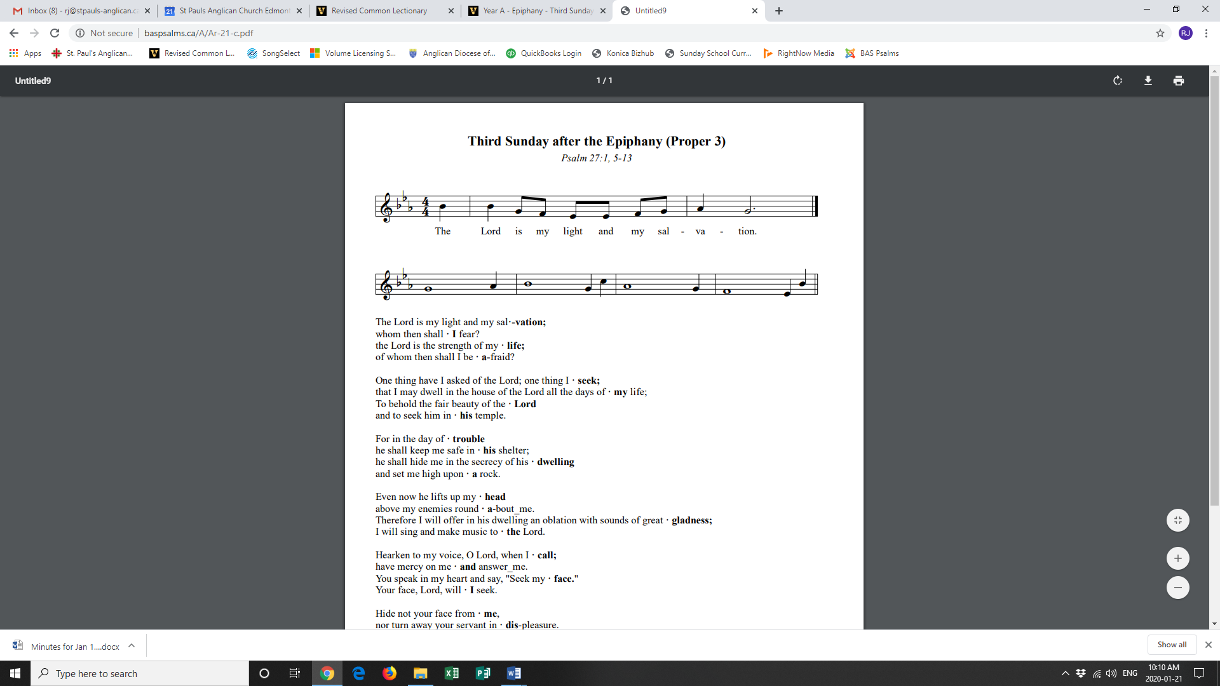

**Refrain:**

The Lord is my light and my salvation; whom then shall I fear? The Lord is the strength of my life; of whom then shall I be afraid? **Refrain**

One thing have I asked of the Lord; one thing I seek; that I may dwell in the house of the Lord all the days of my life; To behold the fair beauty of the Lord and to seek him in his temple. **Refrain**

For in the day of trouble he shall keep me safe in his shelter; he shall hide me in the secrecy of his dwelling and set me high upon a rock. **Refrain**

Even now he lifts up my head above my enemies round about me. Therefore, I will offer in his dwelling an oblation with sounds of great gladness; I will sing and make music to the Lord. **Refrain**

Hearken to my voice, O Lord, when I call; have mercy on me and answer me. You speak in my heart and say, "Seek my face." Your face, Lord, will I seek. **Refrain**

Hide not your face from me, nor turn away your servant in displeasure. You have been my helper; cast me not away; do not forsake me, O God of my salvation. **Refrain**

Second Reading: 1 Corinthians 1:10-18 (pg. 807 in the red pew Bible)

Reader: The Word of the Lord.

**People:** **Thanks be to God.**

**Processional Chorus – *Lord, I Need You***

Lord I need You, oh I need You  
Every hour I need You  
My one defense, my righteousness  
Oh God, how I need You

**The Gospel Reading**

Reader: The Lord be with you.

**People: And also with you.**

Reader: The Holy Gospel of our Lord Jesus Christ according to St. Matthew.

**People: Glory to you, Lord Jesus Christ.**

Gospel Reading: Matthew 4:12-23 (pg. 683 in the red pew Bible)

Reader: The Gospel of Christ.

**People: Praise to you, Lord Jesus Christ.**

**Worship Through Song**

***Lord, I Need You***

Lord I come, I confess  
Bowing here, I find my rest  
And without You I fall apart  
You're the one that guides my heart

(*Chorus*) Lord I need You, oh I need You  
Every hour I need You  
My one defense, my righteousness  
Oh God, how I need You

Where sin runs deep, Your grace is more  
Where grace is found is where You are  
And where You are, Lord, I am free  
Holiness is Christ in me (*To Chorus*)

So teach my song to rise to You  
When temptation comes my way  
And when I cannot stand I'll fall on You  
Jesus You're my hope and stay (*Repeat*)

(To Chorus)

***Cornerstone***

My hope is built on nothing less  
Than Jesus' blood and righteousness  
I dare not trust the sweetest frame  
But wholly trust in Jesus' Name

(*Chorus*) Christ alone, cornerstone  
Weak made strong in the Saviour's love  
Through the storm He is Lord  
Lord of all

When darkness seems to hide His face  
I rest on His unchanging grace  
In every high and stormy gale  
My anchor holds within the veil

(*To Chorus*)

When He shall come

With trumpet sound  
Oh may I then in Him be found  
Dressed in His righteousness alone  
Faultless stand before the throne

(*To Chorus*)

Lord I need You, oh I need You  
Every hour I need You  
My one defense, my righteousness  
Oh God, how I need You

**Listening Time**

**Sermon by David Heritage – Sermon Notes:**

________________________________________________________________________________________________________________________________________________________________________________________________________________________________________________________________________________________________________________________________________________________________________________________________________________________________________________________________________________________________________________________

________________________________________________________________________________________________________________________________________________________________________________________________________________________

________________________________________________________________________________________________________________________________________________________________________________________________________________________________________________________________________________________________

________________________________________________________________________________________________________________________________________________________________________________________________________________________

**Affirmation of Faith – God’s Rule of Grace**

**All: We believe in God, creator of all things, ruler of all that is and all that is to come. God is transforming the world into the place of God’s justice and mercy. We follow Jesus, who taught and healed, who died and rose, revealing God’s abundant grace. He sent disciples out into the world to heal, to proclaim the good news of your grace, and to participate in the Reign of God in all that we do. He reigns in love over all Creation, and holds all accountable to their faithfulness to God’s rule of grace. We rely upon the unfailing grace of God, the presence of the Holy Spirit, the community of the church as the Body of Christ, the unity of all believers, the power of forgiveness, the reality of resurrection and the alluring blessing of eternal life. Therefore, we devote ourselves to lives of daily prayer, study, service and reflection, following Jesus as our Master, for the sake of the transformation of the world by the grace of God. Amen.**

**Prayers of the People**

**Confession of Sin**

Celebrant: *(pg. 191)* Dear friends in Christ, God is steadfast in love and infinite in mercy; he welcomes sinners and invites them to his table. Let us confess our sins, confident in God’s forgiveness.

*Silent Confession*

Celebrant:Father, Son, and Holy Spirit,

**All: you are everything we need all of the time. But we confess to you that we have been tempted to be self reliant and self sufficient. We have believed we need to provide our own daily bread. We have attempted to generate our own peace. In our weakness, we have tried to rely on our own strength. We have tried to light the dark with our own torch. We have trusted our own counsel. Father, out of your great love for us, and because you have given Jesus to die for us, grant that, through his cross, our sins might be taken away, remembered no more and not held against us. Cleanse us and empower us with your Spirit to be like Christ, to joyfully and willingly look to you for everything we need. Amen.**

Celebrant: Almighty God have mercy upon you, pardon and deliver you from all your sins, confirm and strengthen you in all goodness and keep you in eternal life through Jesus Christ our Lord.

**People:Amen.**

**The Peace**

Celebrant: The peace of the Lord be always with you.

**People: And also with you.**

**Offertory Song: *How Great is Our God***

The splendor of the King

Clothed in majesty  
Let all the earth rejoice

All the earth rejoice  
He wraps Himself in light  
And darkness tries to hide  
And trembles at His voice  
And trembles at His voice

How great is our God  
Sing with me, how great is our God  
And all will see how great  
How great is our God

And age to age He stands  
And time is in His hands  
Beginning and the End  
Beginning and the End  
 (*continued on next page*)  
The Godhead three in one  
Father, Spirit, Son  
The Lion and the Lamb  
The Lion and the Lamb

(*Chorus*) How great is our God  
Sing with me, how great is our God  
And all will see how great  
How great is our God

Name above all names  
Worthy of all praise  
My heart will sing  
How great is our God (*To Chorus*)

**Prayer Over the Gifts**

Celebrant: *(pg. 351)* Loving God,

**All: before the world began you called us. Make holy all we offer you this day, and strengthen us in that calling. We ask this in the name of Jesus Christ the Lord. Amen.**

Celebrant: *(pg. 196)* The Lord be with you.

**People: And also with you.**

Celebrant: Lift up your hearts.

**People: We lift them to the Lord.**

Celebrant: Let us give thanks to the Lord our God.

**People: It is right to give our thanks and praise.**

Celebrant: We give you thanks and praise, almighty God……. Now with all creation we raise our voices to proclaim the glory of your name.

**All:** ***(Sung)*** **Holy, holy, holy Lord, God of power and might, heaven and earth of Your glory are full. Hosanna, hosanna, hosanna in the highest. Blessed is he who comes in the name of the Lord.   
Blessed is he who comes in the name of the Lord.   
Holy, holy, holy Lord, God of power and might, heaven and earth of Your glory are full. Hosanna, hosanna, hosanna in the highest.**

Celebrant: *(pg. 197)* Holy and gracious God, accept our praise……. All glory and honour are yours, Father and Son, with the Holy Spirit, in the holy Church, now and for ever.

**All: Amen.**

Celebrant: *(pg. 211)* As our Saviour taught us, let us pray,

**All: *(Sung)* Our Father in heaven, holy is your name. Your kingdom come on earth as in heaven. Our Father in heaven, reveal who you are. Your will be done on earth as in heaven. Feed us today what we need to live. Forgive all our sins as we forgive and keep us safe. The kingdom is yours, the power is yours, and the glory forever. The kingdom is yours, the power is yours, and the glory forever.**

Celebrant: *(pg. 212)* Creator of all, you gave us golden fields of wheat, whose many grains we have gathered and made into this one bread.

**All: So may your Church be gathered from the ends of the earth into your kingdom.**

Celebrant: *(pg. 213)* The gifts of God for the People of God.

**People: Thanks be to God.**

**The Communion**

*You are welcome to receive communion or come forward for a blessing. If you prefer to receive a blessing, please fold your arms over your chest. There is de-alcoholized wine available in the centre and gluten-free wafers available upon request.*

**Lamb of God**

*(Sung)* Lamb of God, you take away the sin of the world, have mercy on us.

Lamb of God, you take away the sin of the world, have mercy on us.

Lamb of God, you take away the sin of the world, grant us your peace.

**Communion Music**

***How Deep the Father’s Love For Us***

How deep the Father's love for us  
How vast beyond all measure  
That He should give His only Son  
To make a wretch His treasure  
How great the pain of searing loss  
The Father turns His face away  
As wounds which mar the Chosen One  
Bring many sons to glory

Behold the Man upon a cross  
My sin upon His shoulders  
Ashamed I hear my mocking voice  
Call out among the scoffers  
It was my sin that held Him there  
Until it was accomplished  
His dying breath has brought me life  
I know that it is finished

(*continued on next page*)

I will not boast in anything  
No gifts, no power, no wisdom  
But I will boast in Jesus Christ  
His death and resurrection  
Why should I gain from His reward  
I cannot give an answer  
But this I know with all my heart  
His wounds have paid my ransom

***We Fall Down***

We fall down, we lay our crowns  
At the feet of Jesus  
The greatness of mercy and love  
At the feet of Jesus

And we cry holy, holy, holy  
And we cry holy, holy, holy  
And we cry holy, holy, holy is the Lamb

**Prayer After Communion**

Celebrant: *(pg. 351)* Gracious God,

**All: our hands have taken holy things; our lives have been nourished by the body of your Son. May we who have eaten at this holy table be strengthened for service in your world. We ask this in the name of Jesus Christ the Lord.** **Amen.**

Celebrant: *(pg. 214)* Glory to God,

**All:whose power, working in us, can do infinitely more than we can ask or imagine. Glory to God from generation to generation, in the Church and in Christ Jesus, for ever and ever. Amen.**

**Blessing**

**Congregational Announcements *(Peter J.)***

**Closing Song: *Here I Am to Worship***

Light of the world  
You stepped down into darkness  
Opened my eyes, let me see  
Beauty that made  
This heart adore You  
Hope of a life spent with You

(*Chorus*) So here I am to worship  
Here I am to bow down  
Here I am to say that You're my God  
You're altogether lovely  
Altogether worthy  
Altogether wonderful to me

King of all days, oh so highly exalted  
Glorious in heaven above  
Humbly You came  
 (*continued on next page*)  
To the earth You created  
All for love's sake became poor

(*Chorus*) So here I am to worship  
Here I am to bow down  
Here I am to say that You're my God  
You're altogether lovely  
Altogether worthy  
Altogether wonderful to me

And I'll never know how much it cost  
To see my sin upon that cross  
And I'll never know how much it cost  
To see my sin upon that cross

(*To Chorus*)

**The Dismissal**Celebrant: *(pg. 215)* Go forth in the name of Christ.

**All: Thanks be to God. Amen.**

*Please join us in the hall for coffee following the service.*

**Philosopher’s Cafe – January 26**

**4:00-6:00PM at Christ Church**

What does it mean to have hope in the “end times” - in the wake of colonialisms, genocides, nuclear threat, social upheavals, and pending ecological and economic collapses? All are welcome (and childcare is provided!) as Rev. Myron Penner presents *Faith and the Future.*

**AGM and Sandwiches – February 9**

Please join us for the St. Paul’s Annual General Meeting following the service on February 9. We will also be having a Sandwich Sunday that day so please plan to join us for lunch!!

**Are You Interested in Joining the Chapel Prayer Team?**

**Chapel Prayer training will be held on Thursday evenings in February. If you are interested in joining this important ministry at St. Paul’s, please contact the office to register and for more info.**

**Offering Envelopes in Foyer**

**There are still a few sets of 2020 offering envelopes awaiting pickup in the foyer.**

**Wednesday Supper and Bible Study**

The *Wednesday Night Bible Before Sunday* plans to have a monthly supper starting Wednesday, January 29th at 6:30PM in the Hall. If you would like to come for just supper (or for supper and the study), please email Peter at [pjackson@sjsa.ab.ca](mailto:pjackson@sjsa.ab.ca) by Monday at midnight so we have an idea of numbers.

**Confirmation/Baptism Interest?**

**There will be a service of Confirmation on March 1. If you are interested in Confirmation or Baptism, please speak with Rev. Myron or contact the office.**

**Games Night – Friday, Jan. 10**

Are you ready to play?! Please join us every 2nd Friday of the month for games in the Hall starting at 6:00PM. Come learn a new game, bring your favourite to teach others, or play a classic with new friends! We also have a Puzzlers Corner for those who want to build puzzles together!



@StEdmonton

facebook.com/stpachurchedmonton

**St. Paul’s Vestry:**

Peter Jackson, *Rector’s Warden*

Pat Stretch, *People’s Warden*

David Heritage, *Treasurer*

Margot Byer, *Vestry Member*

John Green, *Vestry Member*

Deanna Kalles, *Vestry Member*

David Parker, *Vestry Member*

Carol Rudat, *Vestry Member*

**St. Paul’s Staff:**

*Rector:*

The Reverend Myron Bradley Penner  
*Office Administrator:*

RJ Chambers

*Youth Leader:* Victoria Eeles

**For prayer requests** **email**:

office@stpauls-anglican.ca

**For urgent prayer requests call**

the church office: (780) 455-0771

**For pastoral emergencies call:**

(587) 334-2130

**Office Hours:**

Monday-Thursday: 9:00AM-12:00PM

Closed: Fri/Sat/Sun and Stat Holidays

**St. Paul’s Anglican Church**

10127 145 Street, Edmonton T5N 2X6

Phone: (780) 455-0771; Email: office@stpauls-anglican.ca

Website: www.stpauls-anglican.ca

**This Week’s Readings:**

Isaiah 9:1-4 (pg. 489)

Psalm 27:1, 4-9 (in bulletin)

1 Corinthians 1:10-18 (pg. 807)

Matthew 4:12-23 (pg. 683)

**This Week’s Ministry Teams:**

Music/Sound: RJ’s Team/Cheryl C.

Service Team: Tilburn Team

Prayers: Deanna K.; Vestry: Peter J.

Chapel Prayer: Laurier B. and Pat S.

Kid’s Ministry: Carol G. and Abigail P.

**St. Paul’s Cycle of Prayer:**

Paul, Jennifer, and Caroline Jacquier;   
Lukasz Mazurek and Ivy Exconde Mazurek

**Anglican Cycle of Prayer:**

The Territory of the People; the Rt. Rev. Barbara Andrews, Bishop, retired December 31, 2019. The episcopal election is scheduled for next Saturday, January 25, 2020. Diocese of Edmonton Environmental Chaplain: Billy Isenor. Buyé Diocese, Kabanga Parish: Lazar Rudende, Rector. Kehewin Cree Nation.

**Next Week’s Ministry Teams**

Music/Sound: Adele’s Team/Scott M.

Service Team: Jackson Team

Prayers: Gay G.; Vestry: David H.

Chapel Prayer: Wendell and Nora J.

Kid’s Ministry: Renee J. and Carol R.