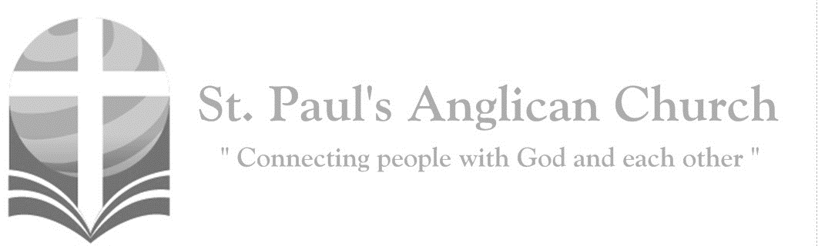

Sunday, January 12, 2020: Baptism of the Lord

*A voice came from heaven, saying, “This is my beloved Son   
with whom I am well pleased.” (Matthew 3:17)*

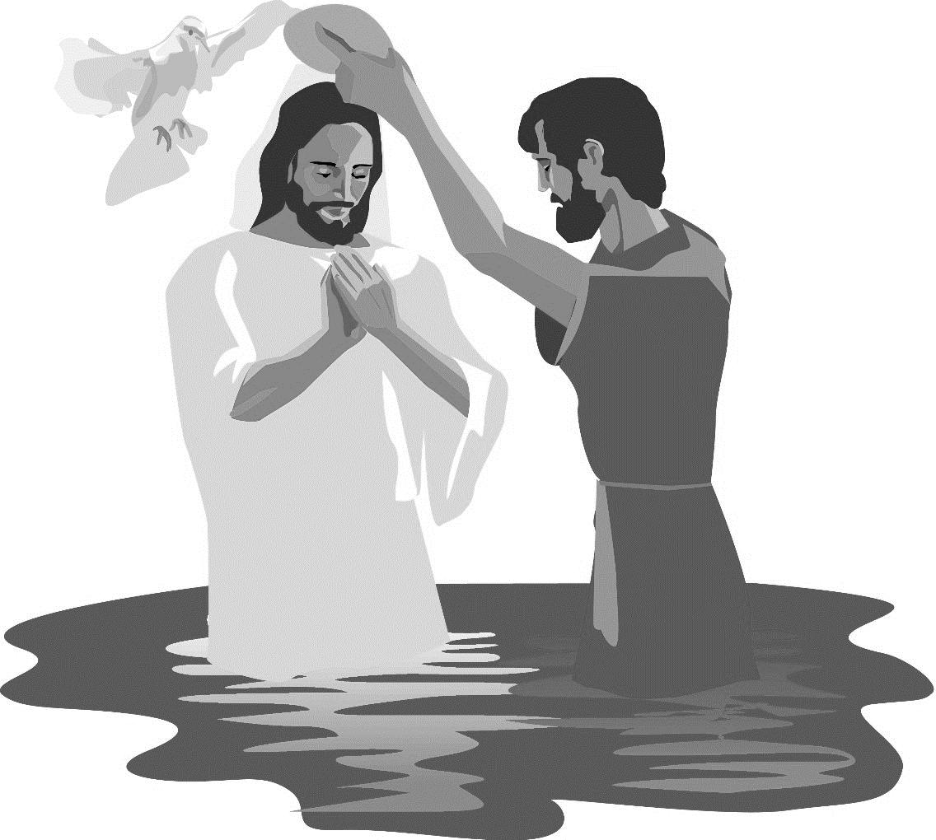

SUNDAYS AT ST. PAUL’S

**REGULAR SERVICES**

* Weekly services held Sundays at 10:00AM
* Interface services - Art based services throughout the year
* Sermons available on our website

**SUNDAY PRAYER**

* Prayer for the service at 9:30AM in the Luke Room
* Individual Prayer in the Chapel during the Sunday service

**SERVING AT ST. PAUL’S**

* Join a Ministry Team (Sunday service team, music team, children’s ministry, Altar guild, or many others)
* Regular or One-Time Giving (cash, cheque, automatic debit, and credit options available)

**LARGE PRINT MATERIALS** Large print Bibles and   
 Books of Alternative   
 Services (BAS) are availableat each Sanctuary door.

Page numbers will not be the same as those listed in the bulletin.

**VISITING TODAY?**

We want to get to know   
 you! Please join us for

in the Hall for coffee and

fellowship following the service. The greeters are also available to help if you have any questions.

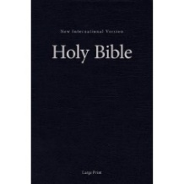



**Assisted listening**

**is available. Please**

**ask a greeter**

**for assistance.**



CONNECT

**St. Paul’s CHILDREN’S MINISTRY**

**KIDS** Pre-School-Grade 2 in the hall / Grade 3-5 in the Matthew Room

Sunday School teaching is weekly during the 10:00AM service.

**St. Paul’s YOUTH MINISTRY**

**YOUTH** Youth Grades 6-12 meet weekly during the 10:00AM service.

Youth also meetbi-weekly for fun events and devotionals.

**St. Paul’s ADULT MINISTRY**

**ADULTS** St. Paul’s has a number of small groups where you can connect with others through Christ. If you are interested in joining a small   
group or starting a small group of your own, please speak with Pat Stretch.

**Opening Song: *On Jordan’s Bank the Baptist’s Cry***

On Jordan's bank the Baptist’s cry  
Announces that the Lord is nigh  
Awake and hearken for He brings  
Glad tidings of the King of kings

Then cleansed be every life from sin  
Make straight the way for God within  
And let us all our hearts prepare  
For Christ to come and enter there

We hail you as our Saviour, Lord

Our refuge and our great reward  
Without your grace we waste away  
Like flowers that wither and decay

Stretch forth your hand

Our health restore  
And make us rise to fall no more  
O let your face upon us shine

And fill the world with love divine

**The Gathering of the Community**

Celebrant: *(BAS pg. 185)* The grace of our Lord Jesus Christ, and the love of God, and the fellowship of the Holy Spirit, be with you all.

**People: And also with you.**

Celebrant:Almighty God,

**All:to you all hearts are open, all desires known, and from you no secrets are hidden. Cleanse the thoughts of our hearts by the inspiration of your Holy Spirit that we may perfectly love you, and worthily magnify your holy name; through Christ our Lord. Amen.**

Celebrant: *(pg. 348)* Eternal Father, who at the baptism of Jesus revealed him to be your Son, anointing him with the Holy Spirit, keep your children, born of water and the Spirit, faithful to their calling; through Jesus Christ our Lord, who lives and reigns with you and the Holy Spirit, one God, now and for ever.

**People:** **Amen**.

**Children’s Dismissal**

**The Reading of Scripture**

First Reading: Isaiah 42:1-9 (pg. 513 in the red pew Bible)

Reader: The Word of the Lord.

**People:** **Thanks be to God.**

Psalm (or Canticle): Psalm 29 (see below)

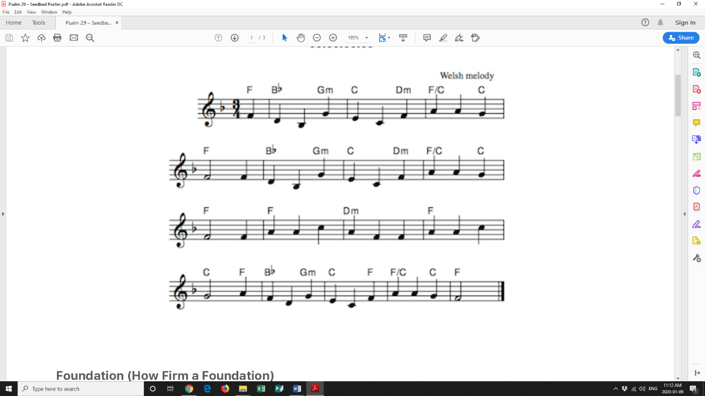

Ascribe to the Lord, all you ones of great might;

Ascribe to the Lord glory, strength in your sight.

Ascribe to Him glory, and His name adore;

In splendor of holiness, worship the Lord.

The voice of the Lord is above the great sea;

He thunders in glory; o’er waters is He!

The voice of the Lord, full of power and might;

His voice is majestic and flaming in light.

The voice of the Lord breaks the cedars in two;

The cedars of Lebanon, He does subdue.

The Lord makes all Lebanon skip like a deer.

Mount Hermon is like a young ox when He’s near.

The voice of the Lord strikes with flashing of light.

His voice shakes the desert of Kadesh with might.

The voice of the Lord strips the forests all bare;

And all in His temple, His glory declare.

The Lord sits enthroned o’er the flood – He is King.

The Lord on His throne sits forever as King.

The Lord gives His people His strength without cease.

The Lord is the One who will bless them with peace.

Second Reading: Acts 10:34-43 (pg. 779 in the red pew Bible)

Reader: The Word of the Lord.

**People:** **Thanks be to God.**

**Processional Chorus – *The Voice of the Lord***

And the earth will shake  
The trees will fall  
As the voice of God is heard  
See the flame burst forth  
New life is born and His people cry  
Glory

**The Gospel Reading**

Reader: The Lord be with you.

**People: And also with you.**

Reader: The Holy Gospel of our Lord Jesus Christ according to St. Matthew.

**People: Glory to you, Lord Jesus Christ.**

Gospel Reading: Matthew 3:13-17 (pg. 682 in the red pew Bible)

Reader: The Gospel of Christ.

**People: Praise to you, Lord Jesus Christ.**

**Worship Through Song**

***The Voice of the Lord***

The voice of the Lord is over the waters  
With power and strength

And glorious thunder

(*Chorus 1*) And the earth will shake  
The trees will fall  
As the voice of God is heard  
See the flame burst forth  
New life is born and His people cry glory

The voice of the Lord

Is mighty to conquer  
The power of death is power no longer

(*Chorus 2*) And the lame will dance  
The blind will see  
And the dead will rise again  
For the Word of God has walked with us  
And He makes us cry glory

The Lord enthroned forever, He is King  
The Lord enthroned forever, He is King  
The Lord enthroned forever (He is King)

(*Repeat Chorus 1 and Chorus 2*)

***Ancient of Days***

Though the nations rage

Kingdoms rise and fall  
There is still one King reigning over all  
So I will not fear

For this truth remains  
That my God is the Ancient of Days

(*Chorus*) None above Him

None before Him

All of time in His hands  
For His throne, it shall remain

And ever stand  
All the power, all the glory  
I will trust in His name  
For my God is the Ancient of days

Though the dread of night  
Overwhelms my soul  
He is here with me, I am not alone  
O His love is sure

And He knows my name  
For my God is the Ancient of Days

(*To Chorus*)

Though I may not see  
What the future brings  
I will watch and wait for the Saviour king  
Then my joy complete  
Standing face to face  
In the presence of the Ancient of Days

(*To Chorus*)

**Listening Time**

**Sermon by the Reverend Dr. Myron Penner – Sermon Notes:**

________________________________________________________________________________________________________________________________________________________________________________________________________________________________________________________________________________________________________________________________________________________________________________________________________________________________________________________________________________________________________________________

________________________________________________________________________________________________________________________________________________________________________________________________________________________

________________________________________________________________________________________________________________________________________________________________________________________________________________________________________________________________________________________________

________________________________________________________________________________________________________________________________________________________________________________________________________________________

________________________________________________________________________

________________________________________________________________________

**Affirmation of Faith – 1 Peter 1:17-25**

**All: Gracious God, you who judge all, we live in reverent awe of you. We have been kidnapped by our own sins, but you paid dearly to set us free – not a ransom of perishable things like silver or gold, but by your precious love, which we see in the blood of Christ. When he died, like an innocent lamb sacrificed for someone else, we saw your willingness to suffer for us. You have had this love for us since the beginning of time; and in Christ, it has now become evident. Through him we have come to trust in you, who raised him from the dead and gave him glory. For you have given us a new birth, through your living and enduring Word. Therefore, our faith and hope are set on you alone. With your love we love one another. The grass withers and fades, but your Word of love endures forever. Alleluia!**

**Prayers of the People**

**Confession of Sin**

Celebrant: *(pg. 191)* Dear friends in Christ, God is steadfast in love and infinite in mercy; he welcomes sinners and invites them to his table. Let us confess our sins, confident in God’s forgiveness.

*Silent Confession*

Celebrant:Almighty God,

**All: Father of our Lord Jesus Christ, you made all things, and you call everyone to account. With shame we admit that we have sinned against you, in what we have thought, said, and done, and we deserve your judgment. We turn from our sins and are truly sorry for them. Have mercy on us, most merciful Father. For the sake of your Son, our Lord Jesus Christ, forgive us all that is past. Enable us to serve and please you in new life, to your honour and glory, through Jesus Christ our Lord. Amen.**

Celebrant: Almighty God have mercy upon you, pardon and deliver you from all your sins, confirm and strengthen you in all goodness and keep you in eternal life through Jesus Christ our Lord.

**People:Amen.**

**The Peace**

Celebrant: The peace of the Lord be always with you.

**People: And also with you.**

**Offertory Song: *Lord Most High***

From the ends of the earth (ECHO)  
From the depths of the sea (ECHO)  
From the heights of the heavens (ECHO)  
Your name be praised  
From the hearts of the weak (ECHO)  
From the shouts of the strong (ECHO)  
From the lips of all people (ECHO)  
This song we raise Lord

Throughout the endless ages  
You will be crowned with praises  
Lord Most High  
Exalted in every nation  
Sovereign of all creation  
Lord Most High be magnified

(*Repeat all*)

**Prayer Over the Gifts**

Celebrant: *(pg. 348)* God of life and freedom,

**All: we celebrate the revelation of Jesus as the Christ who makes all creation new. Accept all we offer you this day and make us new in him, who is Lord for ever and ever. Amen.**

Celebrant: *(pg. 198)* The Lord be with you.

**People: And also with you.**

Celebrant: Lift up your hearts.

**People: We lift them to the Lord.**

Celebrant: Let us give thanks to the Lord our God.

**People: It is right to give our thanks and praise.**

Celebrant: *(pg. 218)* Blessed are you, gracious God, creator of heaven and earth; by water and the Holy Spirit you have made us a holy people in Jesus Christ our Lord; you renew that mystery in bread and wine and nourish us, to show forth your glory in all the world. Therefore, with angels and archangels, and with all the holy people who have served you in every age, we raise our voices to proclaim the glory of your name.

**All:** ***(Sung)*** **Holy, holy, holy Lord, God of power and might, heaven and earth of Your glory are full. Hosanna, hosanna, hosanna in the highest. Blessed is he who comes in the name of the Lord.   
Blessed is he who comes in the name of the Lord.   
Holy, holy, holy Lord, God of power and might, heaven and earth of Your glory are full. Hosanna, hosanna, hosanna in the highest.**

Celebrant: *(pg. 198)* We give thanks to you, Lord our God, for the goodness and love……. Therefore, Father, according to his command,

**All: we remember his death, we proclaim his resurrection, we await his coming in glory;**

Celebrant: and we offer our sacrifice of praise and thanksgiving……by whom, and with whom, and in whom, in the unity of the Holy Spirit, all honour and glory are yours, almighty Father, now and for ever.

**All: Amen.**

Celebrant: *(pg. 211)* As our Saviour taught us, let us pray,

**All: *(Sung)* Our Father in heaven, holy is your name. Your kingdom come on earth as in heaven. Our Father in heaven, reveal who you are. Your will be done on earth as in heaven. Feed us today what we need to live. Forgive all our sins as we forgive and keep us safe. The kingdom is yours, the power is yours, and the glory forever. The kingdom is yours, the power is yours, and the glory forever.**

Celebrant: *(pg. 212)* “I am the bread of life,” says the Lord. “Whoever comes to me will never be hungry; whoever believes in me will never thirst.”

**All: Taste and see that the Lord is good; happy are they who trust in him!**

Celebrant: *(pg. 213)* The gifts of God for the People of God.

**People: Thanks be to God.**

**The Communion**

*You are welcome to receive communion or come forward for a blessing. If you prefer to receive a blessing, please fold your arms over your chest. There is de-alcoholized wine available in the centre and gluten-free wafers available upon request.*

**Lamb of God**

*(Sung)* Lamb of God, you take away the sin of the world, have mercy on us.

Lamb of God, you take away the sin of the world, have mercy on us.

Lamb of God, you take away the sin of the world, grant us your peace.

**Communion Music**

***Revelation Song***

Worthy is the Lamb who was slain  
Holy, holy is He  
Sing a new song to Him who sits on  
Heaven's mercy seat

(*Chorus*)Holy, holy, holy  
Is the Lord God Almighty  
Who was and is and is to come  
With all creation I sing  
Praise to the King of kings  
You are my everything  
And I will adore You

Clothed in rainbows of living color  
Flashes of lightning, rolls of thunder  
Blessing and honor, strength and glory  
And power be to You the only wise King

(*To Chorus*)

(*Continued on next page*)

Filled with wonder, awestruck wonder  
At the mention of Your name  
Jesus Your name is power

Breath and living water  
Such a marvelous mystery

Holy, holy, holy  
Is the Lord God Almighty  
Who was and is and is to come  
With all creation I sing  
Praise to the King of kings  
You are my everything  
And I will adore You

***Search Me, Know Me***

Search me, know me, try me and see  
Every worthless affection hidden in me  
All I'm asking for  
Is that You'd cleanse me, Lord

Create in me a heart that's clean  
Conquer the power of secret shame  
Come wash away the guilty stain

Of all my sin  
Clothe me in robes of righteousness  
Cover my nakedness with grace  
All of my life before You now

I humbly bring

**Prayer After Communion**

Celebrant: *(pg. 349)* Gracious God, lover of all,

**All: by this sacrament you make us one family in Christ your Son, one in the sharing of his body and blood, one in communion of his Spirit. Help us to grow in love for one another and come to the full maturity of the Body of Christ. We ask this in his name.** **Amen.**

Celebrant: *(pg. 214)* Glory to God,

**All:whose power, working in us, can do infinitely more than we can ask or imagine. Glory to God from generation to generation, in the Church and in Christ Jesus, for ever and ever. Amen.**

**Blessing**

**Congregational Announcements *(Myron P.)***

**Closing Song: *You Shine***

Why should I fear man  
When You made the heavens  
Why should I be afraid  
When You put the stars in place  
Why should I lose heart  
When I know how great You are  
Why should I give up  
When Your plans are full of love

In this world we will have trouble  
But You have overcome the world

You shine  
Brighter than the brightest star  
Your love  
Purer than the purest heart  
You shine  
Filling us with courage and strength  
To follow You

**The Dismissal**Celebrant: *(pg. 215)* Go forth in the name of Christ.

**All: Thanks be to God. Amen.**

*Please join us in the hall for coffee following the service.*

**AGM and Sandwiches – February 9**

Please join us for the St. Paul’s Annual General Meeting following the service on February 9. We will also be having a Sandwich Sunday that day so please plan to join us for lunch!!

**Interested in Confirmation**

**and/or Baptism?**

**There will be a service of Confirmation on March 1. If you are interested in Confirmation or Baptism, please speak with Rev. Myron or contact the office.**

**Chapel Prayer Team Training**

**Chapel Prayer training will be held on Thursday evenings in February. Please contact the office for more information.**

**Winter Clothing Donations**

We are about to hit a deep freeze. If you have extra coats, toques, gloves and mittens, and other warm clothing, please consider donating it. Donations can be dropped off at St. Paul’s next Sunday or anytime during office hours. These items will then be given to local Edmonton shelters as they prepare for the cold.

**Epiphany: Revelation!**

**Saturday, January 18, 7:00PM**

St. Paul's and Interface Worship will celebrate the season of Epiphany with the worship service Epiphany: Revelation!  
This service will feature the Bread of Life liturgical sculpture, a Black Water Reflecting Pool, prayer stations, meditative time, open art tables, and the extensive use of original symbols, rituals, and imagery. The Eucharistic liturgy allows worshipers to embody the theme through a unique sacramental ritual of enduring quality and significance. Please join us!

**Games Night – Friday, Jan. 10**

Are you ready to play?! Please join us every 2nd Friday of the month for games in the Hall starting at 6:00PM. Come learn a new game, bring your favourite to teach others, or play a classic with new friends! We also have a Puzzlers Corner for those who want to build puzzles together!



@StEdmonton

facebook.com/stpachurchedmonton

**St. Paul’s Vestry:**

Peter Jackson, *Rector’s Warden*

Pat Stretch, *People’s Warden*

David Heritage, *Treasurer*

Margot Byer, *Vestry Member*

John Green, *Vestry Member*

Deanna Kalles, *Vestry Member*

David Parker, *Vestry Member*

Carol Rudat, *Vestry Member*

**St. Paul’s Staff:**

*Rector:*

The Reverend Myron Bradley Penner  
*Office Administrator:*

RJ Chambers

*Youth Leader:* Victoria Eeles

**For prayer requests** **email**:

office@stpauls-anglican.ca

**For urgent prayer requests call**

the church office: (780) 455-0771

**For pastoral emergencies call:**

(587) 334-2130

**Office Hours:**

Monday-Thursday: 9:00AM-12:00PM

Closed: Fri/Sat/Sun and Stat Holidays

**St. Paul’s Anglican Church**

10127 145 Street, Edmonton T5N 2X6

Phone: (780) 455-0771; Email: office@stpauls-anglican.ca

Website: www.stpauls-anglican.ca

**This Week’s Readings:**

Isaiah 42:1-9 (pg. 513)

Psalm 29 (in bulletin)

Acts 10:34-43 (pg. 779)

Matthew 3:13-17 (pg. 682)

**This Week’s Ministry Teams:**

Music/Sound: Adele’s Team/Scott M.

Service Team: Green and Friends Team

Prayers: Nancy W-S.; Vestry: Carol R.

Chapel Prayer: Kjeryn A. and Barb M.

Kid’s Ministry: Gay G. and Abigail P.

**St. Paul’s Cycle of Prayer:**

Neil and Laura Rogers and Scott;

Marcel and Terry Berard;  
Alvina Cook

**Anglican Cycle of Prayer:**

Diocese of Saskatoon; the Rt. Rev. Chris Harper, Bishop. Diocese of Edmonton Educational Chaplain: Heather Liddell. Buyé Diocese, Kayanza (St. Martin) Parish: Amos Mutezimana, Rector. Frog Lake First Nation.

**Next Week’s Ministry Teams**

Music/Sound: Andrew’s Team/Jennifer S.

Service Team: Parker Team

Prayers: Kjeryn A.; Vestry: Deanna K.

Chapel Prayer: Dudley B. and Pat H-B.

Kid’s Ministry: Margot B. and Ryan Y.