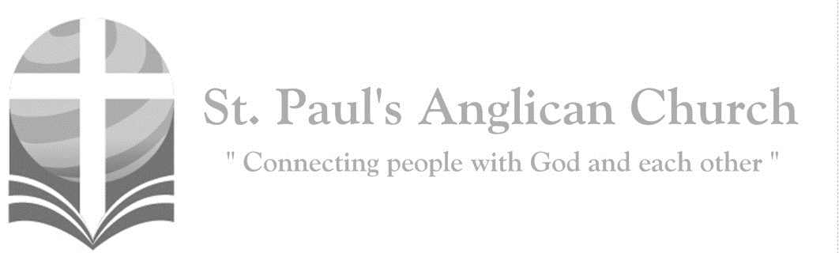



***Christmas Day***

***Holy Eucharist***

***December 25, 2019, 9:00AM***

*I bring you good news of a great joy which   
 will come to all the people; for to you is born   
 this day a Saviour, Christ the Lord.   
 (Luke 2:10-11)*

SUNDAYS AT ST. PAUL’S

**REGULAR SERVICES**

* Weekly services held Sundays at 10:00AM
* Interface services - Art based services throughout the year
* Sermons available on our website

**SUNDAY PRAYER**

* Prayer for the service at 9:30AM in the Luke Room
* Individual Prayer in the Chapel during the Sunday service

**SERVING AT ST. PAUL’S**

* Join a Ministry Team (Sunday service team, music team, children’s ministry, Altar guild, or many others)
* Regular or One-Time Giving (cash, cheque, automatic debit, and credit options available)

**LARGE PRINT MATERIALS** Large print Bibles and   
 Books of Alternative   
 Services (BAS) are availableat each Sanctuary door.

Page numbers will not be the same as those listed in the bulletin.

**VISITING TODAY?**

We want to get to know   
 you! Please join us for

in the Hall for coffee and

fellowship following the service. The greeters are also available to help if you have any questions.

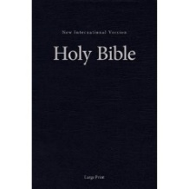



**Assisted listening**

**is available. Please**

**ask a greeter**

**for assistance.**



CONNECT

**St. Paul’s CHILDREN’S MINISTRY**

**KIDS** Pre-School-Grade 2 in the hall / Grade 3-5 in the Matthew Room

Sunday School teaching is weekly during the 10:00AM service.

**St. Paul’s YOUTH MINISTRY**

**YOUTH** Youth Grades 6-12 meet weekly during the 10:00AM service.

Youth also meetbi-weekly for fun events and devotionals.

**St. Paul’s ADULT MINISTRY**

**ADULTS** St. Paul’s has a number of small groups where you can connect with others through Christ. If you are interested in joining a small   
group or starting a small group of your own, please speak with Pat Stretch.

**The Gathering of the Community**

Celebrant: *(BAS pg. 185)* The grace of our Lord Jesus Christ, and the love of God, and the fellowship of the Holy Spirit, be with you all.

**People: And also with you.**

Celebrant:Almighty God,

**All:to you all hearts are open, all desires known, and from you no secrets are hidden. Cleanse the thoughts of our hearts by the inspiration of your Holy Spirit that we may perfectly love you, and worthily magnify your holy name; through Christ our Lord. Amen.**

Celebrant: *(pg. 274)* O God our Father, whose Word has come among us in the Holy Child of Bethlehem, may the light of faith illumine our hearts and shine in our words and deeds; through him who is Christ our Lord, who lives and reigns with you and the Holy Spirit, one God, now and for ever.

**People:** **Amen**.

**Opening Song: *O Come, All Ye Faithful***

O come, all ye faithful  
Joyful and triumphant  
O come ye, O come ye to Bethlehem  
Come and behold Him  
Born the King of angels

(*Chorus*)

O come, let us adore Him  
O come, let us adore Him  
O come, let us adore Him  
Christ the Lord

Sing choirs of angels, sing in exultation  
O, sing all ye bright  
Hosts of heav'n above  
Glory to God

All glory in the highest (*To Chorus*)

Yea Lord, we greet Thee  
Born this happy morning  
Jesus, to Thee be all glory giv'n  
Word of the Father  
Now in flesh appearing (*To Chorus*)

**Introductory Responses**

Celebrant: Blessed be the Lord, the Father, the Son, and the Holy Spirit.

**People: May all the earth be filled with God’s glory.**

Celebrant: Light has sprung up for all people,

**People: and joyful gladness for those who are true-hearted.**

Celebrant: Glory to God in the highest,

**People: and peace to His people on earth.**

**The Reading of Scripture**

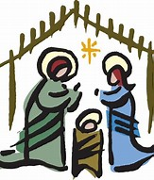First Reading: Isaiah 52:7-10 (pg. 523 in the red pew Bible)

Reader: The Word of the Lord.

**People:** **Thanks be to God.**

Second Reading: Hebrews 1:1-4 (pg. 846 in the red pew Bible)

Reader: The Word of the Lord.

**People:** **Thanks be to God.**

Gospel Reading: John 1:1-14 (pg. 750 in the red pew Bible)

Reader: The Lord be with you.

**People: And also with you.**

Reader: The Holy Gospel of our Lord Jesus Christ according to St. John.

**People: Glory to you, Lord Jesus Christ.**

*The Gospel Reading*

Reader: The Gospel of Christ.

**People: Praise to you, Lord Jesus Christ.**

Sermon: The Reverend Dr. Myron Penner

**Sermon Notes**

________________________________________________________________________________________________________________________________________________________________________________________________________________________________________________________________________________________________________________________________________________________________________________________________________________________________________________________________________________________________________________________________________________________________________________________________________________________________________________________________________________________________________________________________________________________________________________________________________________________________________________________________________________________________________________________________________________________________________________________________________________________________________________

**Confession of Sin**

Celebrant: *(pg. 191)* Dear friends in Christ, God is steadfast in love and infinite in mercy; he welcomes sinners and invites them to his table. Let us confess our sins, confident in God’s forgiveness.

*Silent Confession*

Celebrant:Most merciful God,

**All: we confess that we have sinned against you in thought word, and deed, by what we have done and by what we have left undone. We have not loved you with our whole heart; we have not loved our neighbours as ourselves. We are truly sorry and we humbly repent. For the sake of your Son Jesus Christ, have mercy on us and forgive us, that we may delight in your will, and walk in your ways, to the glory of your name. Amen.**

Celebrant: Almighty God have mercy upon you, pardon and deliver you from all your sins, confirm and strengthen you in all goodness and keep you in eternal life through Jesus Christ our Lord.

**People:Amen.**

**The Peace**

Celebrant: The peace of the Lord be always with you.

**People: And also with you.**

**Offertory Song: *Joy to the World***

Joy to the world! The Lord is come

Let earth receive her King

Let every heart prepare him room

And heav’n and nature sing (2x)

And heav’n, and heav’n and nature sing

Joy to the earth! The saviour reigns

Let men their songs employ

While fields and floods

Rocks, hills and plains

Repeat the sounding joy (2x)

Repeat, repeat the sounding joy

No more let sins and sorrows grow

Nor thorns infest the ground

He comes to make his blessing flow

Far as the curse is found (2x)

Far as, far as the curse is found

He rules the world with truth and grace

And makes the nations prove

The glories of

His righteousness

And wonders of His love (2x)

And wonders, wonders of His love

**Prayer Over the Gifts**

Celebrant: *(pg. 274)* Generous Creator,

**All: in faith and joy we celebrate the birth of your Son. Increase our understanding and our love of the riches you have revealed in him, who is Lord now and for ever. Amen.**

Celebrant: *(pg. 198)* The Lord be with you.

**People: And also with you.**

Celebrant: Lift up your hearts.

**People: We lift them to the Lord.**

Celebrant: Let us give thanks to the Lord our God.

**People: It is right to give our thanks and praise.**

Celebrant: *(pg. 219)* Blessed are you, gracious God, creator of heaven and earth; we give you thanks and praise through Jesus Christ our Lord, who in the mystery of his incarnation was made perfect man of the flesh of the Virgin Mary his mother; in him we have seen a new and radiant vision of your glory. Therefore, with all the angels of heaven, we lift our voices and sing our joyful hymn of praise to proclaim the glory of your name.

**All:** ***(Said)*** **Holy, holy, holy Lord, God of power and might, heaven and earth are full of your glory. Hosanna in the highest. Blessed is he who comes in the name of the Lord. Hosanna in the highest.**

Celebrant: *(pg. 198)* We give thanks to you, Lord our God, for the goodness and love……. Therefore, Father, according to his command,

**All: we remember his death, we proclaim his resurrection, we await his coming in glory;**

Celebrant: and we offer our sacrifice of praise and thanksgiving……by whom, and with whom, and in whom, in the unity of the Holy Spirit, all honour and glory are yours, almighty Father, now and for ever.

**All: Amen.**

Celebrant: *(pg. 211)* As our Saviour taught us, let us pray,

**All: *(Said)* Our Father in heaven, hallowed be your name, your kingdom come, your will be done, on earth as in heaven. Give us today our daily bread. Forgive us our sins as we forgive those who sin against us. Save us from the time of trial, and deliver us from evil. For the kingdom, the power, and the glory are yours, now and for ever. Amen.**

Celebrant: *(pg. 213)* We break the bread of life, and that life is the light of the world.

**All: God here among us, light in the midst of us, bring us to light and life.**

Celebrant: *(pg. 213)* The gifts of God for the People of God.

**People: Thanks be to God.**

**The Communion**

*You are welcome to receive communion or come forward for a blessing. If you prefer to receive a blessing, please fold your arms over your chest. There is de-alcoholized wine available in the centre and gluten-free wafers available upon request.*

**Communion Music**

***Away in a Manger***

Away in a manger, no crib for a bed  
The little Lord Jesus

Laid down His sweet head  
The stars in the sky

Looked down where He lay  
The little Lord Jesus asleep on the hay

***Angels We Have Heard on High***

Angels we have heard on high  
Sweetly singing o'er the plains  
And the mountains in reply  
Echoing their joyous strains

Gloria in excelsis Deo  
Gloria in excelsis Deo

**Prayer After Communion**

Celebrant: *(pg. 275)* Source of truth and joy,

**All: may we who have received the gift of divine life always follow the way of your Son. This we ask in the name of Jesus Christ the Lord. Amen.**

Celebrant: *(pg. 214)* Glory to God,

**All:whose power, working in us, can do infinitely more than we can ask or imagine. Glory to God from generation to generation, in the Church and in Christ Jesus, for ever and ever. Amen.**

**Blessing**

**Closing Song: *Go, Tell It On the Mountain***

(*Chorus*)

Go, tell it on the mountain

Over the hills and everywhere

Go, tell it on the mountain

That Jesus Christ is born

While shepherds kept their watching

O’er silent flocks by night

Behold, throughout the heavens

There shone a holy light

(*To Chorus*)

The shepherds feared and trembled

When lo, above the earth

Rang out the angel chorus

That hailed our Saviour’s birth

(*To Chorus*)

Down in a lowly manger

The humble Christ was born

And God sent our salvation

That blessed Christmas morn

****(*To Chorus*)

**The Dismissal**Celebrant: *(pg. 215)* Go in peace to love and serve the Lord.

**All: Thanks be to God. Alleluia!**

***St. Paul’s Staff and Clergy wish***

***you a very Merry Christmas.***

**St. Paul’s Anglican Church**

10127 145 Street, Edmonton T5N 2X6

Phone: (780) 455-0771; Email: office@stpauls-anglican.ca

Website: www.stpauls-anglican.ca

**Office Hours:** Monday-Thursday: 9:00AM-12:00PM

Closed Fri/Sat/Sun and Stat Holidays

**St. Paul’s Staff:**

*Rector:* The Reverend Myron Bradley Penner  
*Office Administrator:* RJ Chambers

*Youth Leader:* Victoria Eeles

