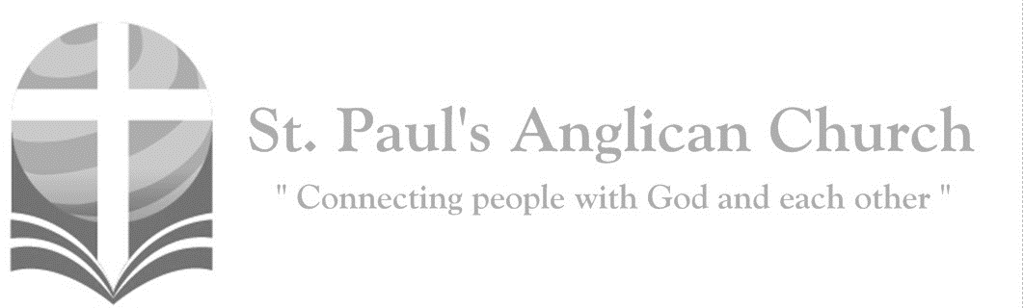
A virgin shall conceive and bear a son, and his name shall be called Emmanuel: God with us. (Matthew 1:23)
Sunday, December 22, 2019: Advent 4 – LOVE

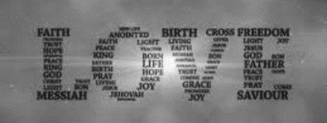
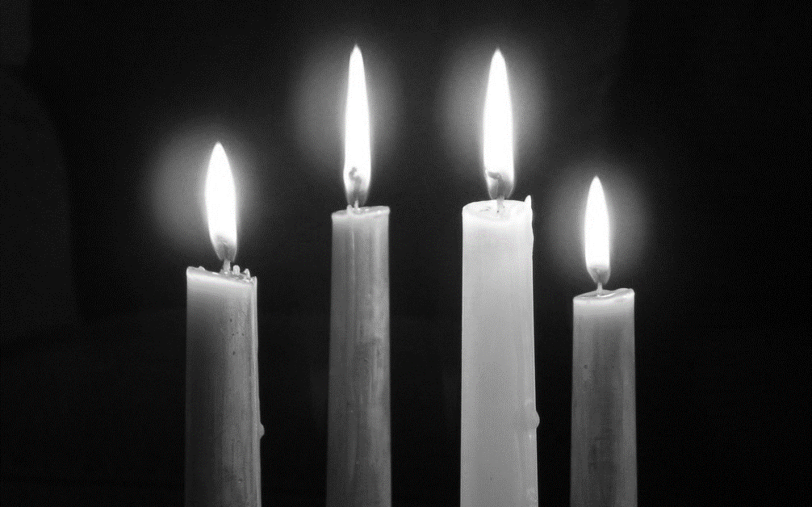

Opening Song: Emmanuel
Emmanuel, Emmanuel
His name is called Emmanuel
God with us, revealed in us
His name is called Emmanuel

Lighting of the Fourth Advent Candle: LOVE
Reader 1: On our journey to Christmas we have lit the candles of Hope, Peace, and Joy on our Advent Wreath. We relight them now to remind us of the hope that Christ will come again, bringing everlasting peace and joy.
(The four candles are lit.)
Reader 2: This is the fourth Sunday of Advent so we light the last candle, the candle of Love. To a world of empires and despots, war and greed, grief and apathy, we proclaim that love is strong enough to overcome all evil and that compassion is more powerful than fear.
Reader 3: The angel Gabriel reassured Mary that “nothing will be impossible with God.” The power of love is the power to overcome what we think is impossible. Love tells us God doesn’t want our excuses for why we dare not try, but our faithfulness to do.
Reader 4: As we light the candle of Love, we remember that God so loves this world that he sent his only son, Jesus, to save us. We do so in honor of those who have shown us how to love even when doing so is not convenient or sensible. We remember those who show us that compassion— unconditional love— is central to a Christian’s life. Let us pray:
All: All-loving God, break into our world and our hearts again. Magnify your love in us until it overflows to our neighbors. Renew our faith to relive the wonder of your love. Prepare our hearts to be transformed by you that we may shine the light of your compassionate love. Come, God of Love, come. Amen.

Lessons and Carols
Song: Come Thou Fount, Come Thou King
Come Thou Fount of every blessing
Tune my heart to sing Thy grace
Streams of mercy never ceasing
Call for songs of loudest praise
Teach me some melodious sonnet
Sung by flaming tongues above
Praise the mount I'm fixed upon it
Mount of Thy redeeming love

I was lost in utter darkness
'Til You came and rescued me
I was bound by all my sin when
(continued on next page)
Your love came and set me free
Now my soul can sing a new song
Now my heart has found a home
Now Your grace is always with me
And I'll never be alone

(Chorus)
Come Thou Fount, come Thou King
Come Thou precious Prince of Peace
Hear Your bride, to You we sing
Come Thou Fount of our blessing
O to grace how great a debtor
Daily I'm constrained to be
Let Thy goodness like a fetter
Bind my wand'ring heart to Thee
Prone to wander Lord I feel it
Prone to leave the God I love
Here's my heart Lord take and seal it
Seal it for Thy courts above
(To Chorus)

First Reading: Genesis 3:1-20 (pg. 2 in the red pew Bible), read by Barb M.

Song: O Come, O Come Emmanuel (Choir Only)
O come, O come Emmanuel
And ransom captive Israel
That mourns in lowly exile here
Until the Son of God appear
O come Thou Dayspring
Come and cheer
Our spirits by Thine advent here
Disperse the gloomy clouds of night
And death's dark shadows put to flight

Rejoice, rejoice, Emmanuel
Shall come to thee, O Israel
Rejoice, rejoice, Emmanuel
Shall come to thee
O Israel rejoice

Second Reading: Genesis 22:15-18 (pg. 15 in the red pew Bible), read by Jennifer B.

Song: Blessed Be Your Name

Blessed be Your name
In the land that is plentiful
Where Your streams of abundance flow
Blessed be Your name
Blessed be Your name
When I'm found in the desert place
Though I walk through the wilderness
Blessed be Your name

Every blessing You pour out
I’ll turn back to praise
When the darkness closes in Lord
Still I will say

Blessed be the name of the Lord
Blessed be Your name
Blessed be the name of the Lord
Blessed be Your glorious name
(continued on next page)

Blessed be Your name
When the sun's shining down on me
When the world's all as it should be
Blessed be Your name
Blessed be Your name
On the road marked with suffering
Though there's pain in the offering
Blessed be Your name

Every blessing You pour out
I’ll turn back to praise
When the darkness closes in Lord
Still I will say
(Chorus)
Blessed be the name of the Lord
Blessed be Your name
Blessed be the name of the Lord
Blessed be Your glorious name

You give and take away
You give and take away
My heart will choose to say
Lord blessed be Your name
(To Chorus)

Third Reading: Isaiah 40:1-11 (pg. 511 in the red pew Bible), read by Carol R.

Song: You’ll Come

Chains be broken, lives be healed
Eyes be opened, Christ is revealed
I have decided, I have resolved
To wait upon You Lord
My Rock and Redeemer
Shield and reward
I'll wait upon You Lord

As surely as the sun will rise
You'll come to us
Certain as the dawn appears

(Chorus)
You'll come, let Your glory fall
As You respond to us
Spirit rain
Flood into our thirsty hearts again
You'll come, You'll come

We are not shaken, we are not moved
We wait upon You Lord
Mighty deliverer, triumph and truth
We wait upon You Lord

As surely as the sun will rise
You'll come to us
Certain as Your word endures
(To Chorus)

Chains be broken, lives be healed
Eyes be opened, Christ is revealed
(To Chorus)

Fourth (Congregational) Reading: Isaiah 11:1-3a
All: A shoot will come up from the stump of Jesse: from his roots a Branch will bear fruit. The Spirit of the Lord will rest on him – the Spirit of wisdom and of understanding, the Spirit of counsel and of power, the Spirit of knowledge and of the fear of the Lord – and he will delight in the fear of the Lord.

Song: Your Name (Christmas Version)

Humbly to the earth You came
Born into this world to save
God with us, Emmanuel
Now we adore Your name

(Chorus)
Your name is a strong and mighty tower
Your name is a shelter like no other
Your name, let the nations sing it louder
For nothing has the power to save
But Your name
Jesus in Your name we pray
Come and fill our hearts today
Lord give us strength to live for You
And glorify Your name (To Chorus)

Wonderful Counselor, Prince of Peace
Wonderful Counselor, Prince of Peace
(To Chorus)

God with us Emmanuel (3x)
Now we adore Your name

Fifth Reading: Luke 1:26-38 (pg. 723 in the red pew Bible), read by Nancy W-S.

Song: In the Bleak Midwinter

In the bleak midwinter
Frosty wind made moan
Earth stood hard as iron
Water like a stone
Snow had fallen snow on snow
Snow on snow
In the bleak midwinter
Long ago

Our God, heav'n cannot hold Him
Nor earth sustain
Heav'n and earth shall flee away
When He comes to reign
In the bleak midwinter
A stable place sufficed
The Lord God Almighty
Jesus Christ

Angels and archangels
May have gathered there
Cherubim and seraphim
Thronged the air
But His mother only
In her maiden bliss
Worshipped the Beloved
With a kiss (continued on next page)
What can I give Him
Poor as I am
If I were a shepherd
I would bring a lamb
If I were a wise man
I would do my part
Yet what can I give Him
Give my heart

Collect
Celebrant: (pg. 272) Heavenly Father, who chose the Virgin Mary, full of grace, to be the mother of our Lord and Saviour, now fill us with your grace, that we in all things may embrace your will and with her rejoice in your salvation; through Jesus Christ our Lord, who lives and reigns with you and the Holy Spirit, one God, now and for ever.
People: Amen.

Sixth Reading: Luke 2:1, 3-20 (KJV), read by Abigail Penner from The Christmas Story

Song: O Come, All Ye Faithful

O come, all ye faithful
Joyful and triumphant
O come ye, O come ye to Bethlehem
Come and behold Him
Born the King of angels

(Chorus) O come let us adore Him
O come let us adore Him
O come let us adore Him
Christ the Lord

Sing, choirs of angels
Sing in exultation
O sing, all ye citizens of heav'n above
Glory to God
All glory in the highest (To Chorus)

Christ the Lord
You are the Lord

Yea Lord, we greet Thee
Born this happy morning
Jesus to Thee be all glory giv'n
Word of the Father
Now in flesh appearing (To Chorus)

Christ the Lord
You are the Lord

Short Creed
Celebrant: Do you believe and trust in God the Father, source of all being and life, the one for whom we exist?
All: We believe and trust in him.

Celebrant: Do you believe and trust in God the Son, who took on our human nature, died for us and rose again so that we might be forgiven?
All: We believe and trust in him.
Celebrant: Do you believe and trust in God the Holy Spirit, who gives life to the people of God and makes Christ known in the world through us?
All: We believe and trust in him.
Celebrant: This is the faith of the Church.
All: This is our faith. We believe and trust in one God: Father, Son, and Holy Spirit. Amen.

Confession of Sin
Celebrant: (pg. 191) Dear friends in Christ, God is steadfast in love and infinite in mercy; he welcomes sinners and invites them to his table. Let us confess our sins, confident in God’s forgiveness.
Silent Confession
Celebrant: Most merciful God,
All: we confess that we have sinned against you in thought word, and deed, by what we have done and by what we have left undone. We have not loved you with our whole heart; we have not loved our neighbours as ourselves. We are truly sorry and we humbly repent. For the sake of your Son Jesus Christ, have mercy on us and forgive us, that we may delight in your will, and walk in your ways, to the glory of your name. Amen.
Celebrant: Almighty God have mercy upon you, pardon and deliver you from all your sins, confirm and strengthen you in all goodness and keep you in eternal life through Jesus Christ our Lord.
People: Amen.

The Peace
Celebrant: The peace of the Lord be always with you.
People: And also with you.

Offertory Song: Joy Has Dawned

Joy has dawned upon the world
Promised from creation
God's salvation now unfurled
Hope for every nation
Not with fanfares from above
Not with scenes of glory
(continued on next page)
But a humble gift of love
Jesus born of Mary

Sounds of wonder fill the sky
With the songs of angels
As the mighty Prince of Life
Shelters in a stable
Hands that set each star in place
Shaped the earth in darkness
Cling now to a mother's breast
Vulnerable and helpless

Shepherds bow before the Lamb
Gazing at the glory
Gifts of men from distant lands
Prophesy the story
Gold a King is born today
Incense God is with us
Myrrh His death will make a way
By His blood He'll win us

Son of Adam Son of heaven
Given as a ransom
Reconciling God and man
Christ our mighty Champion
What a Savior what a Friend
What a glorious mystery
Once a babe in Bethlehem
Now the Lord of history

Prayer Over the Gifts
Celebrant: (pg. 272) Gracious God,
All: by the power of the Spirit who sanctified the mother of your Son, make holy all we offer you this day. We ask this in the name of Jesus Christ the Lord. Amen.

Celebrant: (pg. 196) The Lord be with you.
People: And also with you.
Celebrant: Lift up your hearts.
People: We lift them to the Lord.
Celebrant: Let us give thanks to the Lord our God.
People: It is right to give our thanks and praise.
Celebrant: (pg. 219) Blessed are you, gracious God, creator of heaven and earth; we give you thanks and praise through Jesus Christ our Lord, who in the fullness of time came among us in our flesh, and opened to us the way of salvation. Now we watch for the day when he will come again in power and great triumph to judge this world, that we, without shame or fear, may rejoice to behold his appearing. Therefore, we praise you, joining our voices with angels and archangels, and with all the company of heaven, who for ever sing this hymn to proclaim the glory of your name.
All: (Sung) Holy, holy, holy Lord, God of power and might, heaven and earth of Your glory are full. Hosanna, hosanna, hosanna in the highest. Blessed is he who comes in the name of the Lord.
Blessed is he who comes in the name of the Lord.
Holy, holy, holy Lord, God of power and might, heaven and earth of Your glory are full. Hosanna, hosanna, hosanna in the highest.
Celebrant: (pg. 197) Holy and gracious God, accept our praise……. All glory and honour are yours, Father and Son, with the Holy Spirit, in the holy Church, now and for ever.
All: Amen.

Celebrant: (pg. 211) As our Saviour taught us, let us pray,
All: (Sung) Our Father in heaven, holy is your name. Your kingdom come on earth as in heaven. Our Father in heaven, reveal who you are. Your will be done on earth as in heaven. Feed us today what we need to live. Forgive all our sins as we forgive. And keep us safe. The kingdom is yours, the power is yours, and the glory forever. The kingdom is yours, the power is yours, and the glory forever.

Celebrant: (pg. 212) We break this bread to share in the body of Christ.
All: We, being many, are one body, for we all share in the one bread.

Celebrant: (pg. 213) The gifts of God for the People of God.
People: Thanks be to God.

The Communion
You are welcome to receive communion or come forward for a blessing. If you prefer to receive a blessing, please fold your arms over your chest. There is de-alcoholized wine available in the centre and gluten-free wafers available upon request.

Lamb of God
(Sung) Lamb of God, you take away the sin of the world, have mercy on us.
Lamb of God, you take away the sin of the world, have mercy on us.
Lamb of God, you take away the sin of the world, grant us your peace.

Communion Music

In Christ Alone
In Christ alone my hope is found
He is my light, my strength, my song
This Cornerstone, this solid Ground
Firm through the fiercest
Drought and storm
What heights of love
What depths of peace
When fears are stilled
When strivings cease
My Comforter, my All in All
Here in the love of Christ I stand

In Christ alone who took on flesh
Fullness of God in helpless babe
This gift of love and righteousness
Scorned by the ones He came to save
Till on that cross as Jesus died
The wrath of God was satisfied
For every sin on Him was laid
Here in the death of Christ I live

There in the ground His body lay
Light of the world by darkness slain
Then bursting forth in glorious Day
Up from the grave He rose again
And as He stands in victory
Sin's curse has lost its grip on me
For I am His and He is mine
Bought with the precious blood of Christ

No guilt in life, no fear in death
This is the power of Christ in me
From life's first cry to final breath
Jesus commands my destiny
No power of hell, no scheme of man
Can ever pluck me from His hand
Till He returns or calls me home
Here in the power of Christ I'll stand

Christmas Offering
Over the skies of Bethlehem
Appeared a star
While angels sang to lowly shepherds
Three wise men seeking truth
Traveled from afar
Hoping to find the child from Heaven
Falling on their knees
They bowed before the humble
Prince of Peace

I bring an offering of worship to my King
No one on earth deserves
The praises that I sing
Jesus may You receive
The honor that You're due
Oh Lord I bring an offering to You

Prayer After Communion
Celebrant: (pg. 272) Faithful God,
All: in this sacrament we receive the promise of salvation. May we, like the Virgin Mary, be obedient to your will. We ask this in the name of Jesus Christ the Lord. Amen.
Celebrant: (pg. 214) Glory to God,
All: whose power, working in us, can do infinitely more than we can ask or imagine. Glory to God from generation to generation, in the Church and in Christ Jesus, for ever and ever. Amen.

Blessing

Congregational Announcements (Peter J.)

Closing Song: Hark! The Herald Angels Sing

Hark the herald angels sing
Glory to the newborn King
Peace on earth and mercy mild
God and sinners reconciled
Joyful all ye nations rise
Join the triumph of the skies
With th'angelic hosts proclaim
Christ is born in Bethlehem
Hark the herald angels sing
Glory to the newborn King

Christ by highest heav'n adored
Christ the everlasting Lord
Late in time behold Him come
Offspring of the Virgin's womb
Veiled in flesh the Godhead see
Hail th'incarnate Deity
Pleased as man with men to dwell
Jesus our Emmanuel
Hark the herald angels sing
Glory to the newborn King

Hail the heav'n-born Prince of Peace
Hail the Sun of Righteousness
Light and life to all He brings
Ris'n with healing in His wings
Mild He lays His glory by
Born that man no more may die
Born to raise the sons of earth
Born to give them second birth
Hark the herald angels sing
Glory to the newborn King

The Dismissal
Celebrant: (pg. 215) Let us bless the Lord.
All: Thanks be to God. Amen.

Please join us in the hall for coffee following the service.

@StEdmonton
facebook.com/stpachurchedmonton
St. Paul’s Vestry:
Peter Jackson, Rector’s Warden
Pat Stretch, People’s Warden
David Heritage, Treasurer
Margot Byer, Vestry Member
John Green, Vestry Member
Deanna Kalles, Vestry Member
David Parker, Vestry Member
Carol Rudat, Vestry Member

St. Paul’s Staff:
Rector:
The Reverend Myron Bradley Penner
Office Administrator:
RJ Chambers
Youth Leader: Victoria Eeles
For prayer requests email:
office@stpauls-anglican.ca
For urgent prayer requests call
the church office: (780) 455-0771
For pastoral emergencies call:
(587) 334-2130

Office Hours:
Monday-Thursday: 9:00AM-12:00PM
Closed: Fri/Sat/Sun and Stat Holidays
St. Paul’s Anglican Church
10127 145 Street, Edmonton T5N 2X6
Phone: (780) 455-0771; Email: office@stpauls-anglican.ca
Website: www.stpauls-anglican.ca
This Week’s Readings:
Genesis 3:1-20, Genesis 22:15-18,
Isaiah 40:1-11, Isaiah 11:1-3a,
Luke 1:26-38, Luke 2:1, 3-20

This Week’s Ministry Teams:
Music/Sound: RJ’s Team/RJ C.
Service Team: Jackson Team
Prayers: Gay G.; Vestry: Peter J.
Chapel Prayer: Dudley B. and Pat H-B.
Kid’s Ministry: Abigail P. and Renee J.
(Kids in service this week)

St. Paul’s Cycle of Prayer:
Andrew, Nancy, Greg, Tim, and Emily Whistance-Smith; Lorraine Bednar;
Barb Dixon

Anglican Cycle of Prayer:
Diocese of Quebec; the Rt. Rev. Bruce Myers, Bishop. St. Patrick, Whitecourt: Rita Milne, Priest-in-Charge. Buyé Diocese, Murama Parish: Evariste Nsabimana, Rector. Cold Lake First Nations.

Next Week’s Ministry Teams
Music/Sound: Andrew’s Team/Jennifer S.
Service Team: Heritage Team
Prayers: David H.; Vestry: John G.
Chapel Prayer: Laurier B. and Pat S.
Kid’s Ministry: Jodi P. (Kids in service)

