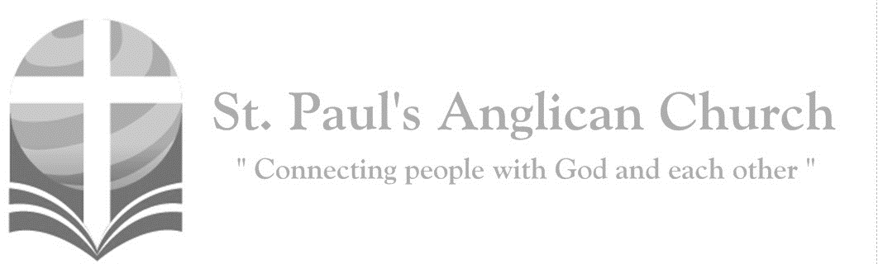

Sunday, November 24, 2019: The Reign of Christ

*Blessed is he who comes in the name of the Lord! Blessed is the kingdom of our father David that is coming! (Mark 11:9-10)*

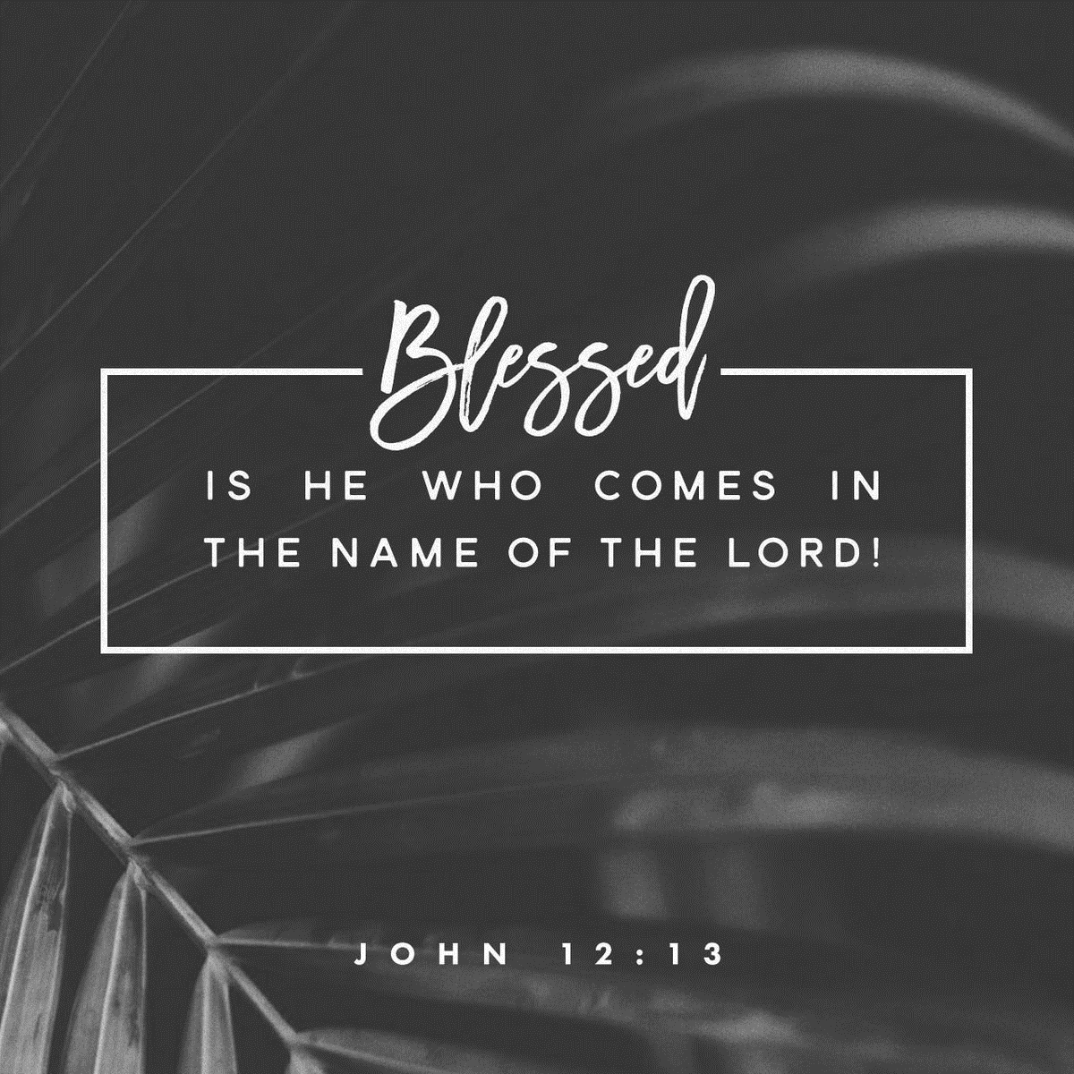

SUNDAYS AT ST. PAUL’S

**REGULAR SERVICES**

* Weekly services held Sundays at 10:00AM
* Interface services - Art based services throughout the year
* Sermons available on our website

**SUNDAY PRAYER**

* Prayer for the service at 9:30AM in the Luke Room
* Individual Prayer in the Chapel during the Sunday service

**SERVING AT ST. PAUL’S**

* Join a Ministry Team (Sunday service team, music team, children’s ministry, Altar guild, or many others)
* Regular or One-Time Giving (cash, cheque, automatic debit, and credit options available)

**LARGE PRINT MATERIALS** Large print Bibles and   
 Books of Alternative   
 Services (BAS) are availableat each Sanctuary door.

Page numbers will not be the same as those listed in the bulletin.

**VISITING TODAY?**

We want to get to know   
 you! Please join us for

in the Hall for coffee and

fellowship following the service. The greeters are also available to help if you have any questions.

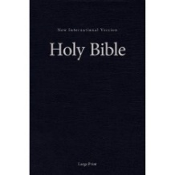



**Assisted listening**

**is available. Please**

**ask a greeter**

**for assistance.**



CONNECT

**St. Paul’s CHILDREN’S MINISTRY**

**KIDS** Pre-School-Grade 2 in the hall / Grade 3-5 in the Matthew Room

Sunday School teaching is weekly during the 10:00AM service.

**St. Paul’s YOUTH MINISTRY**

**YOUTH** Youth Grades 6-12 meet weekly during the 10:00AM service.

Youth also meetbi-weekly for fun events and devotionals.

**St. Paul’s ADULT MINISTRY**

**ADULTS** St. Paul’s has a number of small groups where you can connect with others through Christ. If you are interested in joining a small   
group or starting a small group of your own, please speak with Pat Stretch.

**Opening Song: *Jesus Shall Reign***

Jesus shall reign where'er the sun  
Does its successive journeys run  
His kingdom stretch from shore to shore  
Till sun shall rise and set no more

Blessings abound where'er He reigns  
The pris'ner leaps to lose his chains  
The weary find eternal rest  
And all the sons of want are blessed

(*Chorus*)

To our King be highest praise  
Rising through eternal days  
Just and faithful, He shall reign  
Jesus shall reign

People and realms of every tongue  
Dwell on His love with sweetest song  
And infant voices shall proclaim  
Their early blessings on His name

Let every creature rise and bring  
Blessing and honor to our King  
Angels descend with songs again  
And earth repeat the loud amen

(*To Chorus*)

**The Gathering of the Community**

Celebrant: *(BAS pg. 185)* The grace of our Lord Jesus Christ, and the love of God, and the fellowship of the Holy Spirit, be with you all.

**People: And also with you.**

Celebrant:Almighty God,

**All:to you all hearts are open, all desires known, and from you no secrets are hidden. Cleanse the thoughts of our hearts by the inspiration of your Holy Spirit that we may perfectly love you, and worthily magnify your holy name; through Christ our Lord. Amen.**

Celebrant: *(pg. 394)* Almighty and everlasting God, whose will it is to restore all things in your well-beloved Son, our Lord and King, grant that the peoples of the earth, now divided and enslaved by sin, may be freed and brought together under his gentle and loving rule; who lives and reigns with you and the Holy Spirit, one God, now and for ever.

**People:** **Amen**.

**Children Dismissal**

**The Reading of Scripture**

First Reading: Jeremiah 23:1-6 (pg. 553 in the red pew Bible)

Reader: The Word of the Lord.

**People:** **Thanks be to God.**

Psalm (or Canticle): Luke 1:68-79 (pg. 88 in the BAS to the below tune)

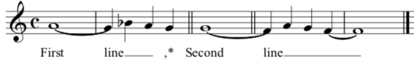

Second Reading: Colossians 1:11-20 (pg. 833 in the red pew Bible)

Reader: The Word of the Lord.

**People:** **Thanks be to God.**

**Worship Through Song**

***With Us in Jesus***

(*Chorus*) Jesus (echo)

You are wonderful (echo)

Counselor (echo), Wonderful (echo)

Jesus (echo)

You are Prince of Peace (echo)

Mighty God (echo)

Eternal Father (echo)

We bless your name

And worship you, O God

For in your wondrous way

With us in… (*To Chorus*)

***He is Exalted***

He is exalted  
The King is exalted on high  
I will praise Him  
He is exalted forever exalted  
And I will praise His name

He is the Lord  
Forever His truth shall reign  
Heaven and earth  
Rejoice in His holy name  
He is exalted  
The King is exalted on high

**Listening Time**

**The Gospel Reading**

Celebrant: The Lord be with you.

**People: And also with you.**

Celebrant: The Holy Gospel of our Lord Jesus Christ according to St. Luke.

**People: Glory to you, Lord Jesus Christ.**

Gospel Reading: Luke 23:33-43 (pg. 748 in the red pew Bible)

Celebrant: The Gospel of Christ.

**People: Praise to you, Lord Jesus Christ.**

**Sermon Notes:** Sermon by the Reverend Dr. Myron Penner

________________________________________________________________________________________________________________________________________________________________________________________________________________________________________________________________________________________________________________________________________________________________________________________________________________________________________________________________________________________________________________________

________________________________________________________________________________________________________________________________________________________________________________________________________________________

________________________________________________________________________________________________________________________________________________________________________________________________________________________________________________________________________________________________________________________________________________________________________________________________________________________________________________________________________________________________________________________________________________________________________________________________________________________________________________________________________

**Affirmation of Faith – We Belong to God**

Celebrant: *(pg. 189)* Let us confess the faith of our baptism, as we say,

**All: We belong to God, eternal and infinite, Creator of all things and all that is to come. We follow Christ, who comes to us from God, and reveals God to us. He heals people and transforms lives, and calls us to join in his ministry. He was crucified, died, and was raised again by God, and reigns over all Creation; and he bids us to die and rise with him in the service of the healing of the world. We are moved by the Holy Spirit, together with the communion of saints, as members of the Body of Christ, God’s holy universal church. We are confident in the forgiveness of sin, the power of resurrection and the reality of eternal life. In all things it is our desire to follow Christ, by the grace of the Holy Spirit, for God’s glory. Amen.**

**Prayers of the People**

**Confession of Sin**

Celebrant: *(pg. 191)* Dear friends in Christ, God is steadfast in love and infinite in mercy; he welcomes sinners and invites them to his table. Let us confess our sins, confident in God’s forgiveness.

*Silent Confession*

Celebrant:Most holy and merciful Father,

**All: we confess to you, to one another, and to the whole communion of saints in heaven and on earth, that we have sinned by our own fault, in thought, word, and deed; by what we have done and by what we have left undone. O God, uphold us by your Spirit that we may live and serve you in newness of life to the honour and glory of your name; through Jesus Christ our Lord. Amen.**

Celebrant: Accomplish in us, O God, the work of your salvation,

**All: that we may show forth your glory to the world.**

Celebrant: By the cross and passion of your Son, our Lord,

**All: bring us with all your saints to the joy of His resurrection.**

Celebrant: Almighty God have mercy upon you, pardon and deliver you from all your sins, confirm and strengthen you in all goodness and keep you in eternal life through Jesus Christ our Lord.

**People:Amen.**

**The Peace**

Celebrant: The peace of the Lord be always with you.

**People: And also with you.**

**Offertory Song: *King of Heaven***

Jesus, let Your kingdom come here  
Let Your will be done here in us  
Jesus, there is no one greater  
You alone are Savior

Show the world Your love

(*Chorus*) King of heaven come down  
King of heaven come now  
Let Your glory reign, shining like the day  
King of heaven come  
King of heaven rise up  
Who can stand against us  
You are strong to save

In Your mighty name  
King of heaven come

We are children of Your mercy  
Rescued for Your glory  
We cry Jesus set our hearts towards You  
That every eye would see You lifted high

(*To Chorus*)

King of heaven come  
King of heaven come  
King of heaven come  
Oh King of heaven come

**Prayer Over the Gifts**

Celebrant: *(pg. 394)* Eternal God,

**All: by your grace you have raised us up and enthroned us with Christ in the heavenly realms. Receive all we offer you this day, and lead us in those good works for which you have created us. We ask this in the name of Jesus Christ the Lord. Amen.**

Celebrant: *(pg. 198)* The Lord be with you.

**People: And also with you.**

Celebrant: Lift up your hearts.

**People: We lift them to the Lord.**

Celebrant: Let us give thanks to the Lord our God.

**People: It is right to give our thanks and praise.**

Celebrant: (*pg. 223*) Blessed are you, gracious God, creator of heaven and earth; we give you thanks and praise through Jesus Christ our Lord. You exalted him as Lord of all creation that he might present to you an eternal and universal kingdom: a kingdom of truth and life, a kingdom of holiness and grace, a kingdom of justice, love, and peace. Therefore, at the name of Jesus every knee shall bow as heaven and earth proclaim the glory of your name.

**All:** ***(Sung)*** **Holy, holy, holy Lord, God of power and might, heaven and earth of Your glory are full. Hosanna, hosanna, hosanna in the highest. Blessed is he who comes in the name of the Lord.   
Blessed is he who comes in the name of the Lord.   
Holy, holy, holy Lord, God of power and might, heaven and earth of Your glory are full. Hosanna, hosanna, hosanna in the highest.**

Celebrant: (pg. 198) We give thanks to you, Lord our God……. Therefore, Father, according to his command,

**All we remember his death, we proclaim his resurrection, we await his coming in glory;**

Celebrant: (pg. 199) and we offer our sacrifice of praise and thanksgiving……. by whom, and with whom, and in whom, in the unity of the Holy Spirit, all honour and glory are yours, almighty Father, now and for ever.

**All: Amen.**

Celebrant: *(pg. 211)* As our Saviour taught us, let us pray,

**All: *(Sung)* Our Father which art in heaven, hallowed be Thy name. Thy kingdom come, thy will be done on earth as it is in heaven. Give us this day our daily bread and forgive us our debts as we forgive our debtors and lead us not into temptation but deliver us from evil.   
For Thine is the kingdom and the power and the glory forever. Amen. For Thine is the kingdom and the power and the glory forever. Amen.**

Celebrant: *(pg. 212)* “I am the bread of life,” says the Lord. “Whoever comes to me will never be hungry; whoever believes in me will never thirst.”

**All: Taste and see that the Lord is good; happy are they who trust in him!**

Celebrant: *(pg. 212)* We break this bread to share in the body of Christ.

**All: We, being many, are one body, for we all share in the one bread.**

**The Communion**

*You are welcome to receive communion or come forward for a blessing. If you prefer to receive a blessing, please fold your arms over your chest. There is de-alcoholized wine available in the centre and gluten-free wafers available upon request.*

**Lamb of God**

*(Sung)* Lamb of God, you take away the sin of the world.

Lamb of God, you take away the sin of the world.

Lord have mercy, Christ have mercy, Lord have mercy on me.

Lord have mercy, Christ have mercy and grant us thy peace.

**Communion Music**

***Once and For All***

God I give You what I can today  
These scattered ashes that I hid away  
I lay it all at Your feet

From the corners of my deepest shame  
The empty places

Where I've worn Your name  
Show me the love I say I believe

Help me to lay it down  
O Lord, I lay it down

O let this be where I die  
My Lord with Thee crucified  
Be lifted high as my kingdoms fall  
Once and for all, once and for all

There is victory in my Savior’s loss  
In the crimson flowing from the cross  
Pour over me, pour over me (*To Chorus*)

O Lord, I lay it down  
O Lord, I lay it down  
Help me to lay it down  
O Lord, I lay it down (*To Chorus*)

***Majesty***

Here I am humbled by Your majesty  
Covered by Your grace so free  
Here I am knowing I'm a sinful man  
Covered by the blood of the Lamb

(*Pre-Chorus*) Now I've found

The greatest love of all is mine  
Since You laid down Your life  
The greatest sacrifice

(*Chorus*) Majesty, majesty  
Your grace has found me just as I am  
Empty handed but alive in Your hands

Here I am  
Humbled by the love that You give  
Forgiven so that I can forgive  
Here I stand  
Knowing that I'm Your desire  
Sanctified by glory and fire

(*Final Chorus*) Majesty, majesty  
Your grace has found me just as I am  
Empty handed but alive in Your hands  
Majesty, majesty  
Forever I am changed by Your love  
In the presence of Your majesty

**Prayer After Communion**

Celebrant: *(pg. 395)* Almighty God,

**All: you have made us a royal priesthood in the kingdom of your Son our Saviour Jesus Christ. Make known his victory through us, we pray, that all the world may see his light. We ask this in the name of Jesus Christ the Lord. Amen.**

Celebrant: *(pg. 214)* Glory to God,

**All:whose power, working in us, can do infinitely more than we can ask or imagine. Glory to God from generation to generation, in the Church and in Christ Jesus, for ever and ever. Amen.**

**Blessing**

**Congregational Announcements *(Carol R.)***

**Closing Song: *Hear the Call of the Kingdom***

Hear the call of the kingdom  
Lift your eyes to the King  
Let His song rise within you  
As a fragrant offering  
Of how God rich in mercy

Came in Christ to redeem  
All who trust in His unfailing grace

Hear the call of the kingdom  
To be children of light  
With the mercy of heaven

The humility of Christ  
Walking justly before Him  
Loving all that is right  
That the life of Christ

May shine through us

(*Chorus*)

King of heaven, we will answer the call  
We will follow

Bringing hope to the world  
Filled with passion

Filled with power to proclaim  
Salvation in Jesus' name

Hear the call of the kingdom  
To reach out to the lost  
With the Father's compassion  
In the wonder of the cross  
Bringing peace and forgiveness  
And a hope yet to come  
Let the nations put their trust in Him

(*To Chorus*)

**The Dismissal**Celebrant: *(pg. 215)* Go forth in the name of Christ.

**All: Thanks be to God. Amen.**

*Please join us in the Hall for coffee following the service.*

**RightNow Media**

Did you know that St. Paul’s parishioners now have access to the RightNow library? With RightNow Media you get exclusive access to a library of over 20,000 biblically based videos including over 2,000 videos in the kid’s library! If you have not already signed up, it is easy as can be. Just scan the QR code below and sign up today!



**Advent Study**

Rev. Myron will be leading a study during Advent Sunday mornings before service starting December 1. If you have an interest in participating, please let us know ASAP. Books have already been ordered but we ordered a few extra. The cost to parishioners will be $10.00 for the book with St. Paul’s picking up any additional cost in excess of the $10.00.

**White Elephant Sale/Fundraiser for**

**Rwanda Mission Trip/Conference**

**PURPOSE:**To raise funds for a trip to Rwanda in Summer 2020 to re-establish relationships in the Cyangugu Diocese, facilitate conferences for youth and pastors and check on progress with pre-established microfinance, housing, and youth education projects.  
  
Come, bring your friends and enjoy some tea and refreshments while finding some special Christmas gifts and supporting a great cause!  
  
**WHEN:**Saturday, Nov. 30, 11AM-3PM  
 **WHERE:**St. Paul’s Anglican Church Hall (10127 145 Street)  
 **REGISTRATION:** Please register on Eventbrite if you plan to attend -  [**https://www.eventbrite.com/e/rwanda-mission-and-conference-fundraiser-tickets-82014392255**](https://www.eventbrite.com/e/rwanda-mission-and-conference-fundraiser-tickets-82014392255)    
 **DONATIONS ACCEPTED:**Donations can be dropped off at the church on Tuesdays and Thursdays between 9:30AM and 12:00PM. All donated items are accepted but should be new or gently used. Also, we are unable to accept clothing items or large furniture items. If you would like more information about acceptable donation items, please email office@stpauls-anglican.ca.

**Gingerbread Night – Fri. Nov. 29**

Please join us for Supper and Gingerbread making on Friday, November 29 at 6:00PM in the Hall. Please sign up in the foyer if you plan to attend. Cost is:

$25 / family (meal and gingerbread kit)

$15 / person (meal and gingerbread kit)

$5 / person (meal only); $10 for extra kit



@StEdmonton

facebook.com/stpachurchedmonton

**St. Paul’s Vestry:**

Peter Jackson, *Rector’s Warden*

Pat Stretch, *People’s Warden*

David Heritage, *Treasurer*

Margot Byer, *Vestry Member*

John Green, *Vestry Member*

Deanna Kalles, *Vestry Member*

David Parker, *Vestry Member*

Carol Rudat, *Vestry Member*

**St. Paul’s Staff:**

*Rector:*

The Reverend Myron Bradley Penner  
*Office Administrator:*

RJ Chambers

*Youth Leader:* Victoria Eeles

**For prayer requests** **email**:

office@stpauls-anglican.ca

**For urgent prayer requests call**

the church office: (780) 455-0771

**For pastoral emergencies call:**

(587) 334-2130

**Office Hours:**

Monday-Thursday: 9:00AM-12:00PM

Closed: Fri/Sat/Sun and Stat Holidays

**St. Paul’s Anglican Church**

10127 145 Street, Edmonton T5N 2X6

Phone: (780) 455-0771; Email: office@stpauls-anglican.ca

Website: www.stpauls-anglican.ca

**This Week’s Readings:**

Jeremiah 23:1-6 (pg. 553)

Luke 1:68-79 (BAS pg. 88)

Colossians 1:11-20 (pg. 833)

Luke 23:33-43 (pg. 748)

**This Week’s Ministry Teams:**

Music/Sound: Andrew’s Team/Jennifer

Service Team: B Team

Prayers: Barb M.; Vestry: Carol R.

Chapel Prayer: Dudley B. and Pat H-B.

Kid’s Ministry: Carol G. and Abigail P.

**St. Paul’s Cycle of Prayer:**

Sivanesan, Gladys, Rebecca, and Ruth Thangiah; Anne Austin;

Kathy Hougham; Kimberley Howard

**Anglican Cycle of Prayer:**

Diocese of Nova Scotia & Prince Edward Island; the Most Rev. Ronald Cutler, Archbishop (Metropolitan of the Ecclesiastical Province of Canada). Holy Trinity, Tofield; St. Mary, Vegreville; St. Matthew, Viking: Laureta Blondin (s. Clarence), Rector. Buyé Diocese, All Saints’ Cathedral: Alfred Uwimanihaye, Rector All First Nations people of Treaty 6.

**Next Week’s Ministry Teams**

Music/Sound: Pat’s Team/Chandra S.

Service Team: Green and Friends Team

Prayers: Nancy W-S.; Vestry: Deanna K.

Chapel Prayer: Laurier B. and Pat S.

Kid’s Ministry: Renée J. and Ryan Y.