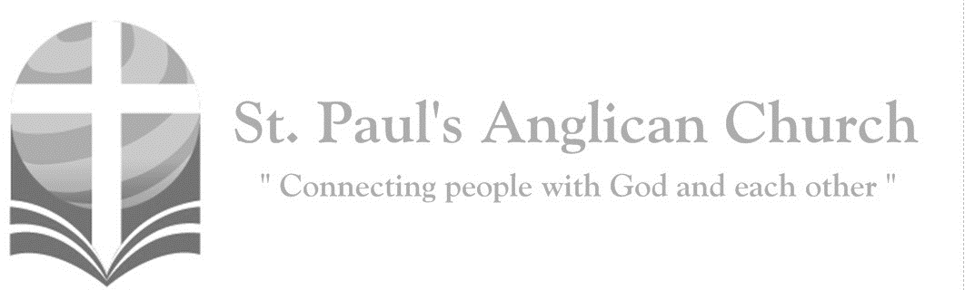

Sunday, November 10, 2019: 22nd Sunday After Pentecost

*Jesus Christ is the first-born of the dead; to him be glory and dominion for ever and ever. Amen. (Revelation 1:5-6)*

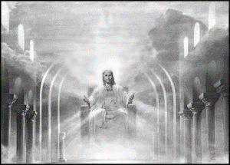

SUNDAYS AT ST. PAUL’S

**REGULAR SERVICES**

* Weekly services held Sundays at 10:00AM
* Interface services - Art based services throughout the year
* Sermons available on our website

**SUNDAY PRAYER**

* Prayer for the service at 9:30AM in the Luke Room
* Individual Prayer in the Chapel during the Sunday service

**SERVING AT ST. PAUL’S**

* Join a Ministry Team (Sunday service team, music team, children’s ministry, Altar guild, or many others)
* Regular or One-Time Giving (cash, cheque, automatic debit, and credit options available)

**LARGE PRINT MATERIALS** Large print Bibles and   
 Books of Alternative   
 Services (BAS) are availableat each Sanctuary door.

Page numbers will not be the same as those listed in the bulletin.

**VISITING TODAY?**

We want to get to know   
 you! Please join us for

in the Hall for coffee and

fellowship following the service. The greeters are also available to help if you have any questions.

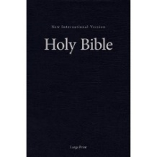



**Assisted listening**

**is available. Please**

**ask a greeter**

**for assistance.**



CONNECT

**St. Paul’s CHILDREN’S MINISTRY**

**KIDS** Pre-School-Grade 2 in the hall / Grade 3-5 in the Matthew Room

Sunday School teaching is weekly during the 10:00AM service.

**St. Paul’s YOUTH MINISTRY**

**YOUTH** Youth Grades 6-12 meet weekly during the 10:00AM service.

Youth also meetbi-weekly for fun events and devotionals.

**St. Paul’s ADULT MINISTRY**

**ADULTS** St. Paul’s has a number of small groups where you can connect with others through Christ. If you are interested in joining a small   
group or starting a small group of your own, please speak with Pat Stretch.

**Opening Song: *O Worship the Lord in the Beauty of Holiness***

O worship the Lord

In the beauty of holiness  
Bow down before Him

His glory proclaim  
With gold of obedience

And incense of lowliness  
Kneel and adore Him

The Lord is His name

Low at His feet

Lay thy burden of carefulness  
High on His heart

He will bear it for thee  
Comfort thy sorrows

And answer thy prayerfulness  
Guiding thy steps

As may best for thee be

Fear not to enter

His courts in the slenderness  
Of the poor wealth

Thou wouldst reckon as thine  
Truth in its beauty

And love in its tenderness  
These are the offerings

To lay on His shrine

O worship the Lord

In the beauty of holiness  
Bow down before Him

His glory proclaim  
With gold of obedience

And incense of lowliness  
Kneel and adore Him

The Lord is His name

**The Gathering of the Community**

Celebrant: *(BAS pg. 185)* The grace of our Lord Jesus Christ, and the love of God, and the fellowship of the Holy Spirit, be with you all.

**People: And also with you.**

Celebrant:Almighty God,

**All:to you all hearts are open, all desires known, and from you no secrets are hidden. Cleanse the thoughts of our hearts by the inspiration of your Holy Spirit that we may perfectly love you, and worthily magnify your holy name; through Christ our Lord. Amen.**

Celebrant: *(pg. 391)* Eternal God, who caused all holy scriptures to be written for our learning, grant us so to hear them, read, mark, learn, and inwardly digest them, that we may embrace and ever hold fast the blessed hope of everlasting life, which you have given us in our Saviour Jesus Christ, who lives and reigns with you and the Holy Spirit, one God, for ever and ever.

**People:** **Amen**.

**Children Dismissal**

**The Reading of Scripture**

First Reading: Haggai 1:15-2:9 (pg. 668 in the red pew Bible)

Reader: The Word of the Lord.

**People:** **Thanks be to God.**

Psalm 98 (pg. 836 in the BAS): Refrain at beginning and after verses 4, 7, and 10.

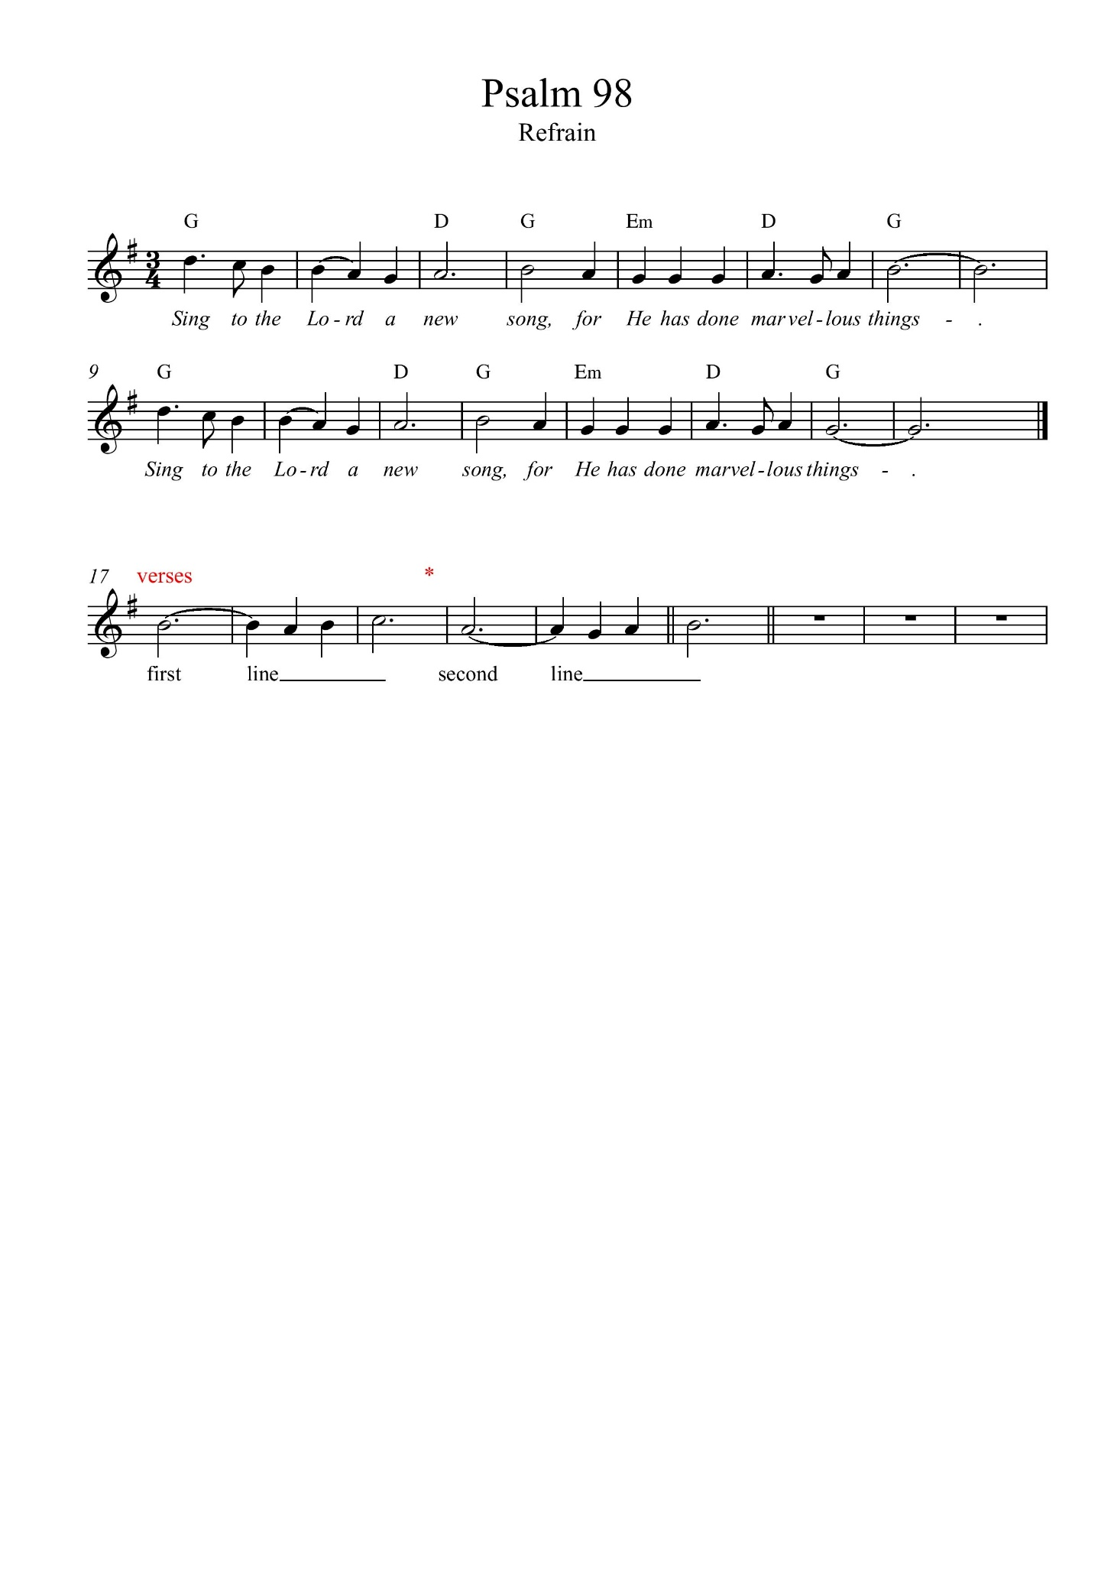

Second Reading: 2 Thessalonians 2:1-5, 13-17 (pg. 838 in the red pew Bible)

Reader: The Word of the Lord.

**People:** **Thanks be to God.**

**Worship Through Song**

***Thank You for Being***

Thank You for being  
Just who You are  
Thank You for shining  
Like the morning star  
Jesus, oh Jesus  
Thank You for being  
My bright and morning star

I love You  
Because You first loved me  
Your healing touch  
Has set me free  
Jesus, oh Jesus  
Your healing touch  
Has set my spirit free

***There is a Redeemer***

There is a Redeemer

Jesus, God's own Son  
Precious Lamb of God, Messiah

Holy One

(*Chorus*) Thank You, O my Father  
For giving us Your Son  
And leaving Your Spirit  
Till the work on earth is done

Jesus my Redeemer

Name above all names  
Precious Lamb of God, Messiah  
O for sinners slain (*To Chorus*)

(*continued on next page*)

When I stand in glory

I will see His face  
There I'll serve my King forever  
In that holy place

Thank You, O my Father  
For giving us Your Son  
And leaving Your Spirit  
Till the work on earth is done

**Listening Time**

**The Gospel Reading**

Celebrant: The Lord be with you.

**People: And also with you.**

Celebrant: The Holy Gospel of our Lord Jesus Christ according to St. Luke.

**People: Glory to you, Lord Jesus Christ.**

Gospel Reading: Luke 20:27-38 (pg. 745 in the red pew Bible)

Celebrant: The Gospel of Christ.

**People: Praise to you, Lord Jesus Christ.**

**Sermon Notes:** Sermon by the Reverend Dr. Myron Penner

________________________________________________________________________________________________________________________________________________________________________________________________________________________________________________________________________________________________________________________________________________________________________________________________________________________________________________________________________________________________________________________

________________________________________________________________________________________________________________________________________________________________________________________________________________________

________________________________________________________________________________________________________________________________________________________________________________________________________________________________________________________________________________________________________________________________________________________________________________________________________________________________________________________________________________________________________________________________________________________________________________________________________________________________________________________________________

**Affirmation of Faith – Christ Accompanies Us**

Celebrant: *(pg. 189)* Let us confess the faith of our baptism, as we say,

**All: We believe in God, Creator of all things, heavenly father, Soul of infinite love, wisdom, and power, ruler of all that is and all that is to come, who is mystery, yet revealed. We follow Christ, God’s chosen one, who loved and served humbly, who healed the broken and included the outcast, who chose to suffer rather than harm for the sake of the healing of all Creation, who gave his life for our redemption, and who was raised by God to new life. In his teaching, in his death and resurrection, and in his presence with us in all circumstances, he reveals God to us. He calls us to serve him for the sake of proclaiming God’s grace. We trust that he accompanies us and will help, guide, heal, and defend us through all difficulty and suffering. We believe the Holy Spirit sustains us, and guides us and empowers us as servants of God’s grace. We live as the body of Christ, in the power of forgiveness and the reality of resurrection, and the light of eternal life. Amen.**

**Prayers of the People**

**Confession of Sin**

Celebrant: *(pg. 191)* Dear friends in Christ, God is steadfast in love and infinite in mercy; he welcomes sinners and invites them to his table. Let us confess our sins, confident in God’s forgiveness.

*Silent Confession*

Celebrant:Father, Son, and Holy Spirit,

**All: you are everything we need all of the time. But we confess to you that we have been tempted to be self reliant and self sufficient. We have believed we need to provide our own daily bread. We have attempted to generate our own peace. In our weakness, we have tried to rely on our own strength. We have tried to light the dark with our own torch. We have trusted our own counsel. Father, out of your great love for us, and because you have given Jesus to die for us, grant that, through his cross, our sins might be taken away, remembered no more and not held against us. Cleanse us and empower us with your Spirit to be like Christ, to joyfully and willingly look to you for everything we need. Amen.**

Celebrant: Almighty God have mercy upon you, pardon and deliver you from all your sins, confirm and strengthen you in all goodness and keep you in eternal life through Jesus Christ our Lord.

**People:Amen.**

**The Peace**

Celebrant: The peace of the Lord be always with you.

**People: And also with you.**

**Offertory Song: *10,000 Reasons***

(*Chorus*) Bless the Lord, O my soul  
O my soul  
Worship His holy name  
Sing like never before  
O my soul  
I'll worship Your holy name

The sun comes up

It's a new day dawning  
It's time to sing Your song again  
Whatever may pass

And whatever lies before me  
Let me be singing

When the evening comes (*To Chorus*)

You're rich in love

And You're slow to anger  
Your name is great

And Your heart is kind  
For all Your goodness

I will keep on singing  
Ten thousand reasons

For my heart to find (*To Chorus*)

And on that day

When my strength is failing  
The end draws near

And my time has come  
Still my soul will sing

Your praise unending  
Ten thousand years

And then forevermore (*To Chorus*)

**Prayer Over the Gifts**

Celebrant: *(pg. 392)* Gracious God,

**All: your word to us is food indeed. Receive all we offer you this day, and let your loving kindness be our comfort, for the sake of Jesus Christ, your living Word. Amen.**

Celebrant: *(pg. 196)* The Lord be with you.

**People: And also with you.**

Celebrant: Lift up your hearts.

**People: We lift them to the Lord.**

Celebrant: Let us give thanks to the Lord our God.

**People: It is right to give our thanks and praise.**

Celebrant: We give you thanks and praise, almighty God……. Now with all creation we raise our voices to proclaim the glory of your name.

**All:** ***(Said)*** **Holy, holy, holy Lord, God of power and might,**

**heaven and earth are full of your glory. Hosanna in the highest.   
Blessed is he who comes in the name of the Lord.   
Hosanna in the highest.**

Celebrant: *(pg. 197)* Holy and gracious God, accept our praise……. All glory and honour are yours, Father and Son, with the Holy Spirit, in the holy Church, now and for ever.

**All: Amen.**

Celebrant: *(pg. 211)* As our Saviour taught us, let us pray,

**All: *(Sung)* Our Father in heaven, hallowed be your name. Your kingdom come, your will be done, on earth as in heaven. Give us today our daily bread. Forgive us our sins as we forgive those who sin against us. Save us from the time of trial, and deliver us from evil. For the kingdom, the power, and the glory are yours, now and for ever. Amen.**

Celebrant: *(pg. 212)* “I am the bread of life,” says the Lord. “Whoever comes to me will never be hungry; whoever believes in me will never thirst.”

**All: Taste and see that the Lord is good; happy are they who trust in him!**

Celebrant: *(pg. 213)* The gifts of God for the People of God.

**People: Thanks be to God.**

**The Communion**

*You are welcome to receive communion or come forward for a blessing. If you prefer to receive a blessing, please fold your arms over your chest. There is de-alcoholized wine available in the centre and gluten-free wafers available upon request.*

**Jesus, Remember Me**

Jesus, remember me when you come into your kingdom (*repeated*)

**Communion Music**

***Remember Me***

On the night You were betrayed  
You took the bread  
After giving thanks  
You broke it and said  
This is My body broken for you  
And as You eat it remember Me  
This is body broken for You  
And as You eat it remember Me

On the night You were betrayed  
You held the cup  
After giving thanks You lifted it up  
This is My blood poured out for you  
And as you drink it remember Me  
This is My blood poured out for you  
And as you drink it remember Me

So we thank You for the wine  
And for the bread  
For we see the life You gave  
And the blood You shed  
And we remember Your wondrous love  
You gave Your body

You shed Your blood  
And we remember Your wondrous love  
You gave Your body

You shed Your blood

**My Heart is Filled with Thankfulness**

My heart is filled with thankfulness  
To Him who bore my pain  
Who plumbed the depths

Of my disgrace and gave me life again  
Who crushed my curse of sinfulness  
And clothed me with His light  
And wrote His law of righteousness  
With power upon my heart

My heart is filled with thankfulness  
To Him who walks beside  
Who floods my weaknesses

With strength and causes fears to fly  
Whose every promise is enough  
For every step I take  
Sustaining me with arms of love  
And crowning me with grace

My heart is filled with thankfulness  
To Him who reigns above  
Whose wisdom is my perfect peace  
Whose every thought is love  
For every day I have on earth  
Is given by the King  
So I will give my life, my all  
To love and follow Him

**Prayer After Communion**

Celebrant: *(pg. 392)* Living God,

**All: in the eucharist you fill us with new hope. May the power of your love, which we have known in word and sacrament, continue your saving work among us, and bring us to the joy you promise. We ask this in the name of Jesus Christ our Lord. Amen.**

Celebrant: *(pg. 214)* Glory to God,

**All:whose power, working in us, can do infinitely more than we can ask or imagine. Glory to God from generation to generation, in the Church and in Christ Jesus, for ever and ever. Amen.**

**Blessing**

**Congregational Announcements *(Margot B.)***

**Closing Song: *Onward Christian Soldiers***

Onward Christian soldiers

Marching as to war  
With the cross of Jesus going on before  
Christ the royal Master

Leads against the foe  
Forward into battle see His banner go

(*Chorus*) Onward Christian soldiers  
Marching as to war  
With the cross of Jesus  
Going on before

At the sign of triumph

Satan's host doth flee  
On then Christian soldiers, on to victory  
Hell's foundations quiver

At the shout of praise  
Brothers lift your voices

Loud your anthems raise (*To Chorus*)

Onward then ye people

Join our happy throng  
Blend with ours your voices

In the triumph song  
Glory laud and honor

Unto Christ the King  
This through countless ages

Men and angels sing

(*To Chorus*)

Crowns and thrones may perish Kingdoms rise and wane  
But the church of Jesus

Constant will remain  
Gates of hell can never

'Gainst the church prevail  
We have Christ's own promise

And that cannot fail

(*To Chorus*)

**The Dismissal**Celebrant: *(pg. 215)* Go forth into the world, rejoicing in the power of the Spirit.

**All: Thanks be to God. Amen.**

*Please join us in the Hall for coffee following the service.*

**Gingerbread Night – Fri. Nov. 29**

Please join us for Supper and Gingerbread making on Friday, November 29 at 6:00PM in the Hall. Please sign up in the foyer if you plan to attend. Cost is:

$25 / family (meal and gingerbread kit)

$15 / person (meal and gingerbread kit)

$5 / person (meal only); $10 for extra kit

**Advent Study**

Rev. Myron will be leading a study during Advent Sunday mornings before service starting December 1. If you have an interest in participating, please let us know ASAP. Books have already been ordered but we ordered a few extra. The cost to parishioners will be $10.00 for the book with St. Paul’s picking up any additional cost in excess of the $10.00.

**Reign of Christ the King Interface Service – Sat. Nov. 23, 7:00-9:00PM**

St. Paul's and Interface will celebrate the Reign of Christ the King with a worship service exploring the themes of 'God Rules from the Wood of the Cross' & 'Our Adoption into God's Royal Family.' The service will feature the use of original symbols, rituals, art, and imagery. This liturgy allows worshipers to embody the themes in a sacramental ritual of enduring quality and significance. If you would like to help with this service, please contact Jim at interfaceworship@gmail.com.

**Church on November 17**

St. Paul’s will hold a service of Morning Prayer at St. Paul’s on Sunday, November 17 (led by RJ). There will also be a service at Camp Nakamun at 10:00AM.

**White Elephant Sale/Fundraiser for**

**Rwanda Mission Trip/Conference**

**Purpose:** To raise funds for a trip to Rwanda in Summer 2020 to re-establish relationships in the Cyangugu diocese, facilitate conferences for youth and pastors and check on progress with microfinance, housing, and youth education projects

**When:** Saturday November 30 between 11:00AM and 3:00PM in the Hall.

Come, bring your friends. Enjoy tea and refreshments and find special Christmas gifts while supporting a great cause!

**Lauren Rudat Update on India Trip**

**Sunday, Nov. 24 at 8:45AM**

Please join us in the John Room at 8:45AM on November 23 as Lauren Rudat will be sharing with the group an account of her recent summer trip to India and the Christian ministries she supports there. Everyone is welcome!

**Camp Nakamun is Next Week   
Map and Packing List**

There are half-page sheets available at each door with a general packing list and map to Nakamun. If you are able to drive other people to the camp or need a ride, please sign up in the foyer.



@StEdmonton

facebook.com/stpachurchedmonton

**St. Paul’s Vestry:**

Peter Jackson, *Rector’s Warden*

Pat Stretch, *People’s Warden*

David Heritage, *Treasurer*

Margot Byer, *Vestry Member*

John Green, *Vestry Member*

Deanna Kalles, *Vestry Member*

David Parker, *Vestry Member*

Carol Rudat, *Vestry Member*

**St. Paul’s Staff:**

*Rector:*

The Reverend Myron Bradley Penner  
*Office Administrator:*

RJ Chambers

*Youth Leader:* Victoria Eeles

**For prayer requests** **email**:

office@stpauls-anglican.ca

**For urgent prayer requests call**

the church office: (780) 455-0771

**For pastoral emergencies call:**

(587) 334-2130

**Office Hours:**

Monday-Thursday: 9:00AM-12:00PM

Closed: Fri/Sat/Sun and Stat Holidays

**St. Paul’s Anglican Church**

10127 145 Street, Edmonton T5N 2X6

Phone: (780) 455-0771; Email: office@stpauls-anglican.ca

Website: www.stpauls-anglican.ca

**This Week’s Readings:**

Haggai 1:15-2:9 (pg. 668)

Psalm 98 (BAS pg. 836)

2 Thessalonians 2:1-5, 13-17 (pg. 838)

Luke 20:27-38 (pg. 745)

**This Week’s Ministry Teams:**

Music/Sound: Carol’s Team/RJ C.

Service Team: Jackson Team

Prayers: Gay G.; Vestry: Margot B.

Chapel Prayer: Wendell and Nora J.

Kid’s Ministry: Margot B., Carol R.

**St. Paul’s Cycle of Prayer:**

Edwin and Elvie Exconde;

Barb Dixon; Natalie Jerwak;   
Patience Oduro

**Anglican Cycle of Prayer:**

Diocese of New Westminster; the Most Rev. Melissa Skelton, Archbishop (Metropolitan of the Ecclesiastical Province of BC and Yukon). St. Thomas, Sherwood Park: Stephen London (s. Stephanie), Rector; Stephanie London (s. Stephen), Associate Priest; Judy Purkis, Vocational Deacon; Anne Wightman (s. Peter), Michael Rolph (s. Cora); Honorary Assistants; Shawna Stirman, Administrative Assistant. Buyé Diocese, Kirima Parish: Etienne Kajekaremerwa, Rector. Samson Cree Nation.

**Next Week’s Ministry Teams**

Music/Sound: RJ’s Team/RJ C.

Service Team: Heritage Team

Prayers: Gay G.; Vestry: David P.

Chapel Prayer: Anyone Available

Kid’s Ministry: Retreat – No Kid’s Ministry