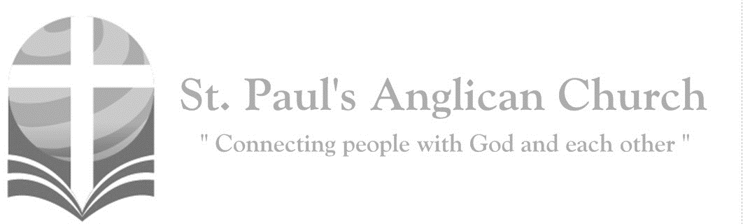

Sunday, October 20, 2019: 19th Sunday After Pentecost

*Creative Engagement Service*

*The word of God is living and active; it sifts the thoughts and intentions of the heart. (Hebrews 4:12)*

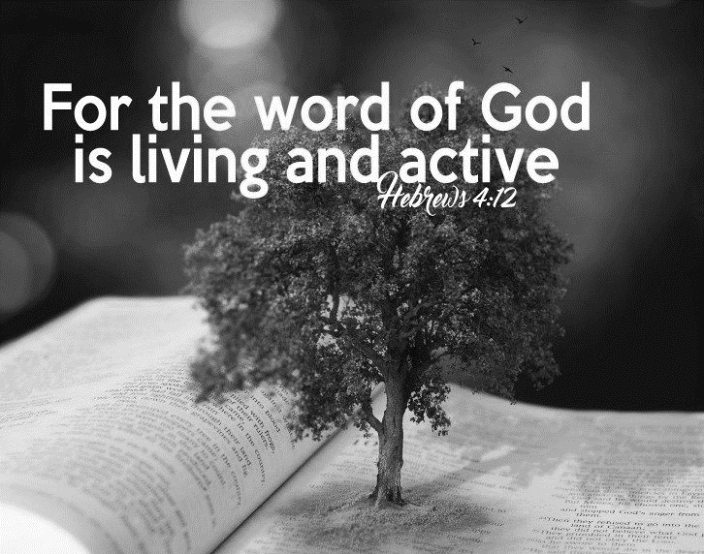

SUNDAYS AT ST. PAUL’S

**REGULAR SERVICES**

* Weekly services held Sundays at 10:00AM
* Interface services - Art based services throughout the year
* Sermons available on our website

**SUNDAY PRAYER**

* Prayer for the service at 9:30AM in the Luke Room
* Individual Prayer in the Chapel during the Sunday service

**SERVING AT ST. PAUL’S**

* Join a Ministry Team (Sunday service team, music team, children’s ministry, Altar guild, or many others)
* Regular or One-Time Giving (cash, cheque, automatic debit, and credit options available)

**LARGE PRINT MATERIALS** Large print Bibles and   
 Books of Alternative   
 Services (BAS) are availableat each Sanctuary door.

Page numbers will not be the same as those listed in the bulletin.

**VISITING TODAY?**

We want to get to know   
 you! Please join us for

in the Hall for coffee and

fellowship following the service. The greeters are also available to help if you have any questions.

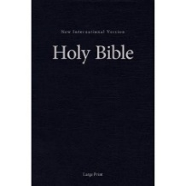



**Assisted listening**

**is available. Please**

**ask a greeter**

**for assistance.**



CONNECT

**St. Paul’s CHILDREN’S MINISTRY**

**KIDS** Pre-School-Grade 2 in the hall / Grade 3-5 in the Matthew Room

Sunday School teaching is weekly during the 10:00AM service.

**St. Paul’s YOUTH MINISTRY**

**YOUTH** Youth Grades 6-12 meet weekly during the 10:00AM service.

Youth also meetbi-weekly for fun events and devotionals.

**St. Paul’s ADULT MINISTRY**

**ADULTS** St. Paul’s has a number of small groups where you can connect with others through Christ. If you are interested in joining a small   
group or starting a small group of your own, please speak with Pat Stretch.

**Games Night – Friday, Nov. 8**

Join us every 2nd Friday of the month for board games from September-June in the Hall!! Come learn a new game, bring your favourite game to teach others, or play a classic with new friends. We sometimes even have goodies to snack on!

**Chair Cleaning in the Hall –**

**Thursday, Oct. 24, 1:00-4:00PM**  
The new blue chairs in the Hall need a good scrubbing. RJ has cleaned about 1/3rd of them and will be at St. Paul’s on October 22 to clean as many more as he can. Would you like to help? Please let RJ know and come by on Thursday!

**Kid’s Play Space in Hall**  
For parents/guardians of children: please help your children clean up if they play in the space after service. Thank you!

**Being Called – Sunday Oct. 27**  
Please join us next week at 8:45-9:45 in the John Room for a discussion led by Laurier Byer on “Being Called.”

**Advent Study**

Rev. Myron will be leading a study during Advent Sunday morning before service exploring the Steven Croft book, *Jesus’ People: What the Church Should Do Next.* If you have an interest in participating, please let us know ASAP. Books have already been ordered but we ordered a few extra. The cost to parishioners will be $10.00 for the book with St. Paul’s picking up any additional cost in excess of the $10.00. If you would like to participate but the purchase of the book is an obstacle, please speak to Myron or RJ.

**Retreat Registration Deadline –**

**Next Week - October 27**

As mentioned above, the deadline to register for the retreat is next Sunday!!

**“Wednesday Before Sunday” Lectionary Study Group**   
All are welcome to attend the new Wednesday evening group (meeting from 7:00-9:00PM in the Luke Room) at St. Paul’s. This group reads through and discusses the lectionary readings for the coming Sunday. A link to the lectionary can be found on our website.

**St. Paul’s Church-Wide Retreat**

**November 15-17 - Camp Nakamun**

The St. Paul’s retreat will be held at Camp Nakamun on November 15-17, 2019. This event is for everyone (singles, couples, families, friends) and will feature a wagon ride, board games, swimming, and whatever else you want to do! If you would like to register, please fill out a registration form (found at each door). Registrations and fees are due by October 27 at the latest. If you would like to attend the retreat but finances do not allow, please speak with Rev. Myron or any member of Vestry.



@StEdmonton

facebook.com/stpachurchedmonton

**St. Paul’s Vestry:**

Peter Jackson, *Rector’s Warden*

Pat Stretch, *People’s Warden*

David Heritage, *Treasurer*

Margot Byer, *Vestry Member*

John Green, *Vestry Member*

Deanna Kalles, *Vestry Member*

David Parker, *Vestry Member*

Carol Rudat, *Vestry Member*

**St. Paul’s Staff:**

*Rector:*

The Reverend Myron Bradley Penner  
*Office Administrator:*

RJ Chambers

*Youth Leader:* Victoria Eeles

**For prayer requests** **email**:

office@stpauls-anglican.ca

**For urgent prayer requests call**

the church office: (780) 455-0771

**For pastoral emergencies call:**

(587) 334-2130

**Office Hours:**

Monday-Thursday: 9:00AM-12:00PM

Closed: Fri/Sat/Sun and Stat Holidays

**St. Paul’s Anglican Church**

10127 145 Street, Edmonton T5N 2X6

Phone: (780) 455-0771; Email: office@stpauls-anglican.ca

Website: www.stpauls-anglican.ca

**This Week’s Readings:**

Jeremiah 31:27-34

2 Timothy 3:14-4:5

Luke 18:1-8

(all readings are on screen)

**This Week’s Ministry Teams:**

Music/Sound: Jodi P. with the Youth/RJ

Service Team: Green and Friends Team

Prayers: Barb M.; Vestry: David H.

Chapel Prayer: Kjeryn A. and Barb M.

Kid’s Ministry: Children in the Service

**St. Paul’s Cycle of Prayer:**

Myron, Jodi, Abigail, and Bella Penner;

Chuck and Kjeryn Allard;   
Yohana Rihana

**Anglican Cycle of Prayer:**

Indigenous Spiritual Ministry of Mishamikoweesh; the Rt. Rev. Lydia Mamakwa, Bishop; the Rt. Rev. Isaiah Larry Beardy, Suffragan Bishop for the Northern Manitoba Area Mission; the Rev. Morris Fiddler, Suffragan Bishop-elect for Northern Ontario. St. Matthew, St. Albert: Lee Bezanson (s. Bernadine), Rector. Buyé Diocese, Giteranyi Parish: Casmir Ndereyimana, Rector. Montana First Nation.

**Next Week’s Ministry Teams**

Music/Sound: Andrew’s Team/Jennifer S.

Service Team: Parker Team

Prayers: Kjeryn A.; Vestry: Pat S.

Chapel Prayer: Dudley B. and Pat H-B.

Kid’s Ministry: Gay G. and Ryan Y.