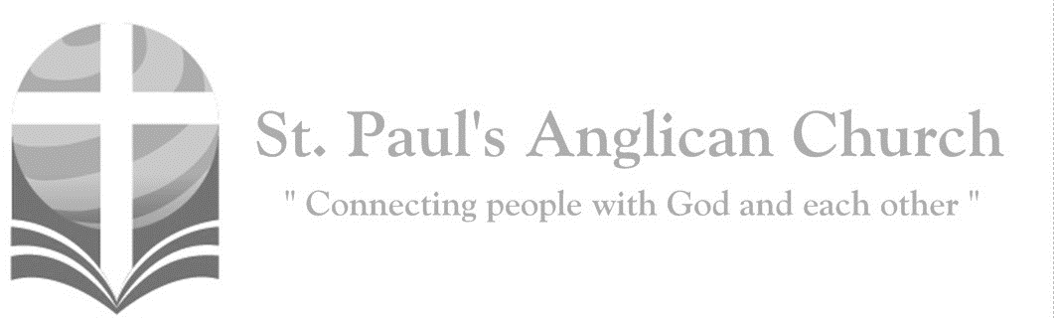

Sunday, September 29, 2019: 16th Sunday After Pentecost

*You know the grace of our Lord Jesus Christ, that though he was rich, yet for your sake became poor, so that by his poverty you might become rich. (2 Corinthians 8:9)*

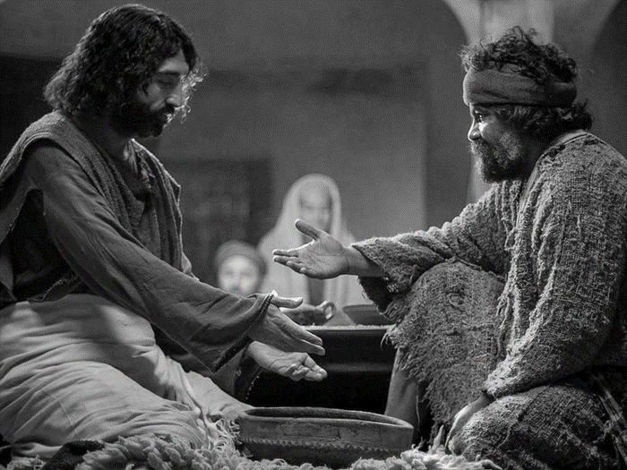

SUNDAYS AT ST. PAUL’S

**REGULAR SERVICES**

* Weekly services held Sundays at 10:00AM
* Interface services - Art based services throughout the year
* Sermons available on our website

**SUNDAY PRAYER**

* Prayer for the service at 9:30AM in the Luke Room
* Individual Prayer in the Chapel during the Sunday service

**SERVING AT ST. PAUL’S**

* Join a Ministry Team (Sunday service team, music team, children’s ministry, Altar guild, or many others)
* Regular or One-Time Giving (cash, cheque, automatic debit, and credit options available)

**LARGE PRINT MATERIALS** Large print Bibles and   
 Books of Alternative   
 Services (BAS) are availableat each Sanctuary door.

Page numbers will not be the same as those listed in the bulletin.

**VISITING TODAY?**

We want to get to know   
 you! Please join us for

in the Hall for coffee and

fellowship following the service. The greeters are also available to help if you have any questions.

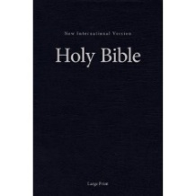



**Assisted listening**

**is available. Please**

**ask a greeter**

**for assistance.**



CONNECT

**St. Paul’s CHILDREN’S MINISTRY**

**KIDS** Pre-School-Grade 2 in the hall / Grade 3-5 in the Matthew Room

Sunday School teaching is weekly during the 10:00AM service.

**St. Paul’s YOUTH MINISTRY**

**YOUTH** Youth Grades 6-12 meet weekly during the 10:00AM service.

Youth also meetbi-weekly for fun events and devotionals.

**St. Paul’s ADULT MINISTRY**

**ADULTS** St. Paul’s has a number of small groups where you can connect with others through Christ. If you are interested in joining a small   
group or starting a small group of your own, please speak with Pat Stretch.

**Opening Song: *Sing to the Lord All the Earth***

Sing to the Lord all the Earth

His salvation proclaim day to day

His wonderful deeds and his glory

Are made known among all the earth

For great is he in strength and majesty

Rejoice, rejoice for the Lord he reigns

(*Sing 3 times*)

**The Gathering of the Community**

Celebrant: *(BAS pg. 185)* The grace of our Lord Jesus Christ, and the love of God, and the fellowship of the Holy Spirit, be with you all.

**People: And also with you.**

Celebrant:Almighty God,

**All:to you all hearts are open, all desires known, and from you no secrets are hidden. Cleanse the thoughts of our hearts by the inspiration of your Holy Spirit that we may perfectly love you, and worthily magnify your holy name; through Christ our Lord. Amen.**

Celebrant: *(pg. 383)* Grant, O merciful God, that your Church, being gathered by your Holy Spirit into one, may show forth your power among the peoples, to the glory of your name; through Jesus Christ our Lord, who lives and reigns with you and the Holy Spirit, one God, now and for ever.

**People:** **Amen**.

**Children Dismissal**

**Youth Video Presentation**

**The Reading of Scripture**

First Reading: Jeremiah 32:1-3a, 6-15 (pg. 561 in the red pew Bible)

Reader: The Word of the Lord.

**People:** **Thanks be to God.**

Psalm: Psalm 91:1-6, 14-16 (pg. 828 in the BAS)

Second Reading: 1 Timothy 6:6-19 (pg. 841 in the red pew Bible)

Reader: The Word of the Lord.

**People:** **Thanks be to God.**

**Worship Through Song**

***O How He Loves You and Me***

O how he loves you and me

O how he loves you and me

He gave his life

What more could he give?

O how he loves you

O how he loves me

O how he loves you and me

Jesus to Calvary did go  
His love for sinners to show  
What He did there  
Brought hope from despair  
O how He loves you  
O how He loves me  
O how He loves you and me

***Open Our Eyes***

Open our eyes Lord  
We want to see Jesus  
To reach out and touch Him  
And say that we love Him  
Open our ears Lord  
And help us to listen  
Open our eyes Lord  
We want to see Jesus

Open our hearts Lord  
That we might receive You  
Open our spirits  
And teach us to worship  
Open our lips Lord  
And teach us to praise You  
Open our eyes Lord  
We want to see Jesus

**Listening Time**

**The Gospel Reading**

Celebrant: The Lord be with you.

**People: And also with you.**

Celebrant: The Holy Gospel of our Lord Jesus Christ according to St. Luke.

**People: Glory to you, Lord Jesus Christ.**

Gospel Reading: Luke 16:19-31 (pg. 741 in the red pew Bible)

Celebrant: The Gospel of Christ.

**People: Praise to you, Lord Jesus Christ.**

**Sermon Notes:** Sermon by the Reverend Dr. Myron Penner

________________________________________________________________________________________________________________________________________________________________________________________________________________________________________________________________________________________________________________________________________________________________________________________________________________________________________________________________________________________________________________________

________________________________________________________________________________________________________________________________________________________________________________________________________________________

________________________________________________________________________________________________________________________________________________________________________________________________________________________________________________________________________________________________________________________________________________________________________________________________________________________________________________________________________________________________________________________________________________________________________________________________________________________________________________________________________________________________________________________________________________

**Affirmation of Faith – The Apostle’s Creed**

Celebrant: *(pg. 189)* Let us confess the faith of our baptism, as we say,

**All: I believe in God, the Father almighty, Creator of heaven and earth. I believe in Jesus Christ, his only Son, our Lord. He was conceived by the power of the Holy Spirit and born of the Virgin Mary. He suffered under Pontius Pilate, was crucified, died and was buried. He descended to the dead. On the third day, he rose again. He ascended into heaven and is seated at the right hand of the Father. He will come again to judge the living and the dead. I believe in the Holy Spirit, the holy catholic Church, the communion of saints, the forgiveness of sins, the resurrection of the body, and the life everlasting. Amen.**

**Prayers of the People**

**Confession of Sin**

Celebrant: *(pg. 191)* Dear friends in Christ, God is steadfast in love and infinite in mercy; he welcomes sinners and invites them to his table. Let us confess our sins, confident in God’s forgiveness.

*Silent Confession*

Celebrant:Most merciful God,

**All: we confess that we have sinned against you in thought, word, and deed, by what we have done and by what we have left undone. We have not loved you with our whole heart; we have not loved our neighbours as ourselves. We are truly sorry and we humbly repent. For the sake of your Son Jesus Christ, have mercy on us and forgive us, that we may delight in your will, and walk in your ways, to the glory of your name. Amen.**

Celebrant: Almighty God have mercy upon you, pardon and deliver you from all your sins, confirm and strengthen you in all goodness and keep you in eternal life through Jesus Christ our Lord.

**People:Amen.**

**The Peace**

Celebrant: The peace of the Lord be always with you.

**People: And also with you.**

**Offertory Song: *He’s Got the Whole World in His Hands***

He's got the whole world in His hands  
He's got the whole world in His hands  
He's got the whole world in His hands  
He's got the whole world in His hands

He's got you and me brother

In His hands  
He's got you and me brother

In His hands  
He's got you and me brother

In His hands  
He's got the whole world in His hands

He's got you and me sister in His hands  
He's got you and me sister in His hands  
He's got you and me sister in His hands  
He's got the whole world in His hands

He's got ev'rybody here in His hands  
He's got ev'rybody here in His hands  
He's got ev'rybody here in His hands  
He's got the whole world in His hands

**Prayer Over the Gifts**

Celebrant: *(pg. 383)* Eternal God,

**All: in Jesus Christ we behold your glory. Receive the offering of your people gathered before you, and open our hearts and mouths to praise your great salvation, the same Jesus Christ our Lord. Amen.**

Celebrant: *(pg. 201)* The Lord be with you.

**People: And also with you.**

Celebrant: Lift up your hearts.

**People: We lift them to the Lord.**

Celebrant: Let us give thanks to the Lord our God.

**People: It is right to give our thanks and praise.**

Celebrant: It is right to give you thanks and praise, O Lord, our God, sustainer of the universe, you are worthy of glory and praise.

**People: Glory to you for ever and ever.**

Celebrant: At your command all things came to be: the vast expanse of interstellar space, galaxies, suns, the planets in their courses, and this fragile earth, our island home; by your will they were created and have their being.

**People: Glory to you for ever and ever.**

Celebrant: From the primal elements you brought forth the human race, and blessed us with memory, reason, and skill; you made us the stewards of creation.

**People: Glory to you for ever and ever.**

Celebrant: But we turn against you, and betray your trust; and we turn against one another. Again and again you call us to return. Through the prophets and sages you reveal your righteous law. In the fullness of time you sent your Son, born of a woman, to be our Saviour. He was wounded for our transgressions, and bruised for our iniquities. By his death he opened to us the way of freedom and peace.

**People: Glory to you for ever and ever.**

Celebrant: *(pg. 202)* Therefore we praise you, joining with the heavenly chorus, with prophets, apostles, and martyrs, and with those in every generation who have looked to you in hope, to proclaim with them your glory, in their unending hymn:

**All:** ***(Sung)*** **Holy, holy, holy Lord, God of power and might, heaven and earth of Your glory are full. Hosanna, hosanna, hosanna in the highest. Blessed is he who comes in the name of the Lord. (*continued next page*)  
Blessed is he who comes in the name of the Lord.   
Holy, holy, holy Lord, God of power and might, heaven and earth of Your glory are full. Hosanna, hosanna, hosanna in the highest.**

Celebrant: *(pg. 202)* Blessed are you, Lord our God……. “Whenever you drink it, do this for the remembrance of me.”

**All: Glory to you for ever and ever.**

Celebrant: *(pg. 203)* Gracious God, we recall the death of your Son……that we who eat and drink at this holy table may share in the divine life of Christ our Lord.

**All: Glory to you for ever and ever.**

Celebrant: Pour out your Spirit……through Christ, with Christ, and in Christ, all honour and glory are yours, creator of all.

**All: Glory to you for ever and ever.**

Celebrant: *(pg. 211)* As our Saviour taught us, let us pray,

**All: *(Sung)* Our Father which art in heaven, hallowed be Thy name. Thy kingdom come, thy will be done on earth as it is in heaven. Give us this day our daily bread and forgive us our debts as we forgive our debtors and lead us not into temptation but deliver us from evil.   
For Thine is the kingdom and the power and the glory forever. Amen. For Thine is the kingdom and the power and the glory forever. Amen.**

Celebrant: *(pg. 212)* Creator of all, you gave us golden fields of wheat, whose many grains we have gathered and made into this one bread.

**All: So may your Church be gathered from the ends of the earth into your kingdom.**

Celebrant: *(pg. 213)* The gifts of God for the People of God.

**People: Thanks be to God.**

**The Communion**

*You are welcome to receive communion or come forward for a blessing. If you prefer to receive a blessing, please fold your arms over your chest. There is de-alcoholized wine available in the centre and gluten-free wafers available upon request.*

**Lamb of God**

*(Sung)* O, Lamb of God, you take away the sin of the world: have mercy on us.

O, Lamb of God, you take away the sin of the world: have mercy on us.

O, Lamb of God, you take away the sin of the world: grant us peace.

**Communion Music**

***Behold the Lamb***

Behold the Lamb

Who bears our sins away  
Slain for us and we remember  
The promise made

That all who come in faith  
Find forgiveness at the cross  
So we share in this Bread of Life  
And we drink of His sacrifice  
As a sign of our bonds of peace  
Around the table of the King

The body of our Saviour Jesus Christ  
Torn for you, eat and remember  
The wounds that heal

The death that brings us life  
Paid the price to make us one  
So we share in this Bread of Life  
And we drink of His sacrifice  
As a sign of our bonds of love  
Around the table of the King

The blood that cleanses

Every stain of sin  
Shed for you, drink and remember  
He drained death's cup

That all may enter in  
To receive the life of God  
So we share in this Bread of Life  
And we drink of His sacrifice  
As a sign of our bonds of grace  
Around the table of the King

And so with thankfulness

And faith we rise  
To respond and to remember  
Our call to follow in the steps of Christ  
As His body here on earth  
As we share in His suffering  
We proclaim Christ will come again  
And we'll join in the feast of heaven  
Around the table of the King

***Wide, Wide as the Ocean***

Wide, wide as the ocean  
High as the heaven above  
Deep, deep as the deepest sea  
Is my Saviour's love

I though so unworthy  
Still am a child of His care  
For His Word teaches me that His love  
Reaches me everywhere

**Prayer After Communion**

Celebrant: *(pg. 383)* Father in heaven,

**All: strengthen the unity of your Church, so that we who have been fed with holy things may fulfil your will in the world. We ask this in the name of Jesus Christ our Lord.** **Amen.**

Celebrant: *(pg. 214)* Glory to God,

**All:whose power, working in us, can do infinitely more than we can ask or imagine. Glory to God from generation to generation, in the Church and in Christ Jesus, for ever and ever. Amen.**

**Blessing**

**Congregational Announcements *(Carol R.)***

**Closing Song: *Amazing Grace***

Amazing grace, how sweet the sound  
That saved a wretch like me  
I once was lost but now am found  
Was blind but now I see

'Twas grace that taught my heart to fear  
And grace my fears relieved  
How precious did that grace appear  
The hour I first believed

Through many dangers toils and snares  
I have already come  
'Tis grace has brought me safe thus far  
And grace will lead me home

The Lord has promised good to me

His word my hope secures

He will my shield and portion be

As long as life endures

Yes, when this flesh and heart shall fail

And mortal life shall cease

I shall possess within the veil

A life of joy and peace

When we've been there

Ten thousand years  
Bright shining as the sun  
We've no less days to sing God's praise  
Than when we've first begun

**The Dismissal**Celebrant: *(pg. 215)* Go forth into the world, rejoicing in the power of the Spirit.

**All: Thanks be to God. Amen.**

*Please join us in the Hall for coffee following the service.*

**$5 – 5 Ways – For Buyé -**

**Supporting a Medical Initiative**

Medical cards (covering 80% of medical expenses) for seniors in Buyé cost $5.00 but that is out of reach for many. If we each contribute $5.00 during coffee time each Sunday this month, we can make a difference for many in the Buyé Diocese. There will be a basket in the Hall for your donations. Please join us in supporting this Diocesan initiative!

**St. Paul’s Church-Wide Retreat**

**November 15-17 - Camp Nakamun**

The St. Paul’s retreat will be held at Camp Nakamun on November 15-17, 2019. This event is for everyone (singles, couples, families, friends) and will feature a wagon ride, board games, swimming, and whatever else you want to do! If you would like to register, please fill out a registration form (found at each door). Registrations and fees are due by October 27 at the latest. If you would like to attend the retreat but finances do not allow, please speak with Rev. Myron or any member of Vestry.

**Ministry Sign-Up**

Did you miss the ministry fair last week? If so, it’s not too late to sign up to help with the ministry of your choice!! The sign up sheets will be available in the Hall. If you are currently involved in a specific ministry area, you do not need to re-sign up for it.

**Community Square Dance and Potluck – Saturday, October 5**   
Please join us, in partnership with Fusion Canada, for a Square Dance and Potluck in the Hall! Potluck begins at 5:30PM with the Square Dance following at 7:00PM. If you want to help, contact Terry Berard.

**Thank You!!!**   
Thank you to all who were able to attend and help out with Myron’s Induction service on Tuesday. The event went very well and was only possible due to your generous help and support!

**Community Solar Workshop at St. Paul’s on October 19 from 1:00-5:00PM in the Hall**

St. Paul’s is hosting a Community Solar Workshop on October 19th from 1:00 to 5:00PM in the Hall. If you have an interest in learning more about solar energy for yourself or your business/community league, please plan to attend. Registration is required - sign up at Eventbrite Edmonton - Community Solar Projects.

**Breaking Free – Video Series for Women- Starting Sep. 30**   
All women are invited to join the group starting on Monday, Sep. 30. They will meet every other week in the Luke Room and be going through *Breaking Free* by Beth Moore. If you would like to attend, please contact Connie P. or the office.



@StEdmonton

facebook.com/stpachurchedmonton

**St. Paul’s Vestry:**

Peter Jackson, *Rector’s Warden*

Pat Stretch, *People’s Warden*

David Heritage, *Treasurer*

Margot Byer, *Vestry Member*

John Green, *Vestry Member*

Deanna Kalles, *Vestry Member*

David Parker, *Vestry Member*

Carol Rudat, *Vestry Member*

**St. Paul’s Staff:**

*Rector:*

The Reverend Myron Bradley Penner  
*Office Administrator:*

RJ Chambers

*Youth Leader:* Victoria Eeles

**For prayer requests** **email**:

office@stpauls-anglican.ca

**For urgent prayer requests call**

the church office: (780) 455-0771

**For pastoral emergencies call:**

(587) 334-2130

**Office Hours:**

Monday-Thursday: 9:00AM-12:00PM

Closed: Fri/Sat/Sun and Stat Holidays

**St. Paul’s Anglican Church**

10127 145 Street, Edmonton T5N 2X6

Phone: (780) 455-0771; Email: office@stpauls-anglican.ca

Website: www.stpauls-anglican.ca

**This Week’s Readings:**

Jeremiah 32:1-3a, 6-15 (pg. 561)

Psalm 91:1-6, 14-16 (BAS, pg. 828)

1 Timothy 6:6-19 (pg. 841)

Luke 16:19-31 (pg. 741)

**This Week’s Ministry Teams:**

Music/Sound: Carol’s Team/RJ

Service Team: Jackson Team

Prayers: Gay G.; Vestry: Carol R.

Chapel Prayer: Dudley B. and Pat H-B.

Kid’s Ministry: Renée J. and Carol R.

**St. Paul’s Cycle of Prayer:**

Ryan and Michelle Young and Carson, Jordan, and Weston;

Rick and Barb Mickelson

**Anglican Cycle of Prayer:**

Diocese of Fredericton; the Rt. Rev. David Edwards, Bishop. St. John the Divine, Onoway: Cheryl Boulet (s. Robert), Rector. Buyé Synod Office: the Rt. Rev. Sixbert Macumi, Bishop; Audace Kwizera, Diocesan Secretary; Leonidas Nizigiyimana, Treasurer, Archdeacon of Buyé; Damascene Bagirubwira, Development Officer; Nehemie Mbonyimpano, Diocesan Typist. Frog Lake First Nation.

**Next Week’s Ministry Teams**

Music/Sound: Pat’s Team/Chandra S.

Service Team: Heritage Team

Prayers: David H.; Vestry: Deanna K.

Chapel Prayer: Laurier B. and Pat S.

Kid’s Ministry: Carol G. and Carol R.