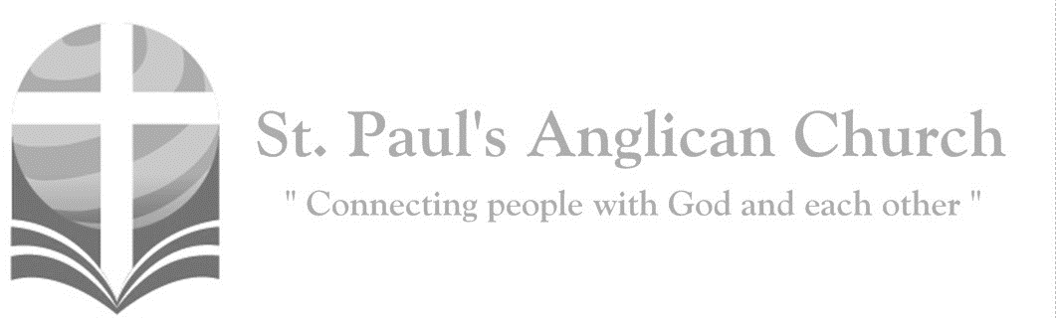

Sunday, September 1, 2019: 12th Sunday After Pentecost

*Take my yoke upon you, and learn from me;*

*for I am gentle and lowly in heart. (Matthew 11:29)*

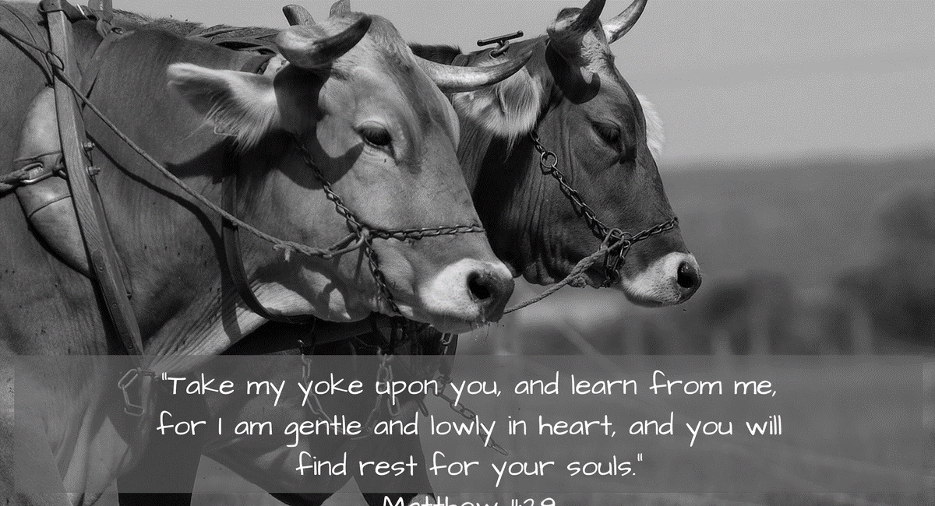

SUNDAYS AT ST. PAUL’S

**REGULAR SERVICES**

* Weekly services held Sundays at 10:00AM
* Interface services - Art based services throughout the year
* Sermons available on our website

**SUNDAY PRAYER**

* Prayer for the service at 9:30AM in the Luke Room
* Individual Prayer in the Chapel during the Sunday service

**SERVING AT ST. PAUL’S**

* Join a Ministry Team (Sunday service team, music team, children’s ministry, Altar guild, or many others)
* Regular or One-Time Giving (cash, cheque, automatic debit, and credit options available)

**LARGE PRINT MATERIALS** Large print Bibles and   
 Books of Alternative   
 Services (BAS) are availableat each Sanctuary door.

Page numbers will not be the same as those listed in the bulletin.

**VISITING TODAY?**

We want to get to know   
 you! Please join us for

in the Hall for coffee and

fellowship following the service. The greeters are also available to help if you have any questions.

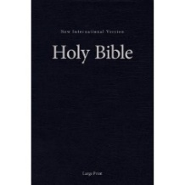



**Assisted listening**

**is available. Please**

**ask a greeter**

**for assistance.**



CONNECT

**St. Paul’s CHILDREN’S MINISTRY**

**KIDS** Chickadees Ages 2-4 / Peacocks Grade K-2 / Falcons Grade 3-5

Sunday School teaching is weekly during the 10:00AM service.

**St. Paul’s YOUTH MINISTRY – September through June**

**YOUTH** Youth Grades 6-12 meet weekly during the 10:00AM service.

Youth also meetbi-weekly for fun events and devotionals.

**St. Paul’s ADULT MINISTRY**

**ADULTS** St. Paul’s has a number of small groups where you can connect with others through Christ. If you are interested in joining a small   
group or starting a small group of your own, please speak with Pat Stretch.

**Opening Song: *O Worship the King***

O worship the King, all glorious above  
And gratefully sing

His power and His love  
Our Shield and Defender

The Ancient of Days  
Pavilioned in splendor

And girded with praise

O tell of His might, O sing of His grace  
Whose robe is the light

Whose canopy space  
His chariots of wrath

The deep thunderclouds form  
And dark is His path

On the wings of the storm

Frail children of dust and feeble as frail  
In Thee do we trust

Nor find Thee to fail  
Thy mercies how tender

How firm to the end  
Our Maker, Defender

Redeemer and Friend

O measureless might, ineffable love  
While angels delight

To worship Thee above  
The humbler creation

Though feeble their lays  
With true adoration

Shall all sing Thy praise

**The Gathering of the Community**

Celebrant: *(BAS pg. 185)* The grace of our Lord Jesus Christ, and the love of God, and the fellowship of the Holy Spirit, be with you all.

**People: And also with you.**

Celebrant:Almighty God,

**All:to you all hearts are open, all desires known, and from you no secrets are hidden. Cleanse the thoughts of our hearts by the inspiration of your Holy Spirit that we may perfectly love you, and worthily magnify your holy name; through Christ our Lord. Amen.**

Celebrant: *(pg. 377)* Author and Giver of all good things, graft in our hearts the love of your name, increase in us true religion, nourish us in all goodness, and of your great mercy keep us in the same; through Jesus Christ our Lord, who lives and reigns with you and the Holy Spirit, one God, now and for ever.

**People:** **Amen**.

**Children Dismissal**

**The Reading of Scripture**

First Reading: Jeremiah 2:4-13 (pg. 534 in the red pew Bible)

Reader: The Word of the Lord.

**People:** **Thanks be to God.**

Psalm: Psalm 81:1, 10-16 (pg. 814 in the BAS)

Second Reading: Hebrews 13:1-8, 15-16 (pg. 853 in the red pew Bible)

Reader: The Word of the Lord.

**People:** **Thanks be to God.**

**Worship Through Song**

***Heaven is in My Heart***

(*Chorus*) O, heaven is in my heart  
O, heaven is in my heart

The kingdom of our God is here  
(Heaven is in my heart)  
The presence of His majesty  
(Heaven is in my heart)  
And in His presence joy abounds  
(Heaven is in my heart)  
The light of holiness surrounds  
(Heaven is in my heart) (*To Chorus*)

His precious life on me He spent  
To give me life without an end  
In Christ is all my confidence  
The hope of my inheritance  
(*To Chorus*)

We are a temple for His throne  
And Christ is the foundation stone  
He will return to take us home  
The Spirit and the Bride say come  
(*To Chorus*)

***Lord Most High***

From the ends of the earth (ECHO)  
From the depths of the sea (ECHO)  
From the heights of the heavens (ECHO)  
Your name be praised  
From the hearts of the weak (ECHO)  
From the shouts of the strong (ECHO)  
From the lips of all people (ECHO)  
This song we raise Lord

Throughout the endless ages  
You will be crowned with praises  
Lord Most High  
Exalted in every nation  
Sovereign of all creation  
Lord Most High, be magnified

**Listening Time**

**The Gospel Reading**

Celebrant: The Lord be with you.

**People: And also with you.**

Celebrant: The Holy Gospel of our Lord Jesus Christ according to St. Luke.

**People: Glory to you, Lord Jesus Christ.**

Gospel Reading: Luke 14:1, 7-14 (pg. 739 in the red pew Bible)

Celebrant: The Gospel of Christ.

**People: Praise to you, Lord Jesus Christ.**

**Sermon Notes:** Sermon by Reverend Dr. Myron Penner

________________________________________________________________________________________________________________________________________________________________________________________________________________________________________________________________________________________________________________________________________________________________________________________________________________________________________________________________________________________________________________________

________________________________________________________________________________________________________________________________________________

________________________________________________________________________________________________________________________________________________________________________________________________________________________________________________________________________________________________________________________________________________________________________________________________________________________________________________

**Affirmation of Faith – John 14:1-14**

**All: We believe in God, creator of all that is and all that is to come. In God’s house are many rooms, and God prepares a place for us, so that where God is, we may be also. We believe in God; we believe also in Jesus Christ, who is our way, our truth and our life. Through him we have seen God, who lived and worked in him. We believe in the Holy Spirit, who lives and works in us; so that we may do the works that Jesus does, and even greater works; so that the Father may be glorified in the Son. Alleluia.**

**Prayers of the People**

**Confession of Sin**

Celebrant: *(pg. 191)* Dear friends in Christ, God is steadfast in love and infinite in mercy; he welcomes sinners and invites them to his table. Let us confess our sins, confident in God’s forgiveness.

*Silent Confession*

Celebrant:Father, Son, and Holy Spirit,

**All: you are everything we need all of the time. But we confess to you that we have been tempted to be self reliant and self sufficient. We have believed we need to provide our own daily bread. We have attempted to generate our own peace. In our weakness, we have tried to rely on our own strength. We have tried to light the dark with our own torch. We have trusted our own counsel. Father, out of your great love for us, and because you have given Jesus to die for us, grant that, through his cross, our sins might be taken away, remembered no more and not held against us. Cleanse us and empower us with your Spirit to be like Christ, to joyfully and willingly look to you for everything we need. Amen.**

Celebrant: Almighty God have mercy upon you, pardon and deliver you from all your sins, confirm and strengthen you in all goodness and keep you in eternal life through Jesus Christ our Lord.

**People:Amen.**

**The Peace**

Celebrant: The peace of the Lord be always with you.

**People: And also with you.**

**Offertory Song: *Shout to the Lord***

My Jesus, my Saviour  
Lord there is none like You  
All of my days I want to praise  
The wonders of Your mighty love  
My comfort, my shelter  
Tower of refuge and strength  
Let every breath, all that I am  
Never cease to worship You

Shout to the Lord

All the earth, let us sing

Power and majesty  
Praise to the King  
Mountains bow down

And the seas will roar  
At the sound of Your name  
I sing for joy at the work of Your hands  
Forever I'll love You, forever I'll stand  
Nothing compares to the promise  
I have in You

**Prayer Over the Gifts**

Celebrant: *(pg. 378)* Merciful God,

**All: receive all we offer you this day. Give us grace to love one another that your love may be made perfect in us. We ask this in the name of Jesus Christ our Lord. Amen.**

Celebrant: *(pg. 198)* The Lord be with you.

**People: And also with you.**

Celebrant: Lift up your hearts.

**People: We lift them to the Lord.**

Celebrant: Let us give thanks to the Lord our God.

**People: It is right to give our thanks and praise.**

Celebrant: *(pg. 218)* Blessed are you, gracious God, creator of heaven and earth; you are the source of light and life for all your creation, you made us in your own image, and call us to new life in Jesus Christ our Saviour. Therefore, we praise you, joining our voices to proclaim the glory of your name.

**All:** ***(Sung)*** **Holy, holy, holy Lord, God of power and might, heaven and earth of Your glory are full. Hosanna, hosanna, hosanna in the highest. Blessed is he who comes in the name of the Lord.   
Blessed is he who comes in the name of the Lord.   
Holy, holy, holy Lord, God of power and might, heaven and earth of Your glory are full. Hosanna, hosanna, hosanna in the highest.**

Celebrant: (pg. 198) We give thanks to you, Lord our God……. Therefore, Father, according to his command,

**All we remember his death, we proclaim his resurrection, we await his coming in glory;**

Celebrant: (pg. 199) and we offer our sacrifice of praise and thanksgiving……. by whom, and with whom, and in whom, in the unity of the Holy Spirit, all honour and glory are yours, almighty Father, now and for ever.

**All: Amen.**

Celebrant: *(pg. 211)* As our Saviour taught us, let us pray,

**All: *(Sung)* Our Father which art in heaven, hallowed be Thy name. Thy kingdom come, thy will be done on earth as it is in heaven. Give us this day our daily bread and forgive us our debts as we forgive our debtors and lead us not into temptation but deliver us from evil.   
For Thine is the kingdom and the power and the glory forever. Amen. For Thine is the kingdom and the power and the glory forever. Amen.**

Celebrant: *(pg. 212)* Creator of all, you gave us golden fields of wheat, whose many grains we have gathered and made into this one bread.

**All: So may your Church be gathered from the ends of the earth into your kingdom.**

Celebrant: *(pg. 213)* The gifts of God for the People of God.

**People: Thanks be to God.**

**The Communion**

*You are welcome to receive communion or come forward for a blessing. If you prefer to receive a blessing, please fold your arms over your chest. There is de-alcoholized wine available in the centre and gluten-free wafers available upon request.*

**O How He Loves You and Me**

O how He loves you and me. O how He loves you and me. He gave His life. What more could He give? O how He loves you. O how He loves me. O how He loves you and me.

Jesus to Calvary did go, His love for sinners to show. What He did there brought hope from despair. O how He loves you. O how He loves me. O how He loves you and me.

**Communion Music**

***Let There Be Love***

Let there be love shared among us  
Let there be love in our eyes  
May now Your love sweep this nation  
Cause us, O Lord, to arise

Give us a fresh understanding  
Of brotherly love that is real  
Let there be love shared  
Among us

Let there be love

***Make Me a Servant***

Make me a servant, humble and meek  
Lord let me lift up those who are weak  
And may the prayer

Of my heart always be

Make me a servant

Make me a servant  
Make me a servant today

**Prayer After Communion**

Celebrant: *(pg. 378)* Almighty God,

**All: you renew us at your table with the bread of life. May your holy food strengthen us in love and help us to serve you in each other. We ask this in the name of Jesus Christ our Lord.** **Amen.**

Celebrant: *(pg. 214)* Glory to God,

**All:whose power, working in us, can do infinitely more than we can ask or imagine. Glory to God from generation to generation, in the Church and in Christ Jesus, for ever and ever. Amen.**

**Blessing**

**Congregational Announcements *(Pat S.)***

**Closing Song: *May the Peoples Praise You***

You have called us out of darkest night  
Into Your glorious light  
That we may sing the wonders of  
The risen Christ

May our every breath retell the grace  
That broke into our strife  
With boundless love and deepest joy  
With endless life

(*Chorus*) May the peoples praise You  
Let the nations be glad  
All Your blessing comes  
That we may praise  
May praise the Name of Jesus

All the earth is Yours and all within  
Each harvest is Your own  
And from Your hand we give to You  
To make Christ known

May the seeds of mercy grow in us  
For those who have not heard  
May songs of praise build lives of grace  
To spread Your Word (*To Chorus*)

This our holy privilege to declare  
Your praises and Your name  
To every nation tribe and tongue  
Your church proclaims

(*continued on next page*)

(*Chorus*) May the peoples praise You  
Let the nations be glad  
All Your blessing comes  
That we may praise  
May praise the Name of Jesus

Holy, Holy is the Lord Almighty  
Worthy, worthy is the Lamb

Who was slain  
Holy, Holy is the Lord Almighty  
All creation praise Your glorious Name

(*To Chorus*)

**The Dismissal**Celebrant: *(pg. 215)* Go forth into the world, rejoicing in the power of the Spirit.

**All: Thanks be to God. Amen.**

*Please join us in the Hall for coffee following the service.*

**Square Dance – Sat., Oct. 5**   
Join us for Square Dance and Potluck!

**Induction – Tuesday, Sep. 24**   
Join us for Myron’s Induction Service on Tuesday, Sep. 24. Details will come soon.

**Room Wanted**

Johnson Rutsinda and his roommate are looking for a room to stay in for a few weeks or longer. Johnson is awaiting a work permit and is currently unable to work in Canada. While he cannot pay rent until working, he can pay for food and utilities. If you have a spare room available, please speak with Johnson.

**Games Night – Friday, Sep. 13**   
Join us every 2nd Friday of the month for board games in the Hall!! Come learn a new game, bring your favourite to teach others, or play a classic with new friends!

**Kick-Off Sunday and Potluck  
Sunday, September 8**

Please join us for our annual Fall Kick-Off. Sunday, September 8 marks the beginning of a new season of activities at St. Paul's as well as the restart of Children and Youth ministry after the summer break. Following the morning service, we will all join together for a potluck. Please bring something yummy to share!!

**The Ten Commandments and   
the Beatitudes in Real Life**

Please join us Sunday, September 15 at 8:45-9:45AM in the John Room for a group discussion about the Commandments and the Beatitudes led by David Lenzi. To prepare, attendees should read Exodus 20:2-17 and Matthew 5:3-10.

**Wholeness Through Christ**

Wholeness Through Christ (WTC) is a scripturally-based, Spirit-led ministry to

the whole person. WTC is offering a Prayer Ministry Course in Calgary October 16-20. If you register by Sep. 16, you save

$100.00! Please pick up a brochure at

the door for more information.

**St. Paul’s Small Group in Fall**

Please contact Pat Stretch ([stretchg@telus.net](mailto:stretchg@telus.net) or 780-453-3339) or the office if you are interested in joining or starting a new small group.

**St. Paul’s Church-Wide Retreat**

**November 15-17 - Camp Nakamun**

If you would like to register for the St. Paul’s retreat, please fill out a registration form (found at each door). If you would like to attend the retreat but finances do not allow, please speak with Rev. Myron or any member of Vestry.

**Welcome to Abigail Penner**

We are pleased to announce that Abigail Penner will be joining the ministry staff and working with children’s ministry two Sundays a month. Abigail will be starting in September. When you see her, please give her a big welcome!!



@StEdmonton

facebook.com/stpachurchedmonton

**St. Paul’s Vestry:**

Peter Jackson, *Rector’s Warden*

Pat Stretch, *People’s Warden*

David Heritage, *Treasurer*

Margot Byer, *Vestry Member*

John Green, *Vestry Member*

Deanna Kalles, *Vestry Member*

David Parker, *Vestry Member*

Carol Rudat, *Vestry Member*

**St. Paul’s Staff:**

*Rector:*

The Reverend Myron Bradley Penner  
*Office Administrator:*

RJ Chambers

*Youth Leader:* Victoria Eeles

**For prayer requests** **email**:

office@stpauls-anglican.ca

**For urgent prayer requests call**

the church office: (780) 455-0771

**For pastoral emergencies call:**

(587) 334-2130

**Office Hours:**

Monday-Thursday: 9:00AM-12:00PM

Closed: Fri/Sat/Sun and Stat Holidays

**St. Paul’s Anglican Church**

10127 145 Street, Edmonton T5N 2X6

Phone: (780) 455-0771; Email: office@stpauls-anglican.ca

Website: www.stpauls-anglican.ca

**This Week’s Readings:**

Jeremiah 2:4-13 (pg. 534)

Psalm 81:1, 10-16 (BAS, pg. 814)

Hebrews 13:1-8, 15-16 (pg. 853)

Luke 14:1, 7-14 (pg. 739)

**This Week’s Ministry Teams:**

Music/Sound: Carol’s Team/RJ C.

Service Team: B Team

Prayers: Barb M.; Vestry: Pat S.

Chapel Prayer: Dudley B. and Pat H-B.

Kid’s Ministry: None Today

**St. Paul’s Cycle of Prayer:**

Neil and Laura Rogers and Scott;

Gene and Kay Wannamaker;

Amanda Wannamaker

**Anglican Cycle of Prayer:**

Diocese of Calgary; the Most Rev. Gregory Kerr-Wilson, Archbishop (Metropolitan of the Ecclesiastical Province of Rupert’s Land). St. George, Fort Saskatchewan: Maude Parsons-Hörst (s. Ron Hörst), Interim Priest-in-Charge. The Diocese of Buyé Mothers’ Union: Clotilde Muhimpundu, MU President; Bibiane Nsengiyumva, Chaplain; Josephine Kezakimana and Clementine Ujeneza, Trainers. Alexis Nakota Sioux Nation.

**Next Week’s Ministry Teams**

Music/Sound: Pat’s Team/Chandra S.

Service Team: Parker Team

Prayers: Nancy W-S.; Vestry: Margot B.

Chapel Prayer: Laurier B. and Pat S.

Kid’s Ministry: Margot B. and Abigail P.