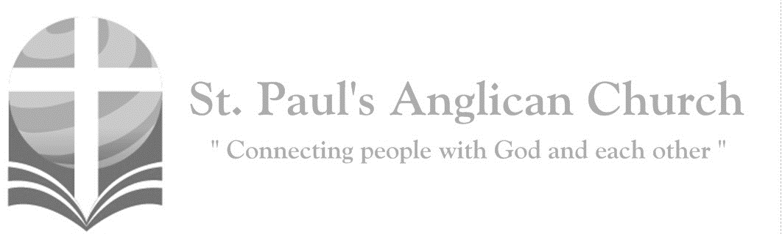

Sunday, August 11, 2019: 9th Sunday After Pentecost

*Watch and be ready, for you do not know on what day*

*your Lord is coming. (Matthew 24:42, 44)*

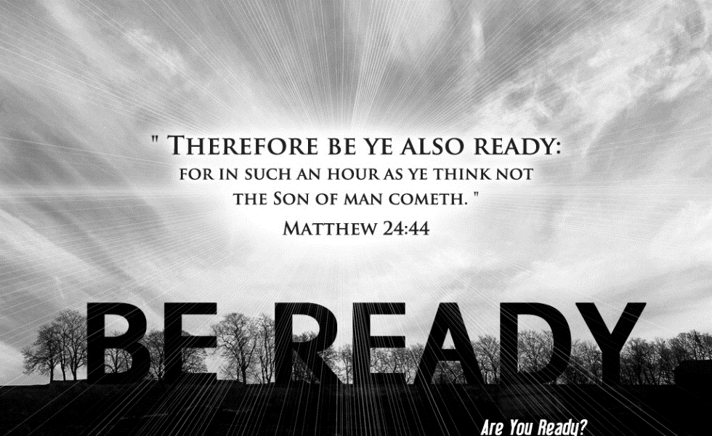

SUNDAYS AT ST. PAUL’S

**REGULAR SERVICES**

* Weekly services held Sundays at 10:00AM
* Interface services - Art based services throughout the year
* Sermons available on our website

**SUNDAY PRAYER**

* Prayer for the service at 9:30AM in the Luke Room
* Individual Prayer in the Chapel during the Sunday service

**SERVING AT ST. PAUL’S**

* Join a Ministry Team (Sunday service team, music team, children’s ministry, Altar guild, or many others)
* Regular or One-Time Giving (cash, cheque, automatic debit, and credit options available)

**LARGE PRINT MATERIALS** Large print Bibles and   
 Books of Alternative   
 Services (BAS) are availableat each Sanctuary door.

Page numbers will not be the same as those listed in the bulletin.

**VISITING TODAY?**

We want to get to know   
 you! Please join us for

in the Hall for coffee and

fellowship following the service. The greeters are also available to help if you have any questions.

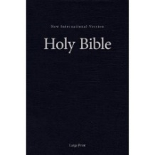



**Assisted listening**

**is available. Please**

**ask a greeter**

**for assistance.**



CONNECT

**St. Paul’s CHILDREN’S MINISTRY**

**KIDS** Chickadees Ages 2-4 / Peacocks Grade K-2 / Falcons Grade 3-5

Sunday School teaching is weekly during the 10:00AM service.

**St. Paul’s YOUTH MINISTRY – September through June**

**YOUTH** Youth Grades 6-12 meet weekly during the 10:00AM service.

Youth also meetbi-weekly for fun events and devotionals.

**St. Paul’s ADULT MINISTRY**

**ADULTS** St. Paul’s has a number of small groups where you can connect with others through Christ. If you are interested in joining a small   
group or starting a small group of your own, please speak with Pat Stretch.

**Opening Song: *Holy, Holy, Holy***

Holy, holy, holy  
Lord God Almighty  
Early in the morning  
Our song shall rise to Thee  
Holy, holy, holy  
Merciful and mighty  
God in three persons  
Blessed Trinity

Holy, holy, holy  
All the saints adore Thee  
Casting down their golden crowns  
Around the glassy sea  
Cherubim and seraphim  
Falling down before Thee  
Which wert and art  
And evermore shalt be

Holy, holy, holy  
Though the darkness hide Thee  
Though the eye of sinful man  
Thy glory may not see  
Only Thou art holy  
There is none beside Thee  
Perfect in power  
In love and purity

Holy, holy, holy  
Lord God Almighty  
All Thy works shall praise Thy name  
In earth and sky and sea  
Holy, holy, holy  
Merciful and mighty  
God in three persons  
Blessed Trinity

**The Gathering of the Community**

Celebrant: *(BAS pg. 185)* The grace of our Lord Jesus Christ, and the love of God, and the fellowship of the Holy Spirit, be with you all.

**People: And also with you.**

Celebrant:Almighty God,

**All:to you all hearts are open, all desires known, and from you no secrets are hidden. Cleanse the thoughts of our hearts by the inspiration of your Holy Spirit that we may perfectly love you, and worthily magnify your holy name; through Christ our Lord. Amen.**

Celebrant: *(pg. 373)* Almighty God, you sent your Holy Spirit to be the life and light of your Church. Open our hearts to the riches of your grace, that we may bring forth the fruit of the Spirit in love, joy, and peace; through Jesus Christ our Lord, who is alive and reigns with you and the Holy Spirit, one God, now and forever.

**People:** **Amen**.

**Children Dismissal**

**The Reading of Scripture**

First Reading: Isaiah 1:1, 10-20 (pg. 483 in the red pew Bible)

Reader: The Word of the Lord.

**People:** **Thanks be to God.**

Psalm Reading: Psalm 50:1-8, 22-23 (pg. 768 in the BAS)

Second Reading: Hebrews 11:1-3, 8-16 (pg. 851 in the red pew Bible)

Reader: The Word of the Lord.

**People:** **Thanks be to God.**

**Worship Through Song**

***Forever***

Give thanks to the Lord  
Our God and King  
His love endures forever  
For He is good, He is above all things  
His love endures forever  
Sing praise, sing praise

With a mighty hand  
And an outstretched arm  
His love endures forever  
For the life that's been reborn  
His love endures forever  
Sing praise, sing praise

Sing praise, sing praise

(*Chorus*) Forever God is faithful  
Forever God is strong  
Forever God is with us  
Forever, forever

From the rising to the setting sun  
His love endures forever  
And by the grace of God  
We will carry on  
His love endures forever  
Sing praise, sing praise

Sing praise, sing praise (*To Chorus*)

***Praise Adonai***

Who is like Him, the Lion and the Lamb  
Seated on the throne  
Mountains bow down

Every ocean roars to the Lord of Hosts

Praise Adonai from the rising of the sun  
'Til the end of every day  
Praise Adonai  
All the nations of the earth  
All the angels and the saints  
Sing praise

**Listening Time**

**The Gospel Reading**

Celebrant: The Lord be with you.

**People: And also with you.**

Celebrant: The Holy Gospel of our Lord Jesus Christ according to St. Luke.

**People: Glory to you, Lord Jesus Christ.**

Gospel Reading: Luke 12:32-40 (pg. 737 in the red pew Bible)

Celebrant: The Gospel of Christ.

**People: Praise to you, Lord Jesus Christ.**

**Sermon Notes:** Sermon by Rev. Nick Trussell

________________________________________________________________________________________________________________________________________________________________________________________________________________________________________________________________________________________________________________________________________________________________________________________________________________________________________________________________________________________________________________________

________________________________________________________________________________________________________________________________________________

________________________________________________________________________________________________________________________________________________________________________________________________________________________________________________________________________________________________________________________________________________________________________________________________________________________________________________________________________________________________________________________

**Affirmation of Faith – The Apostle’s Creed**

**All: I believe in God, the Father almighty, Creator of heaven and earth. I believe in Jesus Christ, his only Son, our Lord. He was conceived by the power of the Holy Spirit and born of the Virgin Mary. He suffered under Pontius Pilate, was crucified, died and was buried. He descended to the dead. On the third day, he rose again. He ascended into heaven and is seated at the right hand of the Father. He will come again to judge the living and the dead. I believe in the Holy Spirit, the holy catholic Church, the communion of saints, the forgiveness of sins, the resurrection of the body, and the life everlasting. Amen.**

**Prayers of the People**

**Confession of Sin**

Celebrant: *(pg. 191)* Dear friends in Christ, God is steadfast in love and infinite in mercy; he welcomes sinners and invites them to his table. Let us confess our sins, confident in God’s forgiveness.

*Silent Confession*

Celebrant:Most merciful God,

**All: we confess that we have sinned against you in thought, word, and deed, by what we have done and by what we have left undone. We have not loved you with our whole heart; we have not loved our neighbours as ourselves. We are truly sorry and we humbly repent. For the sake of your Son Jesus Christ, have mercy on us and forgive us, that we may delight in your will, and walk in your ways, to the glory of your name. Amen.**

Celebrant: Almighty God have mercy upon you, pardon and deliver you from all your sins, confirm and strengthen you in all goodness and keep you in eternal life through Jesus Christ our Lord.

**People:Amen.**

**The Peace**

Celebrant: The peace of the Lord be always with you.

**People: And also with you.**

**Offertory Song: *Guide Me, O Thou Great Jehovah***

Guide me, O Thou great Jehovah  
Pilgrim through this barren land  
I am weak but Thou art mighty  
Hold me with Thy powerful hand  
Bread of heaven, Bread of heaven  
Feed me now and ever more   
Feed me now and ever more

Open now the crystal fountain  
Whence the healing stream doth flow  
Let the fiery cloudy pillar  
Lead me all my journey through  
Strong Deliverer, strong Deliverer  
Be Thou still my strength and shield  
Be Thou still my strength and shield

When I tread the verge of Jordan  
Bid my anxious fears subside  
Death of death and hell's destruction  
Land me safe on Canaan's side  
Songs of praises, songs of praises  
I will ever give to Thee (*repeat line*)

**Prayer Over the Gifts**

Celebrant: *(pg. 373)* Father,

**All: receive all we offer you this day, and grant that in this eucharist we may be enriched by the gifts of the Spirit. We ask this in the name of Jesus Christ our Lord. Amen.**

Celebrant: *(pg. 198)* The Lord be with you.

**People: And also with you.**

Celebrant: Lift up your hearts.

**People: We lift them to the Lord.**

Celebrant: Let us give thanks to the Lord our God.

**People: It is right to give our thanks and praise.**

Celebrant: *(pg. 218)* Blessed are you, gracious God, creator of heaven and earth; you are the source of light and life for all your creation, you made us in your own image, and call us to new life in Jesus Christ our Saviour. Therefore, we praise you, joining our voices to proclaim the glory of your name.

**All:** ***(Sung)*** **Holy, holy, holy is the Lord God Almighty. Holy, holy, holy is the Lord God Almighty.Who was, and is, and is to come. Who was, and is, and is to come. Lift up his name with the sound of singing.   
Lift up his name in all the earth. Lift up your voice and give him glory.   
For he is worthy to be praised. For he is worthy to be praised.   
For he is worthy to be praised.**

Celebrant: (pg. 198) We give thanks to you, Lord our God……. Therefore, Father, according to his command,

**All we remember his death, we proclaim his resurrection, we await his coming in glory;**

Celebrant: (pg. 199) and we offer our sacrifice of praise and thanksgiving……. by whom, and with whom, and in whom, in the unity of the Holy Spirit, all honour and glory are yours, almighty Father, now and for ever.

**All: Amen.**

Celebrant: *(pg. 211)* As our Saviour taught us, let us pray,

**All: *(Sung)* Our Father in heaven, holy is your name. Your kingdom come on earth as it is in heaven. Our Father in heaven, reveal who you are. Your will be done on earth as in heaven. Feed us today what we need to live. Forgive all our sins as we forgive. And keep us safe. The kingdom is yours, the power is yours, and the glory forever. The kingdom is yours, the power is yours, and the glory forever.**

Celebrant: *(pg. 212)* “I am the bread of life,” says the Lord. “Whoever comes to me will never be hungry; whoever believes in me will never thirst.”

**All: Taste and see that the Lord is good; happy are they who trust in him!**

Celebrant: *(pg. 213)* The gifts of God for the People of God.

**People: Thanks be to God.**

**The Communion**

*You are welcome to receive communion or come forward for a blessing. If you prefer to receive a blessing, please fold your arms over your chest. There is de-alcoholized wine available in the centre and gluten-free wafers available upon request.*

**Lamb of God**

*(Sung)* Lamb of God, you take away the sin of the world.

Lamb of God, you take away the sin of the world.

Lord have mercy, Christ have mercy, Lord have mercy on me.

Lord have mercy, Christ have mercy and grant us thy peace.

**Communion Music**

***Resting Place***

Heaven is My throne

And earth is My footstool  
Where is the house you will build for Me  
Whom of you will hear

The cry of My heart  
Where will My resting place be

Here, oh Lord

Have I prepared for You a home  
Long have I desired for You to dwell  
Here, oh Lord

Have I prepared a resting place  
Here, oh Lord, I wait for You alone

***God Will Make a Way***

(*Chorus*) God will make a way  
Where there seems to be no way  
He works in ways we cannot see  
He will make a way for me  
He will be my guide  
Hold me closely to His side  
With love and strength  
For each new day  
He will make a way  
He will make a way

By a roadway in the wilderness  
He'll lead me  
And rivers in the desert

Will I see  
Heaven and earth will fade  
But His Word will still remain  
He will do something new today

(*To Chorus*)

**Prayer After Communion**

Celebrant: *(pg. 374)* Eternal God,

**All: grant to your Church the unity and peace that we have tasted in this eucharist, the fruit of your life-giving Spirit. We ask this in the name of Jesus Christ the Lord.** **Amen.**

Celebrant: *(pg. 214)* Glory to God,

**All:whose power, working in us, can do infinitely more than we can ask or imagine. Glory to God from generation to generation, in the Church and in Christ Jesus, for ever and ever. Amen.**

**Blessing**

**Congregational Announcements *(Deanna K.)***

**Closing Song: *Shout to the North***

Men of faith rise up and sing  
Of the great and glorious King  
You are strong when you feel weak  
In your brokenness complete

(*Chorus*)

Shout to the north and the south  
Sing to the east and the west  
Jesus is Savior to all  
Lord of heaven and earth

Rise up women of the truth  
Stand and sing to broken hearts  
Who can know the healing power  
Of our awesome King of love

(*To Chorus*) (*Continued next page*)

Rise up church with broken wings  
Fill this place with songs again  
Of our God who reigns on high  
By His grace again we'll fly

We've been through fire  
We've been through rain  
We've been refined  
By the power of His name  
We've fallen deeper  
In love with You  
You've burned  
The truth on our lips

Shout to the north and the south  
Sing to the east and the west  
Jesus is Savior to all  
Lord of heaven and earth

Lord of heaven and earth  
Lord of heaven and earth  
Lord of heaven and earth

**The Dismissal**Celebrant: *(pg. 215)* Go forth into the world, rejoicing in the power of the Spirit.

**All: Thanks be to God. Amen.**

*Please join us in the Hall for coffee following the service.*

**Next Week – August 18 – Marg Daly will be at St. Paul’s**

As part of The Pas presentation next week, Marg Daly will be talking about her book, *The Molly Project*. Marg is a member of the team who recently returned from The Pas. A brief description of the book is below. Marg will have copies of her book available for purchase next week. If you would like to purchase a copy of *The Molly Project*, please bring cash with you next week. The books cost $25.00 each.

*Traumatic events have lasting significances even if we are at first unaware. Post-traumatic stress syndrome (PTSS) is more apparent than ever whether it be from being on a war field, being bullied in your school years, or being abused physically, emotionally, or sexually. There are different levels of pain and, therefore many different needs for recovery.* The Molly Project *is a book that integrates story, journey, and scripture towards the path of healing. It provides tips for caregivers, an up-to-date view of research with the brain, and encouragement for those who are processing their own struggles.* The Molly Project *is a must-read for all who seek to understand the role of the subconscious and how to minister to the truly broken-hearted among us.*

**St. Paul’s Hymn Sing and Ice Cream Social – August 21, 7:00PM**

Please join us on Wednesday, August 21 at 7:00PM for a hymn sing in the Hall followed by ice cream!! Ice cream will be provided but please bring your favourite topping/s to share.

**St. Paul’s Church-Wide Retreat**

**November 15-17 - Camp Nakamun**

As we have been discussing over the last couple of months, we are going ahead with a St. Paul’s retreat this fall. The retreat will be held at Camp Nakamun on November 15-17, 2019. This event is for everyone (singles, couples, families, friends) and will feature a wagon ride, board games, swimming, and whatever else you want to do! If you would like to register, please fill out a registration form (found at each door).

If you would like to attend the retreat but finances do not allow, please speak with Rev. Myron or any member of Vestry.

**The Pas Mission Team Presentation Sunday, August 18 and Potluck After Service**

Please join us during our regular service time on August 18 for a presentation and update from The Pas Missions team. Following this service, we will have a potluck in the Hall! Please bring whatever food item you would like to share. We look forward to seeing you next week!

**Myron Away – August 3-21**

Please pray for Myron as he travels to Bolivia and reconnects with a number of ministries that he has been involved with in the past. Please pray that his travel would be smooth and that the Spirit would work through Myron as he ministers while away.

**Office Hours in Myron’s Absence**

The church office will be open Tuesdays and Thursday from 9:30AM-12:30PM while Myron is away. Messages will only be checked at those times as well.

**Sunday School Summer Schedule**

Sunday School will be offered throughout the summer for the weeks we have children in the congregation. All of the Sunday School age children will be together (rather than in age specific classes). Our summer leaders are:

August 11: Margot B.

August 18: Renée J.

August 25: Gay G.

**St. Paul’s Small Group in Fall**

Please be thinking ahead to the fall, and think about becoming part of a new Small Group at St. Paul’s. As this would be a new group, it could be set up as the members wanted regarding what to study, the time, and place. There are many options – men, ladies, mixed, etc. Please contact Pat Stretch ([stretchg@telus.net](mailto:stretchg@telus.net) or 780-453-3339) or the office if you are interested.



@StEdmonton

facebook.com/stpachurchedmonton

**St. Paul’s Vestry:**

Peter Jackson, *Rector’s Warden*

Pat Stretch, *People’s Warden*

David Heritage, *Treasurer*

Margot Byer, *Vestry Member*

John Green, *Vestry Member*

Deanna Kalles, *Vestry Member*

David Parker, *Vestry Member*

Carol Rudat, *Vestry Member*

**St. Paul’s Staff:**

*Rector:*

The Reverend Myron Bradley Penner  
*Office Administrator:*

RJ Chambers

*Youth Leader:* Victoria Eeles

**For prayer requests** **email**:

office@stpauls-anglican.ca

**For urgent prayer requests call**

the church office: (780) 455-0771

**For pastoral emergencies call:**

(587) 334-2130

**Office Hours:**

Monday-Thursday: 9:00AM-12:00PM

Closed: Fri/Sat/Sun and Stat Holidays

**St. Paul’s Anglican Church**

10127 145 Street, Edmonton T5N 2X6

Phone: (780) 455-0771; Email: office@stpauls-anglican.ca

Website: www.stpauls-anglican.ca

**This Week’s Readings:**

Isaiah 1:1, 10-20 (pg. 483)

Psalm 50:1-8, 22-23 (BAS, pg. 768)

Hebrews 11:1-3, 8-16 (pg. 851)

Luke 12:32-40 (pg. 737)

**This Week’s Ministry Teams:**

Music/Sound: Adele’s Team/Scott M.

Service Team: Tilburn Team

Prayers of the People: Deanna K.

Chapel Prayer: Laurier B. and Pat S.

Vestry on Duty: Deanna K.

**St. Paul’s Cycle of Prayer:**

Marcel and Terry Berard;

David and Heather Mackintosh;

Kathy Paterson

**Anglican Cycle of Prayer:**

Diocese of Brandon; the Rt. Rev. William Cliff, Bishop; Rt. Rev. Larry Beardy, Assisting Bishop. St. Timothy, Edmonton: Lorne Manweiler, Interim Priest-in-Charge; Regula Brandle, Associate Priest; Donald Gray, Honorary Assistant; John Gee, Honorary Deacon Assistant; Pam Gaskin, Parish Secretary. Buyé Diocese Bible School: Daniel Bizimana, Director; Alfred Uwimanihaye, Teacher. All First Nations people of Treaty 6.

**Next Week’s Ministry Teams**

Music/Sound: Jodi’s Team/RJ C.

Service Team: Jackson Team

Prayers of the People: Gay or Dudley

Chapel Prayer: Wendell and Nora

Vestry on Duty: Peter J.