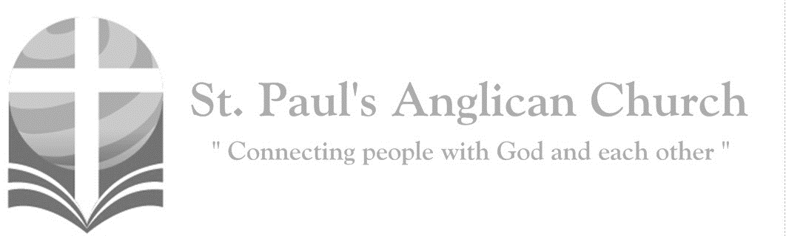

Sunday, July 14, 2019: 5th Sunday After Pentecost

*The words you have spoken are spirit and life, O Lord;*

*you have the words of eternal life. (John 6:63, 68)*

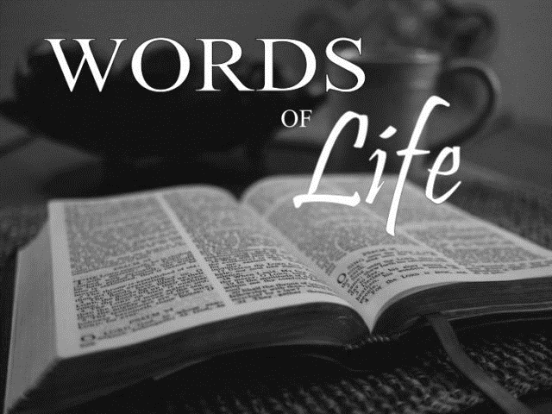

SUNDAYS AT ST. PAUL’S

**REGULAR SERVICES**

* Weekly services held Sundays at 10:00AM
* Interface services - Art based services throughout the year
* Sermons available on our website

**SUNDAY PRAYER**

* Prayer for the service at 9:30AM in the Luke Room
* Individual Prayer in the Chapel during the Sunday service

**SERVING AT ST. PAUL’S**

* Join a Ministry Team (Sunday service team, music team, children’s ministry, Altar guild, or many others)
* Regular or One-Time Giving (cash, cheque, automatic debit, and credit options available)

**LARGE PRINT MATERIALS** Large print Bibles and   
 Books of Alternative   
 Services (BAS) are availableat each Sanctuary door.

Page numbers will not be the same as those listed in the bulletin.

**VISITING TODAY?**

We want to get to know   
 you! Please join us for

in the Hall for coffee and

fellowship following the service. The greeters are also available to help if you have any questions.

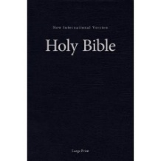



**Assisted listening**

**is available. Please**

**ask a greeter**

**for assistance.**



CONNECT

**St. Paul’s CHILDREN’S MINISTRY – September through June**

**KIDS** Chickadees Ages 2-4 / Peacocks Grade K-2 / Falcons Grade 3-5

Sunday School teaching is weekly during the 10:00AM service.

**St. Paul’s YOUTH MINISTRY – September through June**

**YOUTH** Youth Grades 6-12 meet weekly during the 10:00AM service.

Youth also meetbi-weekly for fun events and devotionals.

**St. Paul’s ADULT MINISTRY**

**ADULTS** St. Paul’s has a number of small groups where you can connect with others through Christ. If you are interested in joining a small   
group or starting a small group of your own, please speak with Pat Stretch.

**Opening Song: *All People That On Earth Do Dwell***

All people that on earth do dwell  
Sing to the Lord with cheerful voice  
Him serve with fear, His praise forth tell  
Come ye before Him and rejoice

The Lord ye know is God indeed  
Without our aid He did us make  
We are His flock, He doth us feed  
And for His sheep He doth us take

O enter then His gates with praise  
Approach with joy His courts unto  
Praise laud and bless His name always  
For it is seemly so to do

For why the Lord our God is good  
His mercy is forever sure  
His truth at all times firmly stood  
And shall from age to age endure

To Father Son and Holy Ghost  
The God whom heaven and earth adore  
From earth and from the angel host  
Be praise and glory evermore

**The Gathering of the Community**

Celebrant: *(BAS pg. 185)* The grace of our Lord Jesus Christ, and the love of God, and the fellowship of the Holy Spirit, be with you all.

**People: And also with you.**

Celebrant:Almighty God,

**All:to you all hearts are open, all desires known, and from you no secrets are hidden. Cleanse the thoughts of our hearts by the inspiration of your Holy Spirit that we may perfectly love you, and worthily magnify your holy name; through Christ our Lord. Amen.**

Celebrant: *(pg. 367)* Almighty God, you have made us for yourself, and our hearts are restless until they find their rest in you. May we find peace in your service, and in the world to come, see you face to face; through Jesus Christ our Lord, who lives and reigns with you and the Holy Spirit, one God, now and forever.

**People:** **Amen**.

**Children and Youth Dismissal**

**The Reading of Scripture**

First Reading: Amos 7:7-17 (pg. 651 in the red pew Bible)

Reader: The Word of the Lord.

**People:** **Thanks be to God.**

Psalm Reading: Psalm 82 (pg. 815 in the BAS)

Second Reading: Colossians 1:1-14 (pg. 833 in the red pew Bible)

Reader: The Word of the Lord.

**People:** **Thanks be to God.**

**Worship Through Song**

***Here I Am to Worship***

Light of the world  
You stepped down into darkness  
Opened my eyes, let me see  
Beauty that made  
This heart adore You  
Hope of a life spent with You

(*Chorus*) So here I am to worship  
Here I am to bow down  
Here I am to say that You're my God  
You're altogether lovely  
Altogether worthy  
Altogether wonderful to me

King of all days  
Oh so highly exalted  
Glorious in heaven above  
Humbly You came  
To the earth You created  
All for love's sake became poor

(*To Chorus*)

And I'll never know how much it cost  
To see my sin upon that cross  
And I'll never know how much it cost  
To see my sin upon that cross

(*To Chorus*)

***Your Faithfulness***

I don't know what this day will bring  
Will it be disappointing  
Or filled with longed-for things  
I don't know what tomorrow holds  
Still I know I can trust Your faithfulness

I don't know if these clouds mean rain  
If they do

Will they pour down blessing or pain  
I don't know what the future holds  
Still I know I can trust Your faithfulness

(*Chorus*)

Certain as the rivers reach the sea  
Certain as the sunrise in the east  
I can rest in Your faithfulness  
Surer than a mother's tender love  
Surer than the stars still shine above  
I can rest in Your faithfulness

I don't know how or when I'll die  
Will it be a thief  
Or will I have a chance to say good-bye  
No, I don't know how much time is left  
But in the end

I will know Your faithfulness

(*continued on next page*)

When darkness overwhelms my soul  
When thoughts are storms of doubt  
Still I trust You are always faithful  
Always faithful

Certain as the rivers reach the sea

Certain as the sunrise in the east  
I can rest in Your faithfulness  
Surer than a mother's tender love  
Surer than the stars still shine above  
I can rest in Your faithfulness

**Listening Time**

**The Gospel Reading**

Celebrant: The Lord be with you.

**People: And also with you.**

Celebrant: The Holy Gospel of our Lord Jesus Christ according to St. Luke.

**People: Glory to you, Lord Jesus Christ.**

Gospel Reading: Luke 10:25-37 (pg. 735 in the red pew Bible)

Celebrant: The Gospel of Christ.

**People: Praise to you, Lord Jesus Christ.**

Sermon: The Reverend Dr. Myron Penner

**Sermon Notes**

________________________________________________________________________________________________________________________________________________________________________________________________________________________________________________________________________________________________________________________________________________________________________________________________________________________________________________________________________________________________________________________

________________________________________________________________________________________________________________________________________________

________________________________________________________________________________________________________________________________________________________________________________________________________________________________________________________________________________________________________________________________________________________________________

**Affirmation of Faith – Brother and Teacher**

**All: We trust in God, Spirit of life, Creator of all that is and all that is to come; who surrounds us and fills us; who speaks the Word of life in us; and so we listen. We listen to Jesus, Revealer of God, our brother and teacher; who lived in prayer and in love. Listening to God’s voice and doing God’s will, he gave his life in love; but God raised him to life that is eternal; and so we follow him. We follow in the power of the Holy Spirit, God alive in us, for the sake of the healing of the world. We trust in the power of forgiveness, the reality of resurrection, the gift of the universal Church as the body of Christ, and the mystery of eternal life. Amen.**

**Prayers of the People**

**Confession of Sin**

Celebrant: *(pg. 191)* Dear friends in Christ, God is steadfast in love and infinite in mercy; he welcomes sinners and invites them to his table. Let us confess our sins, confident in God’s forgiveness.

*Silent Confession*

**All: We confess to God, the Father, the Son, and the Holy Spirit, and before the whole company of heaven, that we have sinned in what we have thought, said, and done, through our own fault, and we pray God to have mercy on us. God, you rule over all, have mercy on us, forgive us all our sins and save us from all evil; make us strong to do good and bring us to everlasting life, through Jesus Christ our Lord. Amen.**

Celebrant: Almighty God have mercy upon you, pardon and deliver you from all your sins, confirm and strengthen you in all goodness and keep you in eternal life through Jesus Christ our Lord.

**People:Amen.**

**The Peace**

Celebrant: The peace of the Lord be always with you.

**People: And also with you.**

**Offertory Song: *I Want to Walk as a Child of the Light***

I want to walk as a child of the light  
I want to follow Jesus  
God set the stars

To give light to the world  
The star of my life is Jesus

(*Chorus*)

In Him there is no darkness at all  
The night and the day are both alike  
The Lamb is the light of the city of God  
Shine in my heart Lord Jesus

I want to see the brightness of God  
I want to look at Jesus  
Clear Sun of righteousness

Shine on my path  
And show me the way to the Father

(*To Chorus*)

I'm looking for the coming of Christ  
I want to follow Jesus  
When we have run

With patience the race  
We shall know the joy of Jesus

(*To Chorus*)

**Prayer Over the Gifts**

Celebrant: *(pg. 368)* Father,

**All: your word creates in us a yearning for your kingdom. Receive all we offer you this day, and keep us in your peace; for the sake of Jesus Christ the Lord. Amen.**

Celebrant: *(pg. 204)* The Lord be with you.

**People: And also with you.**

Celebrant: Lift up your hearts.

**People: We lift them to the Lord.**

Celebrant: Let us give thanks to the Lord our God.

**People: It is right to give our thanks and praise.**

Celebrant: We give you thanks and praise, almighty God, for the gift of a world full of wonder, and for our life which comes from you. By your power you sustain the universe.

**All: Glory to you for ever and ever.**

Celebrant: You created us to love you with all our heart, and to love each other as ourselves, but we rebel against you by the evil that we do. In Jesus, your Son, you bring healing to our world and gather us into one great family. Therefore, with all who serve you on earth and in heaven, we praise your wonderful name, as we sing,

**All:** ***(Sung)*** **Holy, holy, holy is the Lord God Almighty. Holy, holy, holy is the Lord God Almighty.Who was, and is, and is to come. Who was, and is, and is to come. Lift up his name with the sound of singing.   
Lift up his name in all the earth. Lift up your voice and give him glory.   
For he is worthy to be praised. For he is worthy to be praised.   
For he is worthy to be praised.**

Celebrant: (pg. 205) We give you thanks and praise, loving Father....... By raising him from the dead you show us the power of your love to bring new life to all your people.

**All: Glory to you for ever and ever.**

Celebrant: Gracious God, we recall the death of your Son Jesus Christ……. that we who eat and drink at this holy table may share the divine life of Christ our Lord.

**All: Glory to you for ever and ever.**

Celebrant: On the night before he gave up his life for us……. which is shed for you and for many, so that sins may be forgiven. Do this in memory of me.”

**All: Glory to you for ever and ever.**

Celebrant: Gracious God……. and share in the life of the family of your children.

**All: Glory to you for ever and ever.**

Celebrant: Father, you call us to be your servants……. We sing your praise, almighty Father, through Jesus, our Lord, in the power of the Holy Spirit, now and for ever.

**All: Glory to you for ever and ever. Amen.**

Celebrant: *(pg. 211)* As our Saviour taught us, let us pray,

**All: *(Sung)* Our Father in heaven, holy is your name. Your kingdom come on earth as it is in heaven. Our Father in heaven, reveal who you are. Your will be done on earth as in heaven. Feed us today what we need to live. Forgive all our sins as we forgive. And keep us safe. The kingdom is yours, the power is yours, and the glory forever. The kingdom is yours, the power is yours, and the glory forever.**

Celebrant: *(pg. 212)* “I am the bread of life,” says the Lord. “Whoever comes to me will never be hungry; whoever believes in me will never thirst.”

**All: Taste and see that the Lord is good; happy are they who trust in him!**

Celebrant: *(pg. 213)* The gifts of God for the People of God.

**People: Thanks be to God.**

**The Communion**

*You are welcome to receive communion or come forward for a blessing. If you prefer to receive a blessing, please fold your arms over your chest. There is de-alcoholized wine available in the centre and gluten-free wafers available upon request.*

**Lamb of God**

*(Sung)* Lamb of God, you take away the sin of the world.

Lamb of God, you take away the sin of the world.

Lord have mercy, Christ have mercy, Lord have mercy on me.

Lord have mercy, Christ have mercy and grant us thy peace.

**Communion Music**

***Sanctuary***

Lord prepare me  
To be a sanctuary  
Pure and holy  
Tried and true  
With thanksgiving  
I'll be a living  
Sanctuary for You

***Be Exalted, O God***

I will give thanks to Thee  
O Lord among the people  
I will sing praises to Thee  
Among the nations  
For Thy steadfast love is great  
Is great to the heavens  
And Thy faithfulness  
Thy faithfulness to the clouds

Be exalted, O God, above the heavens  
Let Thy glory be over all the earth

Be exalted, O God, above the heavens  
Let Thy glory be over all the earth

**Prayer After Communion**

Celebrant: *(pg. 368)* Living God,

**All: in this sacrament we have share in your eternal kingdom. May we who taste this mystery forever serve you in faith, hope, and love. We ask this in the name of Jesus Christ the Lord.** **Amen.**

Celebrant: *(pg. 214)* Glory to God,

**All:whose power, working in us, can do infinitely more than we can ask or imagine. Glory to God from generation to generation, in the Church and in Christ Jesus, for ever and ever. Amen.**

**Blessing**

**Congregational Announcements *(John G.)***

**Closing Song: *Do Something Beautiful***

We are a shining light  
City on a hill that can't be hidden  
A shining light  
And this shining light

Is the life of Jesus in us  
Oh what a light  
The fire of His Spirit burns  
With justice joy and peace  
And works through our hands and feet

(*Chorus*) Go do something beautiful

In the Name of Jesus  
Do something beautiful  
Go do something Jesus would  
Do something beautiful (*repeat line*)

We are the salt of the earth  
Here to purify and flavour  
Salt of the earth  
Sent through all the earth  
To love God and love our neighbour  
Salt of the earth  
As freely as we received  
So freely we must give  
And we are His hands and feet

(*To Chorus*)

Let your light so shine before the world  
That all may see the good you do  
And give their praise  
To God our Father (*To Chorus*)

**The Dismissal**Celebrant: *(pg. 215)* Go forth into the world, rejoicing in the power of the Spirit.

**All: Thanks be to God. Amen.**

*Please join us in the Hall for coffee following the service.*

**Check us out online!!**

Please visit our new website at www.stpauls-anglican.ca. Content continues to be added to the website so please continue to check back for more information. Also, please check out the events page and mark your calendars.

**St. Paul’s Church-Wide Retreat**

**November 15-17 - Camp Nakamun**

As we have been discussing over the last couple of months, we are going ahead with a St. Paul’s retreat this fall. The retreat will be held at Camp Nakamun on November 15-17, 2019. This event is for everyone (singles, couples, families, friends) and will feature a wagon ride, board games, swimming, and whatever else you want to do! If you would like to register, please fill out a registration form (found at each door).

If you would like to attend the retreat but finances do not allow, please speak with Rev. Myron or any member of Vestry.

**St. Paul’s Small Group in Fall**

Please be thinking ahead to the fall, and think about becoming part of a new Small Group at St. Paul’s. As this would be a new group, it could be set up as the members wanted regarding what to study, the time, and place. There are many options – men, ladies, mixed, etc. Please contact Pat Stretch ([stretchg@telus.net](mailto:stretchg@telus.net) or 780-453-3339) or the office if you are interested.

**July Missionary of the Month:**

**Scott and Olga**

Scott and Olga have been in the Far East for many years. They are raising a busy family of five, the oldest who is now 14. Both of them are teaching in a local school and enjoying it though they did

feel the weariness that sometimes hits

at the end of the school year (life gets busy far too easily!!). Eli and Dana recently finished performing in their school's rendition of Robin Hood. Hannah and the younger boys are in soccer. Olga

is still getting used to the demands of

full-time work outside the home.

Each week, Scott and Olga meet with their community of local friends for “growth“ time and deepening their friendship with HIM. They are preparing for a training time this summer in a neighbouring country. Please pray for more love and more of his power in their lives.

**Crosstalk Day Camp**

Crosstalk Day Camp will take place at Edmonton Christian High School July 8 - 12, from 10:00AM-3:00PM. Crosstalk is   
for kids ages 4 (entering kindergarten) to grade 6. This camp is a week of fun, activity, song, friends, and learning more about what it means to walk with Jesus. If you would like more information or would like to register, please contact Renée Jackson ([rjackson@ualberta.ca](mailto:rjackson@ualberta.ca)).



@StEdmonton

facebook.com/stpachurchedmonton

**St. Paul’s Vestry:**

Peter Jackson, *Rector’s Warden*

Pat Stretch, *People’s Warden*

David Heritage, *Treasurer*

Margot Byer, *Vestry Member*

John Green, *Vestry Member*

Deanna Kalles, *Vestry Member*

David Parker, *Vestry Member*

Carol Rudat, *Vestry Member*

**St. Paul’s Staff:**

*Rector:*

The Reverend Myron Bradley Penner  
*Office Administrator:*

RJ Chambers

*Youth Leader:* Victoria Eeles

**For prayer requests** **email**:

office@stpauls-anglican.ca

**For urgent prayer requests call**

the church office: (780) 455-0771

**For pastoral emergencies call:**

(587) 334-2130

**Office Hours:**

Monday-Thursday: 9:00AM-12:00PM

Closed: Fri/Sat/Sun and Stat Holidays

**St. Paul’s Anglican Church**

10127 145 Street, Edmonton T5N 2X6

Phone: (780) 455-0771; Email: office@stpauls-anglican.ca

Website: www.stpauls-anglican.ca

**This Week’s Readings:**

Amos 7:7-17 (pg. 651)

Psalm 82 (BAS pg. 815)

Colossians 1:1-14 (pg. 833)

Luke 10:25-37 (pg. 735)

**This Week’s Ministry Teams:**

Music/Sound: Adele’s Team/Scott M.

Service Team: Heritage Team

Prayers of the People: David H.

Chapel Prayer: Laurier B. and Pat S.

Vestry on Duty: John G.

**St. Paul’s Cycle of Prayer:**

Tom Becker, Trina Larson,

and Vonia and Ivan;

Ranji Samuel; Angela Sutton

**Anglican Cycle of Prayer:**

Primate of Anglican Church of Canada; the Most Rev. Fred Hiltz, Archbishop - stepping down on July 16, 2019. New Primate elected July 13. St. Patrick, Edmonton: Kevin Kraglund (s. Brenda), Rector; Mark Vigrass (s. Manny Penera), Vocational Deacon; John Agwiking, Joanne Chambers (s. Don), Susan Storey, Honorary Assistants. Buyé Diocese, Ruyenzi (St. Emmanuel) Parish: Papias Masengesho. Paul First Nation.

**Next Week’s Ministry Teams**

Music/Sound: Andrew’s Team/Jennifer S.

Service Team: B Team

Prayers of the People: Barb M. or Lauren R.

Chapel Prayer: Wendell and Nora J.

Vestry on Duty: Margot B.