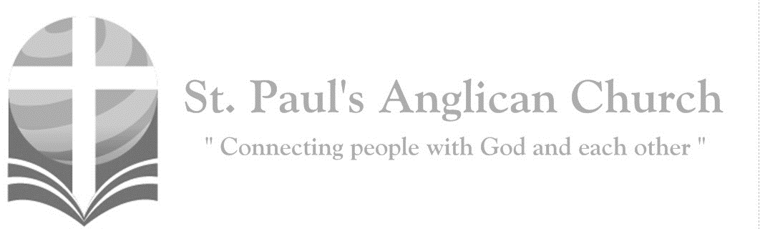

Sunday, June 23, 2019: 2nd Sunday After Pentecost

*My sheep hear my voice, says the Lord;*

*I know them and they follow me. (John 10:27)*

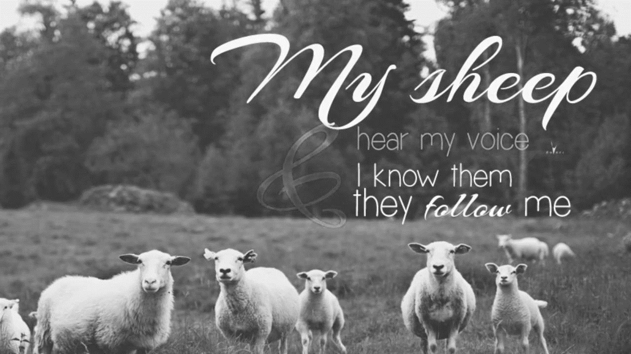

SUNDAYS AT ST. PAUL’S

**REGULAR SERVICES**

* Weekly services held Sundays at 10:00AM
* Interface services - Art based services throughout the year
* Sermons available on our website

**SUNDAY PRAYER**

* Prayer for the service at 9:30AM in the Luke Room
* Individual Prayer in the Chapel during the Sunday service

**SERVING AT ST. PAUL’S**

* Join a Ministry Team (Sunday service team, music team, children’s ministry, Altar guild, or many others)
* Regular or One-Time Giving (cash, cheque, automatic debit, and credit options available)

**LARGE PRINT MATERIALS** Large print Bibles and   
 Books of Alternative   
 Services (BAS) are availableat each Sanctuary door.

Page numbers will not be the same as those listed in the bulletin.

**VISITING TODAY?**

We want to get to know   
 you! Please join us for

in the Hall for coffee and

fellowship following the service. The greeters are also available to help if you have any questions.

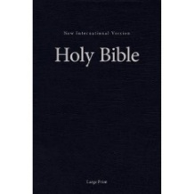



**Assisted listening**

**is available. Please**

**ask a greeter**

**for assistance.**



CONNECT

**St. Paul’s CHILDREN’S MINISTRY**

**KIDS** Chickadees Ages 2-4 / Peacocks Grade K-2 / Falcons Grade 3-5

Sunday School teaching is weekly during the 10:00AM service.

**St. Paul’s YOUTH MINISTRY**

**YOUTH** Youth Grades 6-12 meet weekly during the 10:00AM service.

Youth also meetbi-weekly for fun events and devotionals.

**St. Paul’s ADULT MINISTRY**

**ADULTS** St. Paul’s has a number of small groups where you can connect with others through Christ. If you are interested in joining a small   
group or starting a small group of your own, please speak with Pat Stretch.

**Opening Song: *God Almighty***

Like the water's roar

Is Your voice, O Lord  
There is none before and none beside  
You are set apart  
You alone are God  
Your glory reaches far from sky to sky

(*Chorus*) You are holy, holy

Lord, God Almighty  
Early in the morning we will sing  
Holy, holy we bow down before Thee  
All Your children love to sing Your name  
God Almighty

You're the breath of life  
You're the God on high  
Your song shall rise and never pass away  
O, Your Majesty evermore shall be  
The earth the skies the sea

Shall bring You praise (*To Chorus*)

**The Gathering of the Community**

Celebrant: *(BAS pg. 185)* The grace of our Lord Jesus Christ, and the love of God, and the fellowship of the Holy Spirit, be with you all.

**People: And also with you.**

Celebrant:Almighty God,

**All:to you all hearts are open, all desires known, and from you no secrets are hidden. Cleanse the thoughts of our hearts by the inspiration of your Holy Spirit that we may perfectly love you, and worthily magnify your holy name; through Christ our Lord. Amen.**

Celebrant: *(pg. 363)* O God our defender, storms rage about us and cause us to be afraid. Rescue your people from despair, deliver your sons and daughters from fear, and preserve us all from unbelief; through your Son, Jesus Christ our Lord, who lives and reigns with you and the Holy Spirit, one God, now and for ever.

**People:** **Amen**.

**Children and Youth Dismissal**

**The Reading of Scripture**

First Reading: 1 Kings 19:1-15a (pg. 255 in the red pew Bible)

Reader: The Word of the Lord.

**People:** **Thanks be to God.**

Psalm Reading: Psalm 42 (pg. 758 in the BAS)

Second Reading: Galatians 3:23-29 (pg. 825 in the red pew Bible)

Reader: The Word of the Lord.

**People:** **Thanks be to God.**

**Worship Through Song**

***Sovereign***

Sovereign in the mountain air  
Sovereign on the ocean floor  
With me in the calm  
With me in the storm  
Sovereign in my greatest joy  
Sovereign in my deepest cry  
With me in the dark  
With me at the dawn

In Your everlasting arms  
All the pieces of my life  
From beginning to the end

I can trust You  
In Your never-failing love  
You work everything for good  
God whatever comes my way

I will trust You

***Be Thou My Vision***

Be Thou my vision, O Lord of my heart  
Naught be all else to me

Save that Thou art  
Thou my best thought by day or by night  
Waking or sleeping

Thy presence my light

Be Thou my wisdom

Be Thou my true Word  
I ever with Thee and Thou with me Lord  
Thou my great Father, I Thy true son  
Thou in me dwelling and I with Thee one

Riches I heed not

Nor man's empty praise  
Thou mine inheritance now and always  
Thou and Thou only, be first in my heart  
High King of heaven

My treasure Thou art

High King of heaven when victory is won  
May I reach heaven's joys

O bright heaven's Sun  
Heart of my own heart, whatever befall  
Still be my vision, O Ruler of all

**Listening Time**

**The Gospel Reading**

Celebrant: The Lord be with you.

**People: And also with you.**

Celebrant: The Holy Gospel of our Lord Jesus Christ according to St. Luke.

**People: Glory to you, Lord Jesus Christ.**

Gospel Reading: Luke 8:26-39 (pg. 732 in the red pew Bible)

Celebrant: The Gospel of Christ.

**People: Praise to you, Lord Jesus Christ.**

Sermon: The Reverend Dr. Myron Penner

**Sermon Notes**

________________________________________________________________________________________________________________________________________________________________________________________________________________________________________________________________________________________________________________________________________________________________________________________________________________________________________________________________________________________________________________________

________________________________________________________________________________________________________________________________________________

________________________________________________________________________________________________________________________________________________________________________________________________________________________________________________________________________________________________________________________________________________________________________________________________________________________________________________________________________________________________________________________________________________________________________________________________________________________________________________________________________________________________________________________________________________________________________________________________________________________________________________________________________________________________________________________________________________________________________________________________________________________________________________________________________________________________________________________

**Affirmation of Faith – We Belong to God**

**All: We belong to God, eternal and infinite, Creator of all things and all that is to come. We follow Christ, who comes to us from God, and reveals God to us. He heals people and transforms lives, and calls us to join in his ministry. He was crucified, died, and was raised again by God, and reigns over all Creation; and he bids us to die and rise with him in the service of the healing of the world. We are moved by the Holy Spirit, together with the communion of saints, as members of the Body of Christ, God’s holy universal church. We are confident in the forgiveness of sin, the power of resurrection and the reality of eternal life. In all things it is our desire to follow Christ, by the grace of the Holy Spirit, for God’s glory. Amen.**

**Prayers of the People**

**Confession of Sin**

Celebrant: *(pg. 191)* Dear friends in Christ, God is steadfast in love and infinite in mercy; he welcomes sinners and invites them to his table. Let us confess our sins, confident in God’s forgiveness.

*Silent Confession*

**All: Have mercy upon us, most merciful Father; in your compassion, forgive us our sins, known and unknown, things done and left undone; and so uphold us by your Spirit that we may live and serve you in newness of life to the honour and glory of your name; through Jesus Christ our Lord. Amen.**

Celebrant: Almighty God have mercy upon you, pardon and deliver you from all your sins, confirm and strengthen you in all goodness and keep you in eternal life through Jesus Christ our Lord.

**People:Amen.**

**The Peace**

Celebrant: The peace of the Lord be always with you.

**People: And also with you.**

**Offertory Song: *Holy Spirit***

Holy Spirit, living Breath of God  
Breathe new life into my willing soul  
Let the presence of the risen Lord  
Come renew my heart

And make me whole  
Cause Your word to come alive in me  
Give me faith for what I cannot see  
Give me passion for Your purity  
Holy Spirit breathe new life in me

Holy Spirit come abide within  
May Your joy be seen in all I do  
Love enough to cover every sin  
In each thought and deed and attitude  
Kindness to the greatest and the least  
Gentleness that sows the path of peace  
Turn my strivings into works of grace  
Breath of God, show Christ in all I do

Holy Spirit from creation's birth  
Giving life to all that God has made  
Show Your power once again on earth  
Cause Your church

To hunger for Your ways  
Let the fragrance of our prayers arise  
Lead us on the road of sacrifice  
That in unity the face of Christ  
May be clear for all the world to see

**Prayer Over the Gifts**

Celebrant: *(pg. 364)* Eternal God,

**All: you have made our Saviour Jesus Christ the head of all creation. Receive all we offer you this day and renew us in his risen life, in the name of Jesus Christ the Lord. Amen.**

Celebrant: *(pg. 193)* The Lord be with you.

**People: And also with you.**

Celebrant: Lift up your hearts.

**People: We lift them to the Lord.**

Celebrant: Let us give thanks to the Lord our God.

**People: It is right to give our thanks and praise.**

Celebrant: (pg. 193) It is indeed right that we should praise you, gracious God, for you created all things……. Therefore, with them, and with all your saints who have served you in every age, we give thanks and raise our voices to proclaim the glory of your name.

**All:** ***(Sung)*** **Holy, holy, holy Lord, God of power and might, heaven and earth of Your glory are full. Hosanna, hosanna, hosanna in the highest. Blessed is he who comes in the name of the Lord.   
Blessed is he who comes in the name of the Lord.   
Holy, holy, holy Lord, God of power and might, heaven and earth of Your glory are full. Hosanna, hosanna, hosanna in the highest.**

Celebrant: (pg. 194) Holy God, source of life and goodness, all creation rightly gives you praise……. Gracious God, his perfect sacrifice destroys the power of sin and death; by raising him to life you give us life for evermore. Therefore, we proclaim the mystery of faith.

All: **Christ has died. Christ is risen. Christ will come again.**

Celebrant: (pg. 195) Recalling his death, proclaiming his resurrection, and looking for his coming again in glory, we offer you, Father, this bread and this cup……. Through Christ, with Christ, and in Christ, in the unity of the Holy Spirit, all glory is yours, almighty Father, now and for ever.

**All:** **Amen.**

Celebrant: *(pg. 211)* As our Saviour taught us, let us pray,

**All: *(Sung)* Our Father which art in heaven, hallowed be Thy name. Thy kingdom come, thy will be done on earth as it is in heaven. Give us this day our daily bread and forgive us our debts as we forgive our debtors and lead us not into temptation but deliver us from evil.   
For Thine is the kingdom and the power and the glory forever. Amen. For Thine is the kingdom and the power and the glory forever. Amen.**

Celebrant: *(pg. 212)* We break this bread to share in the body of Christ.

**All: We, being many, are one body, for we all share in the one bread.**

Celebrant: *(pg. 213)* The gifts of God for the People of God.

**People: Thanks be to God.**

**The Communion**

*You are welcome to receive communion or come forward for a blessing. If you prefer to receive a blessing, please fold your arms over your chest. There is de-alcoholized wine available in the centre and gluten-free wafers available upon request.*

**Lamb of God**

*(Sung)* Lamb of God, you take away the sin of the world. Lamb of God, you take away the sin of the world. Lord have mercy, Christ have mercy, Lord have mercy on me.

Lord have mercy, Christ have mercy and grant us thy peace.

**Communion Music**

***Sweet Jesus***

Sweet Jesus, my Savior  
You are my faithful Friend  
You made me, You know me  
You've seen my every sin  
My soul is amazed  
By the gift of Your grace  
And the arms that take me in  
Sweet Jesus, my Savior  
You are my faithful Friend

Sweet Jesus, my shelter  
You are my faithful Friend  
The refuge I run to  
When the world comes closing in  
Why should I be afraid  
When I know I am saved  
By the arms that take me in  
Sweet Jesus, my shelter  
You are my faithful Friend

Sweet Jesus, my Shepherd  
You are my faithful Friend  
You hold me, You lead me  
I'll follow to the end  
And once more I will say  
On that beautiful day  
When Your arms take me in  
Sweet Jesus, my Shepherd  
You are my faithful Friend

***Holy Spirit***

There's nothing worth more

That will ever come close  
No thing can compare

You're our living hope  
Your Presence

I've tasted and seen

Of the sweetest of loves  
Where my heart becomes free

And my shame is undone  
In Your Presence Lord

Holy Spirit, You are welcome here  
Come flood this place

And fill the atmosphere  
Your glory God

Is what our hearts long for  
To be overcome by Your Presence Lord

**Prayer After Communion**

Celebrant: *(pg. 364)* Almighty God,

**All: guide and protect your people who share in this sacred mystery, and keep us always in your love; through Jesus Christ our Lord.** **Amen.**

Celebrant: *(pg. 214)* Glory to God,

**All:whose power, working in us, can do infinitely more than we can ask or imagine. Glory to God from generation to generation, in the Church and in Christ Jesus, for ever and ever. Amen.**

**Blessing**

**Congregational Announcements *(Peter J.)***

**Closing Song: *By Faith***

By faith we see the hand of God  
In the light of creation's grand design  
In the lives of those

Who prove His faithfulness  
Who walk by faith and not by sight

By faith our fathers roamed the earth  
With the power of His promise

In their hearts  
Of a holy city built by God's own hand  
A place where peace and justice reign

(*Chorus*)

We will stand as children of the promise  
We will fix our eyes on Him

Our soul's reward  
Till the race is finished

And the work is done  
We'll walk by faith and not by sight

By faith the prophets saw a day  
When the longed-for Messiah

Would appear  
With the power to break the chains

Of sin and death  
And rise triumphant from the grave

By faith the church was called to go  
In the power of the Spirit to the lost  
To deliver captives

And to preach good news  
In every corner of the earth (*To Chorus*)

By faith the mountain shall be moved  
And the power

Of the gospel shall prevail  
For we know in Christ

All things are possible  
For all who call upon His name

(*To Chorus*)

**The Dismissal**Celebrant: *(pg. 215)* Go forth into the world, rejoicing in the power of the Spirit.

**All: Thanks be to God.**

*Please join us in the Hall for coffee following the service.*

**Upcoming Youth Events**

June 28, 4-7PM: Serving at Hope Mission.

**Permanent Rector for St. Paul’s**

We are pleased to announce that Bishop Jane Alexander, Bishop of the Anglican Diocese of Edmonton, has written a letter of appointment appointing Rev. Myron Penner to the permanent position of Rector of St. Paul’s Anglican Parish effective June 23, 2019, which Myron has signed and returned to the Synod Office. We are pleased to welcome Myron here officially as Rector of St. Paul’s!!

**Crosstalk Day Camp**

Crosstalk Day Camp will take place at Edmonton Christian High School July 8 - 12, from 10:00AM-3:00PM. Crosstalk is   
for kids ages 4 (entering kindergarten) to grade 6. This camp is a week of fun, activity, song, friends, and learning more about what it means to walk with Jesus. If you would like more information or would like to register, please contact Renée Jackson ([rjackson@ualberta.ca](mailto:rjackson@ualberta.ca)).

**Children’s Ministry Meeting – Wednesday, June 26**

If you have children currently in children’s ministry or are teaching in children’s ministry, we want your input!! Please plan to join us Wednesday, June 26 at 6:30PM for a meeting with Myron and RJ to discuss how we can better support this ministry at St. Paul’s.

**June Missionary of the Month: Diocese of the Arctic**

Please pray for the Diocese of the Arctic and the Rt. Rev. David Parsons, Bishop.

It is a vast region, where clergy and lay people minister to people in scattered communities. Pray for good health and safety in travel. Pray for the Arthur

Turner Training School, which reopened

in 2016 to train clergy. Pray for resources and students. As many clergy are due

to retire over at the next few years, pray to the Lord to raise up new workers.

Rev. Parsons is currently traveling to Korea. Please pray for God’s protection and guidance on their trip.

**St. Paul’s Church-Wide Retreat**

**November 15-17 - Camp Nakamun**

As we have been discussing over the last couple of months, we are going ahead with a St. Paul’s retreat this fall. The retreat will be held at Camp Nakamun on November 15-17, 2019. This event is for everyone (singles, couples, families, friends) and will feature a wagon ride, board games, swimming, and whatever else you want to do! If you would like to register, please fill out a registration form (found at each door). Please also note that if you register and pay by June 30, you will save some money!! If you would like to attend the retreat but finances do not allow, please speak with Rev. Myron or any member of Vestry.



@StEdmonton

facebook.com/stpachurchedmonton

**St. Paul’s Vestry:**

Peter Jackson, *Rector’s Warden*

Pat Stretch, *People’s Warden*

David Heritage, *Treasurer*

Margot Byer, *Vestry Member*

John Green, *Vestry Member*

Deanna Kalles, *Vestry Member*

David Parker, *Vestry Member*

Carol Rudat, *Vestry Member*

**St. Paul’s Staff:**

*Interim Rector:*

The Reverend Myron Bradley Penner  
*Office Administrator:*

RJ Chambers

*Youth Leader:* Victoria Eeles

**For prayer requests** **email**:

office@stpauls-anglican.ca

**For urgent prayer requests call**

the church office: (780) 455-0771

**For pastoral emergencies call:**

(587) 334-2130

**Office Hours:**

Monday-Thursday: 9:00AM-12:00PM

Closed: Fri/Sat/Sun and Stat Holidays

**St. Paul’s Anglican Church**

10127 145 Street, Edmonton T5N 2X6

Phone: (780) 455-0771; Email: office@stpauls-anglican.ca

Website: www.stpauls-anglican.ca

**This Week’s Readings:**

1 Kings 19:1-15a (pg. 255)

Psalm 42 (BAS pg. 758)

Galatians 3:23-29 (pg. 825)

Luke 8:26-39 (pg. 732)

**This Week’s Ministry Teams:**

Music/Sound: Andrew’s Team/Jennifer

Service Team: Parker Team

Prayers of the People: Kjeryn A.

Chapel Prayer: Wendell and Nora J.

Vestry on Duty: Peter J.

**St. Paul’s Cycle of Prayer:**

Wendell and Nora James;

Gay Gering;

George Jakeway

**Anglican Cycle of Prayer:**

Diocese of Yukon; the Rt. Rev. Larry Robertson, Bishop. St. Mary, Edmonton: Ruth Sesink-Bott (s. Dawson), Rector; Lori Calkins, Honorary Assistant and Indigenous Ministries Priest. Buyé Diocese, Kabataha Parish: Fabien Miburo, Rector. Kehewin Cree Nation.

**Next Week’s Ministry Teams**

Music/Sound: Pat’s Team/Chandra S.

Service Team: Tilburn Team

Prayers of the People: Deanna K.

Chapel Prayer: Kjeryn A. and Barb M.

Vestry on Duty: David H.