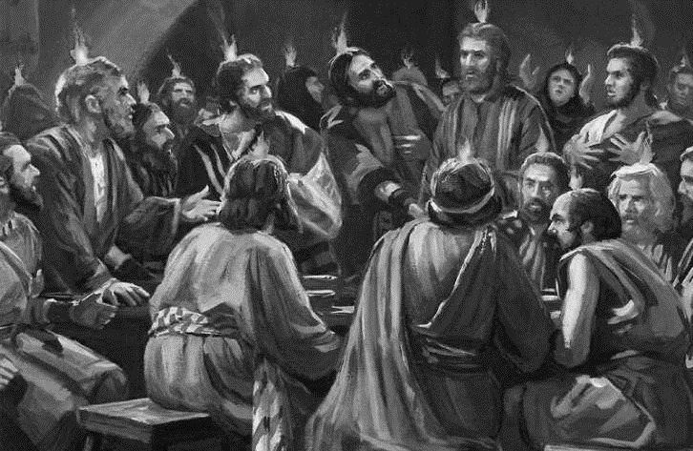
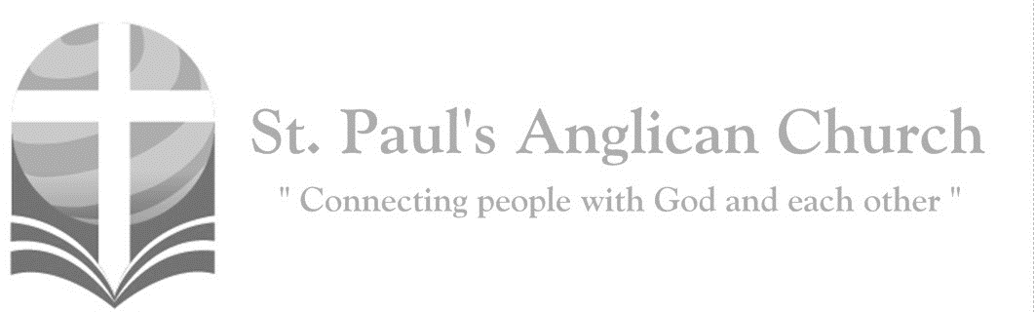
Sunday, June 9, 2019: Day of Pentecost

Come, Holy Spirit, fill the hearts of
your faithful; and kindle in us
the fire of your love.

Opening Song: All Creatures of Our God and King

All creatures of our God and King
Lift up your voice and with us sing
Alleluia, alleluia
Thou burning sun with golden beam
Thou silver moon with softer gleam

(Chorus) O praise Him, O praise Him
Alleluia, alleluia, alleluia

Thou rushing wind that art so strong
Ye clouds that sail in heaven along
O praise Him, alleluia
Thou rising morn in praise rejoice
Ye lights of evening find a voice
(To Chorus)
And all ye men of tender heart
Forgiving others take your part
O sing ye alleluia
Ye who long pain and sorrow bear
Praise God and on Him cast your care
(To Chorus)

Let all things their Creator bless
And worship Him in humbleness
O praise Him, alleluia
Praise, praise the Father, praise the Son
And praise the Spirit, Three in One
(To Chorus)

The Gathering of the Community
Celebrant: (BAS pg. 185) Alleluia! Christ is risen.
People: The Lord is risen indeed. Alleluia!
Celebrant: May his grace and peace be with you.
People: May he fill our hearts with joy.
Celebrant: Almighty God,
All: to you all hearts are open, all desires known, and from you no secrets are hidden. Cleanse the thoughts of our hearts by the inspiration of your Holy Spirit that we may perfectly love you, and worthily magnify your holy name; through Christ our Lord. Amen.

Celebrant: (pg. 345) Almighty and everliving God, who fulfilled the promises of Easter by sending us your Holy Spirit and opening to every race and nation the way of life eternal, keep us in the unity of your Spirit, that every tongue may tell of your glory; through Jesus Christ our Lord, who lives and reigns with you and the Holy Spirit, one God, now and for ever.
People: Amen.

The Reading of Scripture
First Reading: Acts 2:1-21 (pg. 771 in the red pew Bible)
Reader: The Word of the Lord.
People: Thanks be to God.

Psalm Reading: Psalm 104:24-35 (pg. 843 in the BAS)

Second Reading: Romans 8:14-17 (pg. 800 in the red pew Bible)
Reader: The Word of the Lord.
People: Thanks be to God.

Reader: The Lord be with you.
People: And also with you.
Reader: The Holy Gospel of our Lord Jesus Christ according to St. John.
People: Glory to you, Lord Jesus Christ.
Gospel Reading: John 14:8-17 (pg. 764 in the red pew Bible)
Reader: The Gospel of Christ.
People: Praise to you, Lord Jesus Christ.
Sermon: The Reverend Dr. Myron Penner

Sermon Notes:
________________________________________________________________________________________________________________________________________________________________________________________________________________________________________________________________________________________________________________________________________________________________________________________________________________________________________________________________________________________________________________________
________________________________________________________________________________________________________________________________________________
________________________________________________________________________

Affirmation of Faith (Vine and Branches)
All: We believe in God, the Root of all living, Creator of all things. We live in Christ Jesus, God’s Son, who loved all people and who makes us one in his love. He suffered and died, and was raised to new life. In his death and resurrection, we are also raised to new life. Christ is our Vine, and we are his branches; and without him we cannot live. We live by the Holy Spirit, flowing through us so that we may bear fruit for God, the fruit of love. In the Spirit we are one with Christ, one with each other, and one in ministry to all the world. We trust in the one holy church, the communing of saints, the forgiveness of sin, the mystery of resurrection, and the grace of eternal life. Amen.

Prayers of the People

Confession of Sin
Celebrant: (pg. 191) Dear friends in Christ, God is steadfast in love and infinite in mercy; he welcomes sinners and invites them to his table. Let us confess our sins, confident in God’s forgiveness.
Silent Confession
Celebrant: Most merciful God,
All: we confess that we have sinned against you in thought, word, and deed, by what we have done and by what we have left undone. We have not loved you with our whole heart; we have not loved our neighbours as ourselves. We are truly sorry and we humbly repent. For the sake of your Son Jesus Christ, have mercy on us and forgive us, that we may delight in your will, and walk in your ways, to the glory of your name. Amen.
Celebrant: Almighty God have mercy upon you, pardon and deliver you from all your sins, confirm and strengthen you in all goodness and keep you in eternal life through Jesus Christ our Lord.
People: Amen.

The Peace
Celebrant: The peace of the Lord be always with you.
People: And also with you.

Offertory Song: Spirit, Spirit of Gentleness

(Chorus) Spirit, Spirit of Gentleness
Blow through the wilderness
Calling and free
Spirit, Spirit of Restlessness
Stir me from placidness
Wind, wind on the sea

You moved on the waters
You called to the deep
Then you coaxed up the mountains
From the valleys of sleep
And over the aeons
You called to each thing
Wake from your slumbers
And rise on your wings (To Chorus)

You swept through the desert
You stung with the sand
And you goaded your people
With a law and a land
And when they were blinded
With their idols and lies
Then you spoke through your prophets
To open their eyes (To Chorus)

You sang in a stable
You cried from a hill
Then you whispered in silence
When the whole world was still
And down in the city
You called once again
When you blew through your people
On the rush of the wind (To Chorus)

You call from tomorrow
You break ancient schemes
From the bondage of sorrow
The captives dream dreams
Our women see visions
Our men clear their eyes
With bold new decisions
Your people arise (To Chorus)
Prayer Over the Gifts
Celebrant: (pg. 346) Giver of life,
All: receive all we offer you this day. Let the Spirit you bestow on your Church continue to work in the world through the hearts of all who believe. We ask this in the name of Jesus Christ the Lord. Amen.

Celebrant: (pg. 198) The Lord be with you.
People: And also with you.
Celebrant: Lift up your hearts.
People: We lift them to the Lord.
Celebrant: Let us give thanks to the Lord our God.
People: It is right to give our thanks and praise.

Celebrant: (pg. 222) Blessed are you, gracious God, creator of heaven and earth; we give you thanks and praise through Jesus Christ our Lord. In fulfillment of your promise you pour forth your Spirit upon us, filling us with gifts and leading us into all truth. You give us power to proclaim your gospel to all nations and to serve you as a royal priesthood. Therefore, we join our voices with angels and archangels, and with all those in whom the Spirit dwells, to proclaim the glory of your name.
All: (Said) Holy, holy, holy Lord, God of power and might, heaven and earth are full of your glory. Hosanna in the highest.
Blessed is he who comes in the name of the Lord.
Hosanna in the highest.

Celebrant: (pg. 198) We give thanks to you, Lord our God……. Therefore, Father, according to his command,
All: we remember his death, we proclaim his resurrection, we await his coming in glory;
Celebrant: and we offer our sacrifice of praise and thanksgiving to you…… by whom, and with whom, and in whom, in the unity of the Holy Spirit, all honour and glory are yours, almighty Father, now and for ever.
All: Amen.

Celebrant: (pg. 211) As our Saviour taught us, let us pray,
All: (Said) Our Father in heaven, hallowed be your name. Your kingdom come, your will be done, on earth as in heaven. Give us today our daily bread. Forgive us our sins as we forgive those who sin against us. Save us from the time of trial, and deliver us from evil. For the kingdom, the power, and the glory are yours, now and for ever. Amen.

Celebrant: (pg. 213) Lord, we died with you on the cross.
All: Now we are raised to new life.
Celebrant: We were buried in your tomb.
All: Now we share in your resurrection.
Celebrant: Live in us, that we may live in you.

Celebrant: (pg. 213) The gifts of God for the People of God.
People: Thanks be to God.
The Communion
You are welcome to receive communion or come forward for a blessing. If you prefer to receive a blessing, please fold your arms over your chest. There is de-alcoholized wine available in the centre and gluten-free wafers available upon request.

Lamb of God
(Sung) O, Lamb of God, you take away the sin of the world: have mercy on us.
O, Lamb of God, you take away the sin of the world: have mercy on us.
O, Lamb of God, you take away the sin of the world: grant us peace.

Communion Music
Come, Holy Spirit
Come, Holy Spirit
Come now and change my life
Touch my heart of stone
Fill my mouth with a song (repeat)

Break the chains
That keep me bound
Open doors so I belong
In the Kingdom of Jesus

Holy Spirit come, Holy Spirit come
Holy Spirit come now

Spirit of the Living God
Spirit of the living God
Fall fresh on me (repeat)
Melt me, mould me, fill me, use me
Spirit of the living God
Fall fresh on me

Prayer After Communion
Celebrant: (pg. 346) Father,
All: may we who have received this eucharist live in the unity of your Holy Spirit, that we may show forth his gifts to all the world. We ask this in the name of Jesus Christ our Lord. Amen.

Celebrant: (pg. 214) Glory to God,
All: whose power, working in us, can do infinitely more than we can ask or imagine. Glory to God from generation to generation, in the Church and in Christ Jesus, for ever and ever. Amen.

Blessing

Congregational Announcements (Margot B.)

Closing Song: Children of Light

We are the children of light
We are the children of day
So let us worship Him
In whom we have our being
Until the coming of the Lord

We are the children of God
Made in the image of Christ
And on the day He comes
We shall be made like Him
For we shall see Him as He is

(Chorus) Come let us worship now
Let us kneel, let us humbly bow down
He is our God, we are His people
We are the flock in His care
So come let us bow

We are the soldiers of Christ
Dressed for the battle on high
So let us call on Him
For He will fight the battle
And we will march with Him on that day
(To Chorus)

We are the faithful of God
We will endure 'til the end
So let us run the race
That He has set before us
To win the crown of righteousness
(To Chorus)

The Dismissal
Celebrant: (pg. 215) Go in peace to love and serve the Lord.
All: Thanks be to God. Alleluia.

Please join us at Grovenor Park for our Family BBQ and Picnic!!
Office Hours:
Monday-Thursday: 9:00AM-12:00PM
Closed: Fri/Sat/Sun and Stat Holidays
@StEdmonton
facebook.com/stpachurchedmonton

St. Paul’s Vestry:
Peter Jackson, Rector’s Warden
Pat Stretch, People’s Warden
David Heritage, Treasurer
Margot Byer, Vestry Member
John Green, Vestry Member
Deanna Kalles, Vestry Member
David Parker, Vestry Member
Carol Rudat, Vestry Member

St. Paul’s Staff:
Interim Rector:
The Reverend Myron Bradley Penner
Office Administrator:
RJ Chambers
Youth Leader: Victoria Eeles
For prayer requests email:
stpaulsprayerchain@gmail.com
For urgent prayer requests call
the church office: (780) 455-0771
For pastoral emergencies call:
(587) 334-2130

St. Paul’s Anglican Church
10127 145 Street, Edmonton T5N 2X6
Phone: (780) 455-0771; Email: office@stpauls-anglican.ca
Website: www.stpauls-anglican.ca
This Week’s Readings:
Acts 2:1-21 (pg. 771)
Psalm 104:24-35 (BAS pg. 843)
Romans 8:14-17 (pg. 800)
John 14:8-17 (pg. 764)

This Week’s Ministry Teams:
Music/Sound: Carol’s Team/RJ C.
Service Team: Heritage Team
Prayers of the People: David H.
Chapel Prayer: Dudley B. and Pat H-B.
Vestry on Duty: Margot B.

St. Paul’s Cycle of Prayer:
Kyle, Stephanie, Jae, Beck, and Luka Armstrong;
Dee Cartledge; Marjorie Morris

Anglican Cycle of Prayer:
Diocese of Toronto; the Rt. Rev. Andrew Asbil, Bishop; the Rt. Revs. Jenny Andison, Peter Fenty, Kevin Robertson, and Riscylla Walsh Shaw, Suffragan Bishops. St. Margaret, Edmonton: Tim Chesterton (s. Marci), Rector; Brad Lindseth, Theological Student; Melanie Eriksen, Administrative Assistant. Buyé Diocese, Mwumba Parish: Jean Pierre Nsabimana, Rector. Ermineskin Cree Nation.

Next Week’s Ministry Teams
Music/Sound: Pat’s Team/Chandra S.
Service Team: Green and Friends Team
Prayers of the People: Nancy W-S.
Chapel Prayer: Laurier B. and Pat S.
Vestry on Duty: Deanna K.

