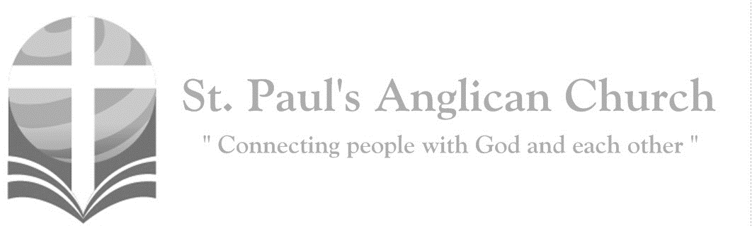

Sunday, May 12, 2019: 4th Sunday of Easter

*I am the good shepherd, says the Lord:*

*I know my own and my own know me. (John 10:14)*

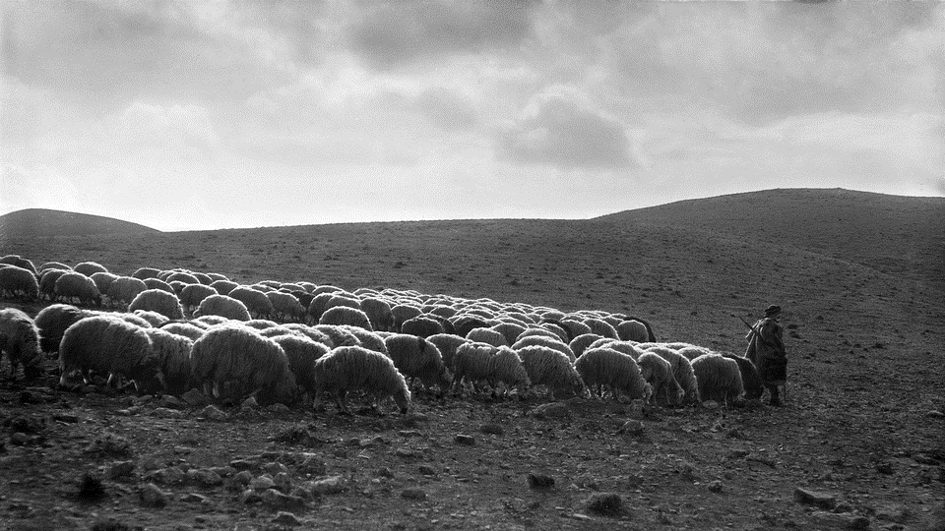

SUNDAYS AT ST. PAUL’S

**REGULAR SERVICES**

* Weekly services held Sundays at 10:00AM
* Interface services - Art based services throughout the year
* Sermons available on our website

**SUNDAY PRAYER**

* Prayer for the service at 9:30AM in the Luke Room
* Individual Prayer in the Chapel during the Sunday service

**SERVING AT ST. PAUL’S**

* Join a Ministry Team (Sunday service team, music team, children’s ministry, Altar guild, or many others)
* Regular or One-Time Giving (cash, cheque, automatic debit, and credit options available)

**LARGE PRINT MATERIALS** Large print Bibles and   
 Books of Alternative   
 Services (BAS) are availableat each Sanctuary door.

Page numbers will not be the same as those listed in the bulletin.

**VISITING TODAY?**

We want to get to know   
 you! Please join us for

in the Hall for coffee and

fellowship following the service. The greeters are also available to help if you have any questions.

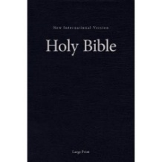



**Assisted listening**

**is available. Please**

**ask a greeter**

**for assistance.**



CONNECT

**St. Paul’s CHILDREN’S MINISTRY**

**KIDS** Chickadees Ages 2-4 / Peacocks Grade K-2 / Falcons Grade 3-5

Sunday School teaching is weekly during the 10:00AM service.

**St. Paul’s YOUTH MINISTRY**

**YOUTH** Youth Grades 6-12 meet weekly during the 10:00AM service.

Youth also meetbi-weekly for fun events and devotionals.

**St. Paul’s ADULT MINISTRY**

**ADULTS** St. Paul’s has a number of small groups where you can connect with others through Christ. If you are interested in joining a small   
group or starting a small group of your own, please speak with Pat Stretch.

**Opening Song: *All Creatures of Our God and King***

All creatures of our God and King  
Lift up your voice and with us sing  
Alleluia, alleluia  
Thou burning sun with golden beam  
Thou silver moon with softer gleam

(*Chorus*) O praise Him, O praise Him  
Alleluia, alleluia, alleluia

Thou rushing wind that art so strong  
Ye clouds that sail in heaven along  
O praise Him, alleluia  
Thou rising morn in praise rejoice  
Ye lights of evening find a voice

(*To Chorus*)

Thou flowing water pure and clear  
Make music for thy Lord to hear  
Alleluia, alleluia  
Thou fire so masterful and bright  
Thou givest man both warmth and light

(*To Chorus*)

And all ye men of tender heart  
Forgiving others take your part  
O sing ye, alleluia  
Ye who long pain and sorrow bear  
Praise God and on Him cast your care

(*To Chorus*)

Let all things their Creator bless  
And worship Him in humbleness  
O praise Him, alleluia  
Praise, praise the Father, praise the Son  
And praise the Spirit Three in One

(*To Chorus*)

**The Gathering of the Community**

Celebrant: *(BAS pg. 185)* Alleluia! Christ is risen.

**People: The Lord is risen indeed. Alleluia!**

Celebrant: May his grace and peace be with you.

**People: May he fill our hearts with joy.**

Celebrant:Almighty God,

**All:to you all hearts are open, all desires known, and from you no secrets are hidden. Cleanse the thoughts of our hearts by the inspiration of your Holy Spirit that we may perfectly love you, and worthily magnify your holy name; through Christ our Lord. Amen.**

Celebrant: *(pg. 339)* O God of peace, who brought again from the dead our Lord Jesus Christ, that great shepherd of the sheep, by the blood of the eternal covenant, make us perfect in every good work to do your will, and work in us that which is well-pleasing in your sight; through Jesus Christ our Lord.

**People:** **Amen**.

**Children and Youth Dismissal**

**The Reading of Scripture**

First Reading: Acts 9:36-43 (pg. 778 in the red pew Bible)

Reader: The Word of the Lord.

**People:** **Thanks be to God.**

Psalm Reading: Psalm 23 (pg. 731 in the BAS)

Second Reading: Revelation 7:9-17 (pg. 871 in the red pew Bible)

Reader: The Word of the Lord.

**People:** **Thanks be to God.**

**Worship Through Song**

***Lord Most High***

From the ends of the earth (echo)  
From the depths of the sea (echo)  
From the heights of the heavens (echo)  
Your name be praised  
From the hearts of the weak (echo)  
From the shouts of the strong (echo)  
From the lips of all people (echo)  
This song we raise Lord

Throughout the endless ages  
You will be crowned with praises  
Lord Most High  
Exalted in every nation  
Sovereign of all creation  
Lord Most High be magnified

***Be Unto Your Name***

We are a moment, You are forever  
Lord of the ages, God before time  
We are a vapour, You are eternal  
Love everlasting, reigning on high

(*Chorus*)

Holy, holy Lord God Almighty  
Worthy is the Lamb who was slain  
Highest praises, honor and glory  
Be unto Your name  
Be unto Your name

We are the broken, You are the healer  
Jesus Redeemer, mighty to save  
You are the love song we'll sing forever  
Bowing before You, blessing Your name

(*To Chorus*)

**Listening Time**

**The Gospel Reading**

Gospel Reading: John 10:22-30 (pg. 760 in the red pew Bible)

Reader: The Lord be with you.

**People: And also with you.**

Reader: The Holy Gospel of our Lord Jesus Christ according to St. John.

**People: Glory to you, Lord Jesus Christ.**

*The Gospel Reading*

Reader: The Gospel of Christ.

**People: Praise to you, Lord Jesus Christ.**

Sermon: The Reverend Dr. Myron Penner

**Sermon Notes**

________________________________________________________________________________________________________________________________________________________________________________________________________________________________________________________________________________________________________________________________________________________________________________________________________________________________________________________________________________________________________________________________________________________________________________________________________________________________________________________________________

________________________________________________________________________________________________________________________________________________________________________________________________________________________________________________________________________________________________________________________________________________________________________________________________________________________________________________________________________________________________________________________________________________________________________________________________________________________________________________________________________________________________________________________________________________________________________________________________________________________________________________________________________________________________________________________________________________________________________

**The Apostle’s Creed**

Celebrant: *(pg. 189)* Let us confess the faith of our baptism, as we say,

**All: I believe in God, the Father almighty, Creator of heaven and earth. I believe in Jesus Christ, his only Son, our Lord. He was conceived by the power of the Holy Spirit and born of the Virgin Mary. He suffered under Pontius Pilate, was crucified, died and was buried. He descended to the dead. On the third day, he rose again. He ascended into heaven and is seated at the right hand of the Father. He will come again to judge the living and the dead. I believe in the Holy Spirit, the holy catholic Church, the communion of saints, the forgiveness of sins, the resurrection of the body, and the life everlasting. Amen.**

**Prayers of the People**

**Confession of Sin**

Celebrant: *(pg. 191)* Dear friends in Christ, God is steadfast in love and infinite in mercy; he welcomes sinners and invites them to his table. Let us confess our sins, confident in God’s forgiveness.

*Silent Confession*

**All: We confess to God, the Father, the Son, and the Holy Spirit, and before the whole company of heaven, that we have sinned in what we have thought, said, and done, through our own fault, and we pray God to have mercy on us. God, you rule over all, have mercy on us, forgive us all our sins and save us from all evil; make us strong to do good and bring us to everlasting life, through Jesus Christ our Lord. Amen.**

Celebrant: Almighty God have mercy upon you, pardon and deliver you from all your sins, confirm and strengthen you in all goodness and keep you in eternal life through Jesus Christ our Lord.

**People:Amen.**

**The Peace**

Celebrant: The peace of the Lord be always with you.

**People: And also with you.**

**Offertory Song: *Better is One Day***

How lovely is Your dwelling place  
O Lord almighty  
For my soul longs

And even faints for You  
For here my heart is satisfied  
Within Your presence  
I sing beneath the shadow of Your wings

(*Chorus*) Better is one day in Your courts  
Better is one day in Your house  
Better is one day in Your courts  
Than thousands elsewhere

One thing I ask and I would seek  
To see Your beauty  
To find You in the place  
Your glory dwells (*repeat*) (*To Chorus*)

My heart and flesh cry out  
For You the living God  
Your Spirit's water to my soul  
I've tasted and I've seen  
Come once again to me  
I will draw near to You  
I will draw near to You to You

(*To Chorus*)

**Prayer Over the Gifts**

Celebrant: *(pg. 339)* God of loving care,

**All: you spread before us the table of life, and give us the cup of salvation to drink. Keep us always in the fold of your Son Jesus Christ, our Saviour and our shepherd. Amen.**

Celebrant: *(pg. 198)* The Lord be with you.

**People: And also with you.**

Celebrant: Lift up your hearts.

**People: We lift them to the Lord.**

Celebrant: Let us give thanks to the Lord our God.

**People: It is right to give our thanks and praise.**

Celebrant: *(pg. 222)* Blessed are you, gracious God, creator of heaven and earth; we give you thanks and praise for the glorious resurrection of your Son Jesus Christ our Lord; for he is the true paschal lamb who has taken away the sin of the world. By his death he destroyed death, and by his rising to life again he has won for us eternal life. Therefore, joining our voices with the whole company of heaven, we sing our joyful hymn of praise to proclaim the glory of your name.

**All:** ***(Sung)*** **Holy, holy, holy is the Lord God Almighty. Holy, holy, holy is the Lord God Almighty.Who was, and is, and is to come. Who was, and is, and is to come. Lift up his name with the sound of singing.   
Lift up his name in all the earth. Lift up your voice and give him glory.   
For he is worthy to be praised. For he is worthy to be praised.   
For he is worthy to be praised.**

Celebrant: *(pg. 198)* We give thanks to you, Lord our God……. Therefore, Father, according to his command,

**All: we remember his death, we proclaim his resurrection, we await his coming in glory;**

Celebrant: and we offer our sacrifice of praise and thanksgiving to you…… by whom, and with whom, and in whom, in the unity of the Holy Spirit, all honour and glory are yours, almighty Father, now and for ever.

**All: Amen.**

Celebrant: *(pg. 211)* As our Saviour taught us, let us pray,

**All: *(Sung)* Our Father in heaven, hallowed be your name. Your kingdom come, your will be done, on earth as in heaven. Give us today our daily bread. Forgive us our sins as we forgive those who sin against us. Save us from the time of trial, and deliver us from evil. For the kingdom, the power, and the glory are yours, now and for ever. Amen.**

Celebrant: *(pg. 213)* Lord, we died with you on the cross.

**All: Now we are raised to new life.**

Celebrant: We were buried in your tomb.

**All: Now we share in your resurrection.**

Celebrant: Live in us, that we may live in you.

Celebrant: *(pg. 213)* The gifts of God for the People of God.

**People: Thanks be to God.**

**The Communion**

*You are welcome to receive communion or come forward for a blessing. If you prefer to receive a blessing, please fold your arms over your chest. There is de-alcoholized wine available in the centre and gluten-free wafers available upon request.*

**Lamb of God**

*(Sung)* Lamb of God, you take away the sin of the world (*repeat*).

Lord have mercy, Christ have mercy, Lord have mercy on me.

Lord have mercy, Christ have mercy and grant us thy peace.

**Communion Music**

***Lamb of God***

Your only Son no sin to hide  
But You have sent Him from Your side  
To walk upon this guilty sod  
And to become the Lamb of God

(*Chorus*)

O Lamb of God, sweet Lamb of God  
I love the holy Lamb of God  
O wash me in His precious blood  
My Jesus Christ the Lamb of God

Your gift of love they crucified  
They laughed and scorned Him

As He died  
The humble King they named a fraud  
And sacrificed the Lamb of God

(*To Chorus*)

I was so lost I should have died  
But You have brought me to Your side  
To be led by Your staff and rod  
And to be called the Lamb of God

(*To Chorus*)

***Revelation Song***

Worthy is the Lamb who was slain  
Holy, holy is He  
Sing a new song to Him who sits on  
Heaven's mercy seat

(*Chorus*) Holy, holy, holy  
Is the Lord God Almighty  
Who was and is and is to come  
With all creation I sing  
Praise to the King of kings  
You are my everything

And I will adore You

Clothed in rainbows of living color  
Flashes of lightning, rolls of thunder  
Blessing and honor, strength and glory  
And power be to You the only wise King

(*To Chorus*)

Filled with wonder, awestruck wonder  
At the mention of Your name  
Jesus Your name is power

Breath and living water  
Such a marvelous mystery (*To Chorus*)

**Prayer After Communion**

Celebrant: *(pg. 340)* God of steadfast love,

**All: watch over the Church redeemed by the blood of your Son. May we who share in these holy mysteries come safely to your eternal kingdom, where there is one flock and one shepherd. We ask this in the name of Jesus Christ the risen Lord. Amen.**

Celebrant: *(pg. 214)* Glory to God,

**All:whose power, working in us, can do infinitely more than we can ask or imagine. Glory to God from generation to generation, in the Church and in Christ Jesus, for ever and ever. Amen.**

**Blessing**

**Congregational Announcements *(Pat Stretch)***

**Closing Song: *Joy, Joyful We Adore Thee***

Joyful, joyful we adore Thee  
God of glory, Lord of love  
Hearts unfold like flowers before Thee  
Opening to the sun above  
Melt the clouds of sin and sadness  
Drive the dark of doubt away  
Giver of immortal gladness  
Fill us with the light of day

All Thy works with joy surround Thee  
Earth and heaven reflect Thy rays  
Stars and angels sing around Thee  
Center of unbroken praise  
Field and forest, vale and mountain  
Flowery meadow, flashing sea  
Chanting bird and flowing fountain  
Call us to rejoice in Thee

Thou art giving and forgiving  
Ever blessing, ever blest  
Wellspring of the joy of living  
Ocean depth of happy rest  
Thou our Father, Christ our Brother  
All who live in love are Thine  
Teach us how to love each other  
Lift us to the joy divine

Mortals join the mighty chorus  
Which the morning stars began  
Father love is reigning o'er us  
Brother love binds man to man  
Ever singing, march we onward  
Victors in the midst of strife  
Joyful music lifts us sunward  
In the triumph song of life

**The Dismissal**Celebrant: *(pg. 215)* Go in peace to love and serve the Lord.

**All: Thanks be to God. Alleluia.**

*Please join us in the Hall for coffee following the service.*

**Praying for the Muslim World**

Learn more about the Muslim World by picking up a copy of the Muslim World Prayer Guide (both adult and children versions available) at either door. Please pray for Muslims May 6 – June 4.

**LED Light Strings Borrowed from Jim Robertson**

Did you borrow a number of LED light strings from Jim Robertson? If so, please speak with him or email him at interfaceworship@gmail.com

**Lay Reader Commissioning**

**Sunday, June 7, 7:00PM**

**at All Saints**

Come support David Heritage as he is commissioned as a Lay Reader on June 2 at All Saints Cathedral.

Following a period of training, a Lay Reader is licensed to lead certain parts of the service and certain special services. If you would like to learn more about this ministry, please speak with Rev. Myron for more information.

**St. Paul’s Spring Clean**

**Saturday, June 1**

Please plan to join us for our annual Spring Clean at St. Paul’s on Saturday, June 1 from 10:00AM-3:00PM. This is an opportunity to do deal with some of the larger cleaning and organizing projects at St. Paul’s as well as do some special cleaning (kid’s toys, windows, etc.). There will also be delicious treats for those who come. There is a sign-up sheet in the foyer – please sign up if you plan to be here that day.

**Potluck and Square Dance**

**Saturday, May 25**

Please join St. Paul’s and Fusion Canada for the final Community Potluck and Square Dance of the 2018/2019 season. Potluck begins at 5:30PM with Square Dance following at 7:00PM – both events are happening in the Hall on Saturday, May 25. If you would like to be involved with this event or would like more info, please speak with Terry Berard.



@StEdmonton

facebook.com/stpachurchedmonton

**St. Paul’s Vestry:**

Peter Jackson, *Rector’s Warden*

Pat Stretch, *People’s Warden*

David Heritage, *Treasurer*

Margot Byer, *Vestry Member*

John Green, *Vestry Member*

Deanna Kalles, *Vestry Member*

David Parker, *Vestry Member*

Carol Rudat, *Vestry Member*

**St. Paul’s Staff:**

*Interim Rector:*

The Reverend Myron Bradley Penner  
*Office Administrator:*

RJ Chambers

*Youth Leader:* Victoria Eeles

**For prayer requests** **email**:

stpaulsprayerchain@gmail.com

**For urgent prayer requests call**

the church office: (780) 455-0771

**For pastoral emergencies call:**

(587) 334-2130

**Office Hours:**

Monday-Thursday: 9:00AM-12:00PM

Closed: Fri/Sat/Sun and Stat Holidays

**St. Paul’s Anglican Church**

10127 145 Street, Edmonton T5N 2X6

Phone: (780) 455-0771; Email: office@stpauls-anglican.ca

Website: www.stpauls-anglican.ca

**This Week’s Readings:**

Acts 9:36-43 (pg. 778)

Psalm 23 (BAS pg. 731)

Revelation 7:9-17 (pg. 871)

John 10:22-30 (pg. 770)

**This Week’s Ministry Teams:**

Music/Sound: Adele’s Team/Scott M.

Service Team: Parker Team

Prayers of the People: Kjeryn A.

Chapel Prayer: Dudley B. and Pat H-B.

Vestry on Duty: Pat S.

**St. Paul’s Cycle of Prayer:**

Frank and Carol Rudat;

Jim and Diane Brick;

Lorraine Bednar

**Anglican Cycle of Prayer:**

Diocese of Rupert’s Land; the Rt. Rev. Geoffrey Woodcroft, Bishop. St. Faith, Edmonton: Travis Enright, Rector; Arthur Dyck (s. Joy), Adenike Yesufu, Sandra Arbeau, Vocational Deacons; Linda Whittle (s. Jim), Honorary Assistant; Madeleine Urion (S. Quinn Strikwerda), Pastoral Associate Priest. Buyé Diocese, Canika Parish: Evariste Nsabimana, Rector. Alexander First Nation.

**Next Week’s Ministry Teams**

Music/Sound: Carol’s Team/RJ C.

Service Team: Tilburn Team

Prayers of the People: Deanna K.

Chapel Prayer: Wendell and Nora J.

Vestry on Duty: John G.